ICS 103, Term 103

Computer Programming in C

HW# 3
Due date: Saturday, July 30, 2011

You are required to write a program to read a text file and encrypt it and store the encrypted text into another file. The same program can be used to decrypt the encrypted file. Encryption/decryption is performed according to a password entered by the user. To implement your program, do the following:

Write a function that receives an integer value and returns a value between 0 and 31. The digit is computed by adding twice the digits in even positions and adding the digits in odd positions of the entered number and if the result is greater than 31, then the process is repeated until the result becomes within the range [0,31]. For example, if the integer is 918, then the program computes 2*9+1+2*8=35>31. Then, the process is repeated and 3+2*5=13. Thus, the function will return the value 13.

Ask the user to enter the file name to encrypt/decrypt and read it. Then, ask the user to enter the output file name and read it. You can define the input and output file names as char infname[40], outfname[40]. Open the input file for reading and the output file for writing handling file not found error.

Ask the user to enter a password as a string of characters and read it. Assume that the password can be a maximum of 100 characters. Write a function that receives a string of characters and returns an integer which is the sum of the ASCII code of these characters. Initialize the random number generator in the beginning of your program by the returned value, pwdvalue, of this function using the function srand(pwdvalue).

Read each character in the input file and encrypt/decrypt it if it is not a new line character. Save the encrypted/decrypted character in the output file. A new line character should be written as is. Encryption/decryption of each character is performed by generating a random number N and using the function developed in (i) with N as input to generate a number M in the range [0,31]. Then a character C is encrypted as C XOR M (XOR operation is ^). You can generate a random number using the function rand().

Test the correctness of your program by encrypting and then decrypting the message given below using the password HelloICS103:
“Welcome to ICS 103!!
HW#3 is interesting.”

Sample executions of the program are shown below:

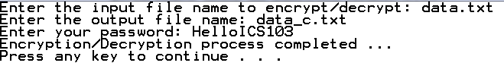
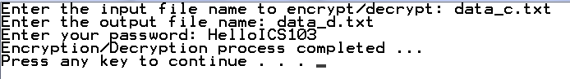

Encrypted file:

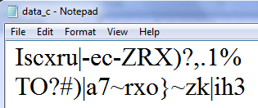

Decrypted file:

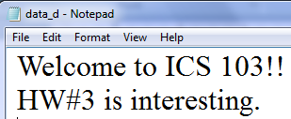

The solution should be well organized and your program should be well documented. Submit a soft copy of your solution in a zip file. Your solution should be submitted in a word file that contains the following items:

Your name and ID

Homework number

Problem statement

Your solution along with the code

Discussion of what worked and what did not work in your program. Include snapshots that demonstrate the working parts of your program. If things did not work and you attempted to solve them, mention that and write about the difficulty that you have faced.

The soft copy should also contain the source code file (i.e. .c).

