ICS 103, Term 103

Computer Programming in C

HW# 2
Due date: Saturday, July 23, 2011

You are required to write a program to do the following:

Prompt the user for the file name and read it.

Display the following menu to the user and read the input from the user. If the input entered by the user is invalid, print that the input is invalid and repeat the process as long as the user does not select the option to exit the program.

Select one of the following options:
(1) Write data into a file
(2) Display the content of a file
(3) Add a number to a file
(4) Delete a number from a file
(5) Exit the program

In case option 1 is selected, ask the user to enter the numbers to be written to the file and write them to the file such that each number is written in a new line. Assume that the numbers entered are integer and that the number -99 indicates the end of the data entered.

In case option 2 is selected, display the content of the file on the screen.

In case option 3 is selected, ask the user to enter the number to be added to the file. Insert the number in the file such that it is inserted before the first number found that is greater than it.

In case option 4 is selected, ask the user to enter the number to be deleted from the file. Delete all occurrences of the number in the file.

Sample executions of the program are given below:
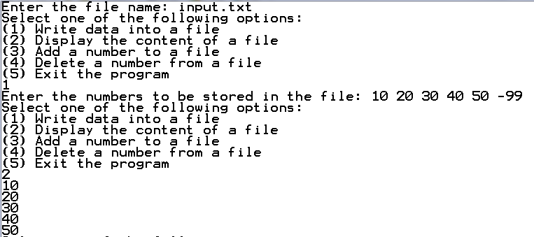
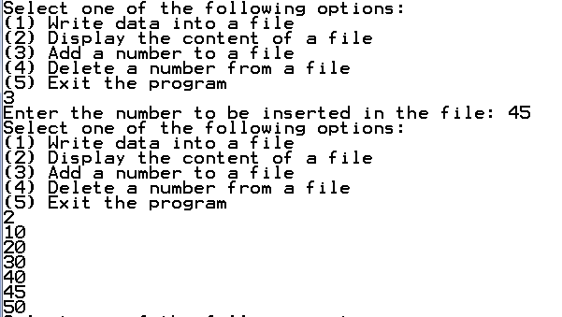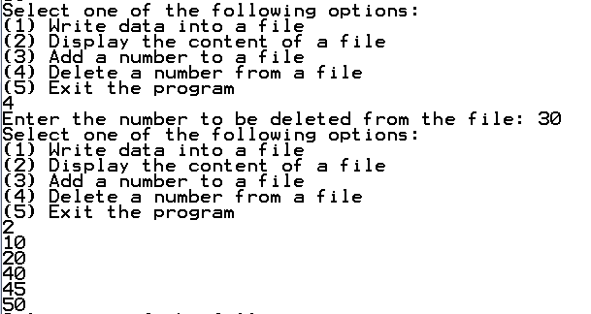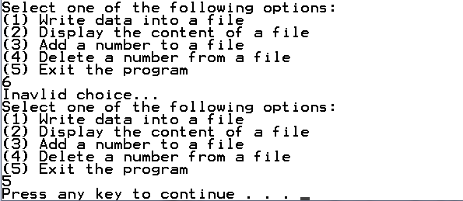

The solution should be well organized and your program should be well documented. Submit a soft copy of your solution in a zip file. Your solution should be submitted in a word file that contains the following items:

Your name and ID

Homework number

Problem statement

Your solution along with the code

Discussion of what worked and what did not work in your program. Include snapshots that demonstrate the working parts of your program. If things did not work and you attempted to solve them, mention that and write about the difficulty that you have faced.

The soft copy should also contain the source code file (i.e. .c) and the executable (i.e. .exe).

