ICS 103, Term 093

Computer Programming in C

HW# 2
Due date: Monday, July 26, 2010

The greatest common divisor (gcd) of two integers is the product of the integers’ common factors. Write a program that inputs two numbers and implements the following approach to finding their gcd. As an example, we will use the numbers -252 and 735. Working with the numbers’ absolute values, we find the remainder of one divided by the other; 252%735=252. Now we calculate the remainder of the old divisor divided by the remainder found; 735%252=231. We repeat this process until the remainder is zero; 252%231=21; 231%21=0. The last divisor (21) is the gcd.

Sample executions of the program are shown below:

Write a program that finds the equivalent series and parallel resistance for a collection of resistor values. Your program should compute the equivalent series resistance for all resistors in the collection and also the parallel resistance correct up to two decimal places. Use any non-positive value to indicate the end of the program data.

Sample executions of the program are shown below:

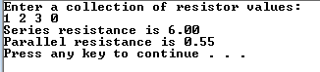
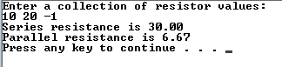

This homework is to be done by a group of two students. The solution should be well organized and your program should be well documented. Submit a soft copy of your solution in a zip file. Your solution should be submitted in a word file that contains the following items:

Your names and IDs

Homework number

Problem statement for each question

Your solution along with the code for each question

Discussion of what worked and what did not work in your programs. Include snapshots that demonstrate the working parts of your programs. If things did not work and you attempted to solve them, mention that and write about the difficulty that you have faced.

The soft copy should also contain the source code files (i.e. .c) for each question separately.

