ICS 103, Term 083

Computer Programming in C

HW# 1 Solution
Due date: Saturday, July 25, 2009

Assume that a curve has a slope of ax+b at each point (x, y) on the curve. You are required to find the equation of the curve assuming that it passes through point (c, d). Write a C program to do the following:

Ask the user to enter the parameters a, b, c, d as integers.

Compute the equation of the curve and print it. Your program should display the equation properly formatted taking into account the sign of the coefficients.

A sample execution of the program is shown below:

#include <stdio.h> /* printf, scanf definitions */
#include <stdlib.h>

int main(void)
{

int a, b, c, d;
double m;

printf ("Enter the parameters a & b of the curve slope: ");
scanf ("%d %d",&a, &b);
printf ("Enter the coordinates (c,d) of the point through which the curve passes: ");
scanf ("%d %d",&c, &d);
m = d - a/2.0 * c*c - b * c;
printf ("Equation of the Curve: Y = %.1f X^2 ", a/2.0);
if (b>0) printf ("+ %d X ",b); else printf ("- %d X ",-b);
if (m>0) printf ("+ %.1f \n",m); else printf ("- %.1f \n",-m);
// Equation can be printed in one line as follows:
// printf ("Equation of the Curve: Y = %.1f X^2 %+d X %+.1f \n", a/2.0, b, m);

system("pause");

return 0;
}

Write a C program that asks the user to enter a decimal number and displays its binary representation. Assume that the decimal number is in the range 0-255.

A sample execution of the program is shown below:

#include <stdio.h> /* printf, scanf definitions */
#include <stdlib.h>

int main(void)
{

int num, q, d0, d1, d2, d3, d4, d5, d6, d7;

printf("Enter a decimal number (0-255): ");
scanf("%d",&num);
d0 = num % 2;
q = num / 2;
d1 = q % 2;
q = q / 2;
d2 = q % 2;
q = q / 2;
d3 = q % 2;
q = q / 2;
d4 = q % 2;
q = q / 2;
d5 = q % 2;
q = q / 2;
d6 = q % 2;
q = q / 2;
d7 = q % 2;
q = q / 2;
printf("Number in Binary is: %d%d%d%d%d%d%d%d\n",d7,d6,d5,d4,d3,d2,d1,d0);
system("pause");

return 0;
}

A cubic equation has the following format: aX³ + bX² + cX + d = 0. The cubic equation can be solved as follows: Let f = ((3c/a) - (b²/a²))/3, g = ((2b³/a³) - (9bc/a²) + (27d/a))/27 and h = (g²/4) + (f³/27).

If (f=0 and g=0 and h=0) then all 3 roots are real and equal. x1 = x2 = x3 = (d/a)^{1/3} * -1.
If (h ≤ 0) then all 3 roots are real and are computed as follows:
i = ((g²/4) - h)^{½}, j = (i)^{1/3}, k = arc cosine (- (g / 2i)), L = j * -1, M = cosine (K/3),
N = (Square Root of 3) * sine (k/3), P = (b/3a) * -1,
x1 = 2j * cosine(k/3) -(b/3a), x2 = L * (M + N) + P, x3 = L * (M - N) + P.
If (h > 0) then there is only one real root computed as follows:
R = -(g/2) + (h)^{½}, S = (R)^{1/3}, T = -(g/2) - (h)^{½}, U = (T)^{1/3}, x1 = (S + U) - (b/3a).

Write a C program that asks the user to input the parameters of the cubic equation and then computes all real roots and prints them. You can test your program by comparing your solution to the cubic equation calculator in http://www.1728.com/cubic.htm.

A sample execution of the program is shown below:

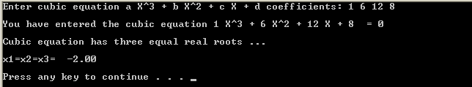

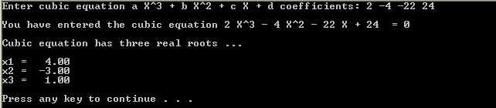

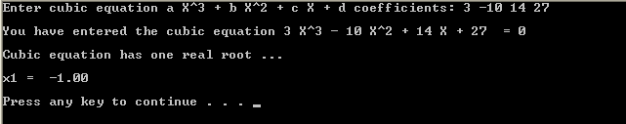

#include <stdio.h> /* printf, scanf definitions */
#include <stdlib.h>
#include <math.h>

int main(void)
{
int a, b, c, d;
double f, g, h, i, j, k, L, M, N, P;
double R, S, T, U;
double x1, x2, x3;

// prompting for the cubic equation
printf("Enter cubic equation a X^3 + b X^2 + c X + d coefficients: ");
scanf("%d %d %d %d",&a, &b, &c, &d);

// displaying the entered cubic equation
printf("\nYou have entered the cubic equation %d X^3", a);
if (b > 0) printf (" + %d X^2",b); else printf (" - %d X^2",-b);
if (c > 0) printf (" + %d X",c); else printf (" - %d X",-c);
if (d > 0) printf (" + %d = 0\n\n",d); else printf (" - %d = 0\n\n",-d);

// The equation could be printed in one statement as:
//printf("\nYou have entered the cubic equation %d X^3 %+d X^2 %+d X %+d = 0\n\n", a, b, c, d);

// computing the real roots of the cubic equation
f = ((3.0*c/a) - ((double) b*b/(a*a)))/3;
g = ((2.0*b*b*b/(a*a*a)) - (9.0*b*c/(a*a)) + (27.0*d/a))/27;
h = (g*g/4) + (f*f*f/27);

if (f==0 && g==0 && h==0){
printf("Cubic equation has three equal real roots ...\n\n");
if ((double)d/a <0) x1 = -pow(-(double)d/a,1.0/3) * -1;
else x1 = pow((double)d/a,1.0/3) * -1;
printf ("x1=x2=x3= %6.2f \n\n",x1);

} else if (h <= 0) {
printf("Cubic equation has three real roots ...\n\n");
i = sqrt(((g*g/4) - h));
if (i<0) j = -pow(-i, 1.0/3); else j = pow(i, 1.0/3);
k = acos(-(g/(2*i)));
L = j * -1;
M = cos(k/3);
N = sqrt(3)* sin(k/3);
P = (b/(3.0*a)) * -1;
x1 = 2 * j * cos(k/3) -(b/(3.0*a));
printf ("x1 = %6.2f \n",x1);
x2 = L * (M + N) + P;
printf ("x2 = %6.2f \n",x2);
x3 = L * (M - N) + P;
printf ("x3 = %6.2f \n\n",x3);
} else {
printf("Cubic equation has one real root ...\n\n");
R = -(g/2) + sqrt(h);
if (R<0) S = -pow(-R,1.0/3); else S = pow(R,1.0/3);
T = -(g/2) - sqrt(h);
if (T<0) U = -pow(-T,1.0/3); else U = pow(T,1.0/3);
x1 = (S + U) - (b/(3.0*a));
printf ("x1 = %6.2f \n\n",x1);
}
system("pause");

return 0;
}

