ICS 103, Term 132

Computer Programming in C

HW# 1
Due date: Tuesday, Feb. 18, 2014

Write a program that outputs the equation of the perpendicular bisector of the line segment between two points. Your program should

prompt for and input the coordinates of the two points [for example, try the
points (2.0, −4.0) and (7.0, −2.0)];

compute the slope of the line between those two points;

compute the coordinates of the midpoint of the line segment between the
two points by averaging the two x coordinates and the two y coordinates;

compute the slope of the perpendicular bisector by taking the negative
reciprocal of the slope of the line segment;

compute the y intercept of the perpendicular bisector (you now have the slope m of the bisector and a point ( x mid , y mid ) on the bisector, so the y intercept is ymid − m xmid ); and

output with labels the original two points, and output in y = m x + b format the equation of the perpendicular bisector. The figure below illustrates the sample line segment mentioned above and its perpendicular bisector.

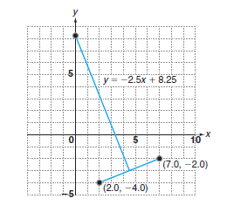

Test your program to be sure it works on different pairs of points. Include at least two pairs of points in your solution. However, there will be some pairs of points for which you can’t make your program work (at least not at this stage). Think about what points will cause your program to fail, and write a paragraph describing which points fall in this category.

The solution should be well organized and your program should be well documented. Submit a soft copy of your solution in a zip file. Your solution should be submitted in a word file that contains the following items:

Your name and ID

Homework number

Problem statement

Your solution along with the code

Discussion of what worked and what did not work in your program. Include snapshots that demonstrate the working parts of your program. If things did not work and you attempted to solve them, mention that and write about the difficulty that you have faced.

The soft copy should also contain the source code file (i.e. .c) and the executable (i.e. .exe).

