ICS 103, Term 083

Computer Programming in C

HW# 1
Due date: Saturday, July 25, 2009

Assume that a curve has a slope of ax+b at each point (x, y) on the curve. You are required to find the equation of the curve assuming that it passes through point (c, d). Write a C program to do the following:

Ask the user to enter the parameters a, b, c, d as integers.

Compute the equation of the curve and print it. Your program should display the equation properly formatted taking into account the sign of the coefficients.

A sample execution of the program is shown below:

Write a C program that asks the user to enter a decimal number and displays its binary representation. Assume that the decimal number is in the range 0-255.

A sample execution of the program is shown below:

A cubic equation has the following format: aX³ + bX² + cX + d = 0. The cubic equation can be solved as follows: Let f = ((3c/a) - (b²/a²))/3, g = ((2b³/a³) - (9bc/a²) + (27d/a))/27 and h = (g²/4) + (f³/27).

If (f=0 and g=0 and h=0) then all 3 roots are real and equal. x1 = x2 = x3 = (d/a)^{1/3} * -1.
If (h ≤ 0) then all 3 roots are real and are computed as follows:
i = ((g²/4) - h)^{½}, j = (i)^{1/3}, k = arc cosine (- (g / 2i)), L = j * -1, M = cosine (K/3),
N = (Square Root of 3) * sine (k/3), P = (b/3a) * -1,
x1 = 2j * cosine(k/3) -(b/3a), x2 = L * (M + N) + P, x3 = L * (M - N) + P.
If (h > 0) then there is only one real root computed as follows:
R = -(g/2) + (h)^{½}, S = (R)^{1/3}, T = -(g/2) - (h)^{½}, U = (T)^{1/3}, x1 = (S + U) - (b/3a).

Write a C program that asks the user to input the parameters of the cubic equation and then computes all real roots and prints them. You can test your program by comparing your solution to the cubic equation calculator in http://www.1728.com/cubic.htm.

A sample execution of the program is shown below:

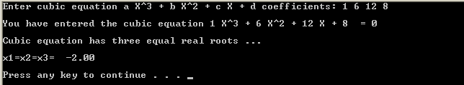

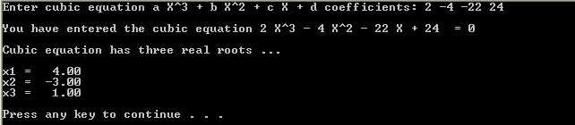

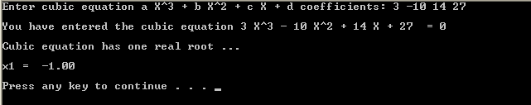

The solution should be well organized and your program should be well documented. Submit a soft copy of your solution in a zip file. Your solution should be submitted in a word file that contains the following items:

Your name and ID

Homework number

Problem statement for each question

Your solution along with the code for each question

Discussion of what worked and what did not work in your programs. Include snapshots that demonstrate the working parts of your programs. If things did not work and you attempted to solve them, mention that and write about the difficulty that you have faced.

The soft copy should also contain the source code files (i.e. .c) for each question separately.

