COE 405, Term 152

Design & Modeling of Digital Systems

HW# 6 Solution

Due date: Sunday, April 17

It is required to design a circuit that computes the average, maximum and minimum of a number of scores N (assuming 0<N≤15), each score with a value in the range [0,15]. Once a user presses a Start button, the number of scores N will be entered. Then, scores will be entered in subsequent clock cycles one score at a time. Once the circuit finishes computation, it will assert a Done signal and will generate the average, maximum and minimum scores. The average will be shown as an integer number resulting from dividing the sum by N with rounding the result to the nearest integer. The Done signal will remain asserted unless the user presses a Reset button.

Develop an ASMD chart for the circuit.

Show the design of your data path unit. Write a Verilog module to model your data path.

Write a Behavioral Verilog module to model the ASMD chart of your circuit.

Write a test bench to verify the correct functionality of your circuit. Show snapshots of your simulation to demonstrate its correctness.

Implement your circuit on FPGA and demonstrate its correct functionality. Include a link for a video snapshot to demonstrate correct functionality of your circuit on FPGA.

First, we will design an unsigned divider to be used for computing the average after computing the sum based on the following algorithm for unsigned division:

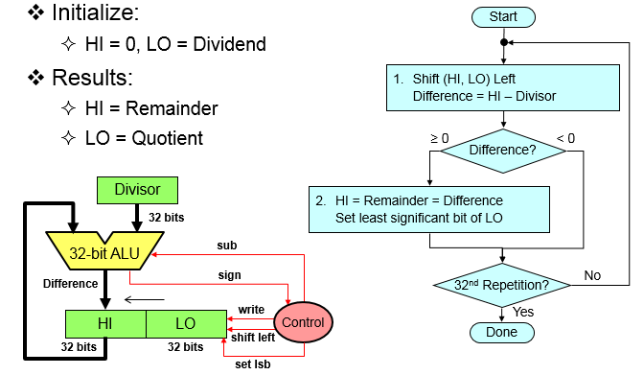

For our problem, the maximum value for the dividend is 15*15=225. Thus, we will use an 8-bit divider where all the registers i.e., HI, LO, Divisor are 8-bits. The Quotient and Remainder will be taken from the least significant 4-bits of LO and HI registers, respectively. Note that it is possible to optimize the design by using only 5 bits for HI and Divisor and subtractor for our example.

The ASMD chart for the unsigned N-bit divider is given below:

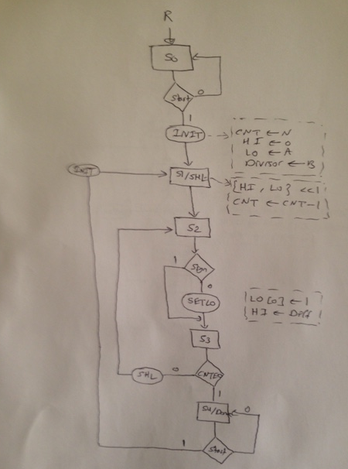

The Verilog modules for the divider are given below:

module Divider #(parameter N=8)(output [N/2-1:0] Q, R, output DONE, input [N-1:0] A, B, input Start, Reset, CLK);

wire [N-1:0] HI, LO;
assign Q = LO[N/2-1:0];
assign R = HI[N/2-1:0];

Divider_DPU #(N) M1 (HI, LO, Sign, CNTEQ0, A, B, SHL, INIT, SETL0, CLK);

Divider_CU M2 (INIT, SHL, SETL0, DONE, Start, Sign, CNTEQ0, Reset, CLK);

endmodule

module Divider_DPU #(parameter N=8) (output reg [N-1:0] HI, LO, output Sign, CNTEQ0, input [N-1:0] A, B, input SHL, INIT, SETL0, CLK);

reg [N-1:0] Divisor;
reg [log2(N):0] CNT;
wire [N-1:0] Diff;

assign Diff = HI - Divisor;
assign CNTEQ0 = ~| CNT;
assign Sign = Diff[N-1];

always @(posedge CLK)
if (INIT) begin
CNT <= N;
Divisor <= B;
HI <= 0;
LO <= A;
end
else if (SHL) begin
HI <= {HI[N-2:0], LO[N-1]};
LO <= {LO[N-2:0], 1'b0};
CNT = CNT-1;
end
else if (SETL0)begin
LO[0] <= 1;
HI <= Diff;
end

function integer log2 (input integer n);
integer i;
begin
log2 = 1;
for (i=0; 2**i<n; i=i+1)
log2 = i+1;
end
endfunction

endmodule;

module Divider_CU (output reg INIT, SHL, SETL0, DONE, input Start, Sign, CNTEQ0, Reset, CLK);

parameter S0 = 3'b000, S1=3'b001, S2=3'b010, S3=3'b011, S4=3'b100;

reg [2:0] state, next_state;

always @(posedge CLK, posedge Reset)
if (Reset) state <= S0;
else state <= next_state;

always @(state, Start, Sign, CNTEQ0) begin
INIT=0; SHL=0; SETL0=0; DONE=0;
case (state)
S0:
if (Start) begin
next_state=S1; INIT=1; end
else next_state=S0;
S1: begin SHL=1; next_state=S2; end
S2: begin
if (!Sign) SETL0=1;
next_state=S3;
end
S3:
if (CNTEQ0) next_state=S4;
else begin
SHL=1; next_state=S2; end
S4: begin DONE=1;
if (Start) begin
next_state=S1; INIT=1; end
else next_state=S4;
end
default: next_state='bx;
endcase
end

endmodule

The ASMD chart for the circuit to compute the Average, Maximum and Minimum is given below:

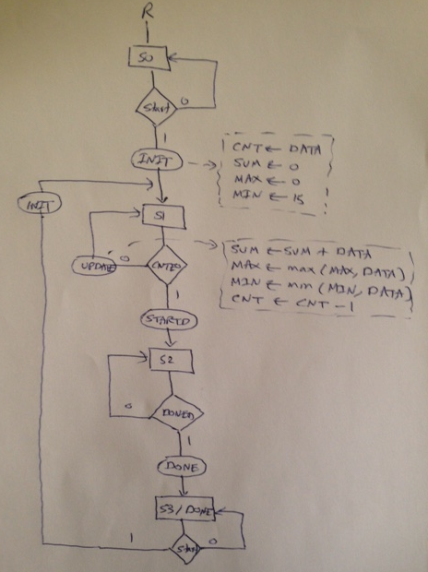

The Verilog modules for the circuit to compute the Average, Maximum and Minimum are given below:

module AVG (output reg [3:0] AVG, output [3:0] MAX, MIN, output DONE,input [3:0] DATA, input START, RESET, CLK);

wire [7:0] SUM;
wire [3:0] Q, R;
reg [7:0] B;

AVG_DP M1 (SUM, MAX, MIN, CNTE0, DATA, INIT, UPDATE, CLK);

AVG_CU M2 (INIT, UPDATE, STARTD, DONE, START, DONED, CNTE0, RESET, CLK);

Divider #(8) M3 (Q, R, DONED, SUM, B, STARTD, RESET, CLK);

// storing the number of scores in register B
always @ (posedge CLK)
if (START)
B <= DATA;

// computing the average
always @(DONED)
if (2*R >= B)
AVG = Q + 1;
else
AVG = Q;

endmodule

module AVG_DP (output reg [7:0] SUM, output reg [3:0] MAX, MIN, output CNTE0, input [3:0] DATA, input INIT, UPDATE, CLK);

reg [3:0] CNT;

assign CNTE0 = ~| CNT;

always @(posedge CLK)

if (INIT) begin
CNT <= DATA;
SUM <= 0;
MAX <= 0;
MIN <= 4'b1111;
end
else if (UPDATE)begin
SUM <= SUM + DATA;
if (DATA > MAX) MAX <= DATA;
if (DATA < MIN) MIN <= DATA;
CNT <= CNT - 1;
end

endmodule

module AVG_CU (output reg INIT, UPDATE, STARTD, DONE, input Start, DONED, CNTE0, Reset, CLK);

parameter S0 = 2'b00, S1=2'b01, S2=2'b10, S3=2'b11;

reg [1:0] state, next_state;

always @(posedge CLK, posedge Reset)
if (Reset) state <= S0;
else state <= next_state;

always @(state, Start, DONED, CNTE0) begin
INIT=0; UPDATE=0; STARTD=0; DONE=0;
case (state)
S0:
if (Start) begin
next_state=S1; INIT=1; end
else next_state=S0;
S1:
if (CNTE0) begin STARTD=1; next_state=S2; end
else begin
UPDATE=1; next_state=S1; end
S2:
if (DONED) begin DONE=1; next_state=S3; end
else next_state=S2;
S3: begin DONE=1;
if (Start) begin
next_state=S1; INIT=1; end
else next_state=S3;
end
default: next_state='bx;
endcase
end

endmodule

The following test bench has been used to test the correct functionality of the average circuit:

module AVG_Test();

wire [3:0] AVG, MAX, MIN;
wire DONE;

reg [3:0] DATA;

reg START, RESET, CLK;

AVG M1 (AVG, MAX, MIN, DONE, DATA, START, RESET, CLK);

initial begin
CLK = 0;
forever
#50 CLK = ~ CLK;
end

initial begin
RESET=1;
#100 RESET=0; START=1; DATA=4;
#100 START=0; DATA=5;
#100 DATA=9;
#100 DATA=15;
#100 DATA=1;
end

endmodule

The simulation snapshot is given below which indicates correct functionality of the circuit:

