Name: Id#

COE 306, Term 161

Introduction to Embedded Systems

Quiz# 5 Solution

Date: Sunday, Jan. 5, 2016

Q1. For the periodic processes shown below:

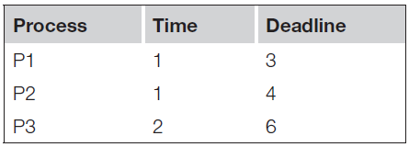

- Compute CPU utilization.
Utilization = 1/3 + 1/4 + 2/6 = 0.9167

- Schedule the processes using an RMS policy.

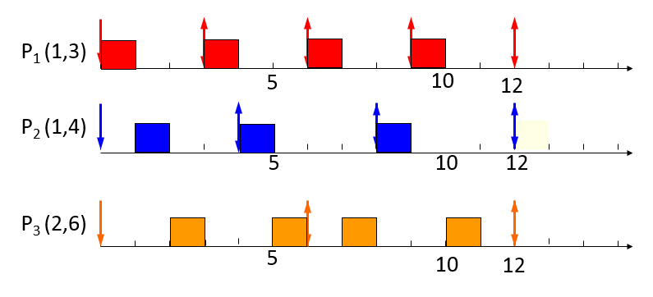

- Schedule the processes using an EDF policy.

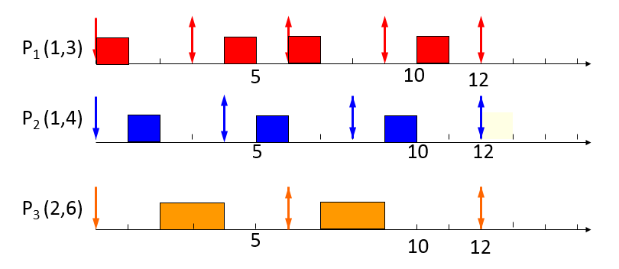
In each case, compute the schedule for an interval equal to the least-common multiple of the periods of the processes. If processes have the same priority, schedule processes to minimize preemption and process waiting time.

