Name: Id#

COE 306, Term 161

Introduction to Embedded Systems

Quiz# 4 Solution

Date: Sunday, Dec. 4, 2016

Q1. It is required to implement the following FIR filter using a circular buffer:

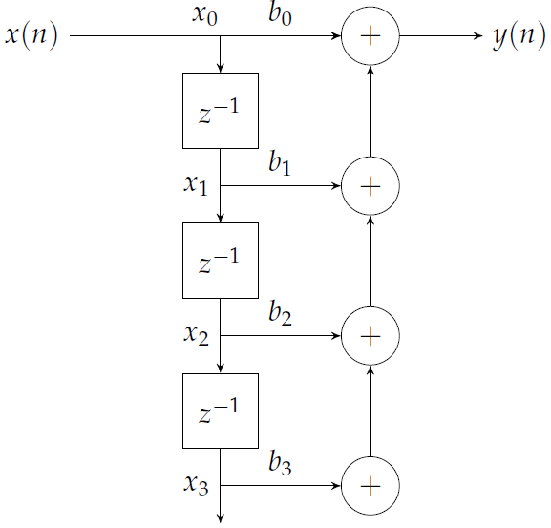

Define the necessary variables for the circular buffer.

#define SIZE 4
int buffer[SIZE];
int pos;

Show the C code for the function init( ) for initializing the buffer.

void init() {
for (int i = 0; i < SIZE; i++)
buffer[i] = 0;
pos = SIZE - 1;
}

Show the C code for the function put( ) for adding a new value to the buffer.

void put(int value) {
pos = (pos + 1) % SIZE;
buffer[pos] = value;
}

Show the C code for the function get( ) for getting a value from the buffer. The function gets the ith value from the circular buffer with zero being the newest value.

/* get the ith value from the circular buffer; zero being the newest value */
int get(int i) {
int index = (pos - i) % SIZE;
return buffer[index];
}

Show the C code for the function fir( ) that receives a new value x(n) and returns a computed value y(n) .

int fir(int value) {
int i, y;
put(value);
for (i = 0, y = 0; i < SIZE; i++)
y += b[i] * get(i);
return y;
}

Q2. Consider the data block given below:

w = a + b;
x = c + d;
w = w * a;
x = x * d;
y = x + w;

Rewrite the given data block in single-assignment form, and then draw the data flow graph for that form.
d
c
a
b
w = a + b;
x = c + d;
+
+
w1 = w * a;
x1 = x * d;
x
w
y = x1 + w1;
*
*

w1
x1
+

y

Determine the minimum number of registers required to perform the operations when they are executed in the order shown in the code. Show the lifetime graph.

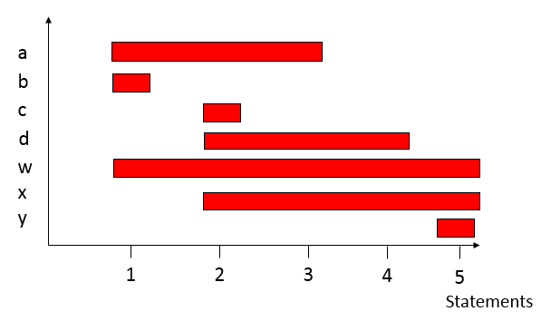
Number of registers = 5

Determine the order of execution of operations that gives the smallest number of required registers and state the number of registers required. Show the lifetime graph.

The operations are reordered as follows:

w = a + b;
w = w * a;
x= c + d;
x = x * d;
y = x + w;

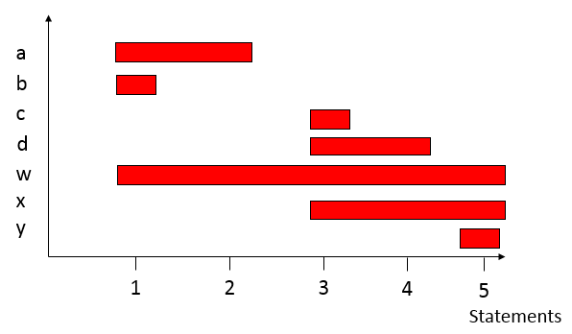

Number of registers = 4

