King Fahd University of Petroleum and Minerals
College of Computer Science and Engineering
Computer Engineering Department

COE 306: INTRODUCTION TO EMBEDDED SYSTEMS
Term 171 (Fall 2017-2018)
Major Exam 1
Saturday Oct. 28, 2017

Time: 120 minutes, Total Pages: 11

Name:______________________________ ID:__________________ Section: _______

Notes:
- Do not open the exam book until instructed
- Answer all questions
- All steps must be shown
- Any assumptions made must be clearly stated

Question | Max Points | Score
Q1 | 29
Q2 | 12
Q3 | 12
Q4 | 9
Total | 62

Dr. Aiman El-Maleh

[29 Points]

(Q1) Fill in the blank in each of the following questions:

The difference between a microprocessor and a microcontroller is _____________ _________________________________________________________________.

Three characteristics of embedded systems are _____________________________ ___________________________________________________________________________________________________________________________________.

Missing deadlines causing failure of an embedded system are called __________ real time deadlines.

Microprocessors have higher ________________ and lower ______________ than FPGAs.

The embedded system design process has the following steps: ________________ ___________________________________________________________________________________________________________________________________.

___________________ of an embedded system should be understandable, unambiguous and should not imply a particular architecture.

Power consumption is an example of __________________ requirement.

In UML, behavior could be described using __________________ and ___________________________.

__________________ architecture has separate memories for data and program, and allows two simultaneous memory fetches

Two types of multiple instruction issue processors are _________________ _________________________________________________________________.

In ARM processors, ______________________________ allows very dense in-line code without branches.

Given that r0=0x5 and r1=0x200, execution of the instruction str r0, [r1], #12 will store the value 0x5 at memory location ________________ and the content of register r1 will be ___________________.

The PICmicro PIC16F has a _______ bit PC and _______ bit word size.

In the PICmicro PIC16F, an 8-level stack is used for ____________________ _________________________________________________________________.

In the PICmicro PIC16F, indirect memory addressing is performed by taking an 8-bit indirect address from ______________________ and 1 bit, _____, from the status register.

In TI C55X DSP processor, the registers BRC0, RSA0 and REA0 are used for ___________________________________________________________________________________________________________________________________.

In TI C55X DSP processor, the registers BKC and BSAC are used for ___________________________________________________________________________________________________________________________________.

The TI C64X DSP processor has the capability of executing up to __________ instructions per cycle.

A memory-mapped I/O means _____________________________________ _________________________________________________________________.

In an interrupt-based I/O system with 8 priorities, the interrupt acknowledge signal has __________ bits.

Given that two devices A and B are connected to a CPU through two interrupt lines with device A having higher priority than B. Suppose that the interrupt handler of device A executes in 30 cycles while that of B executes in 25 cycles. Assume that each instruction in the handlers executes in one clock cycle. If device B initiates an interrupt at the end of cycle 5 when the handler of device A is executing, then the handler of device A will finish execution by the end of cycle______.

Interrupt vectors allow an interrupting device to specify its handler by _________________________________________________________________.

Two types of Cache misses are ______________________________________ _________________________________________________________________.

Given two-level cache memory, L1 and L2, h1 is L1 cache hit rate, h2 is L2 cache hit rate, t_{L1} is the L1 cache access time, t_{L2} is the L2 cache access time and t_{main} is the memory access time, then the average memory access time is _________________________________________________________________.

In memory segmentation, physical address is computed based on adding ___________________________ and ________________________________.

Two methods of reducing power consumption are: ______________________ ___________________________________________________________________________________________________________________________________.

[12 Points]

(Q2)

[7 points] Translate the given C code into ARM assembly code with minimum instructions:

volatile static int Array[10] = {75,60,55,40,85,60,90,88,100,70};

int cnt = 0;
for (i=0; i != 10; i++) {
if ( (Array[i] > 70) && (Array[i] <= 100) ) cnt = cnt + 1;
}

[2 points] Write an ARM code fragment that multiplies the content of register r0 by 225 without the use of multiplication instructions with the minimum number of instructions. HINT: 225=15*15.

[3 points] Determine the content of register 0x27 after executing the following PIC16F assembly code:

MOVLW 0x85
MOVWF 0x25
MOVLW 8
MOVWF 0x26
CLRF 0x27
NEXT BTFSS 0x25, 0
INCF 0x27, f
RRF 0x25, f
DECFSZ 0x26
GOTO NEXT

[12 Points]

(Q3) A system has two memory-mapped I/O devices. The first device has an 8-bit status register at address 0xA000, immediately followed by a 32-bit data register. The second device has a 16-bit status register at address 0xB000, followed by a 32-bit data register. The first device is used to receive data (i.e., input device). The most-significant bit in the status register is a data ready flag, which is set automatically by the device whenever new data is received. For the device to receive more data, the data ready flag must be manually reset by software to indicate that the current data has been processed.

The second device is used to send data (i.e., output device). Bit 0 of its status register is a read-only ready to send flag, and bit 15 is a transmit enable command bit that is automatically reset by the device after each transmission.

We would like to write software that collects 32-bit words of signed values received through the first device, and computes the average of received data until the second device becomes ready to send. Once the second device becomes ready to send data, the average word is sent using the second device. Once the average is sent, the average computation is restarted for the next sample of data, ignoring the previously received data samples.

Write a C program that implements this behavior using polling only.

Assuming that each device has its own interrupt handler, write the handlers for each device in C. The first device generates an interrupt request upon receiving new data. The second device generates an interrupt request upon becoming ready to send new data.

Use the signatures:
void device1_handler(void);
void device2_handler(void);

[9 Points]

(Q4) Given a virtual memory system with 32-bit logical addresses and 1K Byte pages. The system supports up to 1 GB of physical memory.

How many bits are used for the page number and how many bits are used for the offset within a page?

How many entries are there in the full flat page table?

How wide is each entry of the page table for storing the physical page number?

Given the logical address 0x00020FB8, what is the page number, in hexadecimal, for the page that contains this address? What is the offset of this address within its page (hexadecimal)?

Suppose that the page of the logical address 0x00020FB8 got mapped into physical page number 0x20, what is the physical address corresponding to this logical address?

If two-level page tables are used with the first-level page table having 2048 entries, how many entries will be in each of the second-level page tables? How many page tables will be allocated for an 8 Mbyte program?

ARM Instruction Set

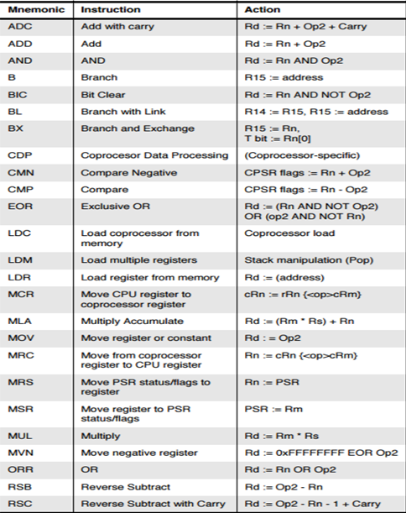
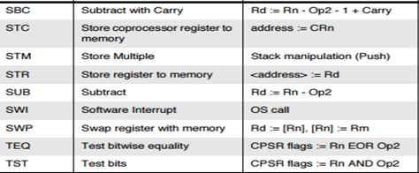

PIC16 Instruction Set

