COE 306, Term 171

Introduction to Embedded Systems

Assignment# 5
Due date: Saturday, Dec. 23, 2017

It is required to write an embedded program to interface with the LSM303D Accelerometer using I2C interface. The accelerometer measures acceleration along the three dimensions, and makes them available in the following registers:

- OUT_X_L_A (28h), OUT_X_H_A (29h)
X-axis acceleration data. The value is expressed in 16 bits as 2’s complement.
- OUT_Y_L_A (2Ah), OUT_X_H_A (2Bh)
Y-axis acceleration data. The value is expressed in 16 bits as 2’s complement.
- OUT_X_L_A (2Ch), OUT_X_H_A (2Dh)
Z-axis acceleration data. The value is expressed in 16 bits as 2’s complement.

Use the LPC1769’s I2C interface to read the accelerometer data from the LSM303D device. The slave address (SAD) associated to the LSM303D is 00111xxb, whereas the xx bits are modified by the SDO/SA0 pin in order to modify the device address. If the SDO/SA0 pin is connected to the voltage supply, the address is 0011101b, otherwise, if the SDO/SA0 pin is connected to ground, the address is 0011110b. This solution permits the connection and addressing of two different accelerometers to the same I2C lines. Consult the LSM303D datasheet for more details [https://www.pololu.com/file/0J703/LSM303D.pdf].

Write a simple application to indicate different stationary positions. For example, indicate whether the device is tilted to the right or to the left, tilted forward or backward, and whether it’s facing upward or downward. Use print statements to reflect this data in real-time. The following table summarizes the readings corresponding to each of the six stationary positions.

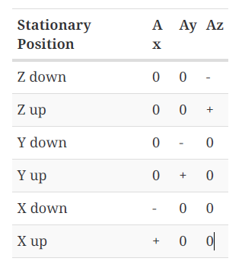

Include the source code of your solution along with a video snapshot to demonstrate correct functionality of your code.

Write an embedded program that interfaces the LPC1769’s UART interface with the PC using CoolTerm. Display first the message “Welcome to COE 306.” Then, display all the text that the user types on the terminal in upper case. All punctual characters should remain as is. Use a 9600 baud rate, 8-bit word, no parity bit and one stop bit (default settings in CoolTerm). Include the source code of your solution along with a video snapshot to demonstrate correct functionality of your code.

