COE 306, Term 171

Introduction to Embedded Systems

Assignment# 4
Due date: Saturday, Nov. 25, 2017

It is required to design a digital system that controls the traffic lights at an intersection. It receives inputs from all four corners indicating pedestrians that want to cross. In absence of crossing requests, it should allow each direction 10 seconds of green light, followed by 2 seconds of yellow light while the other traffic light will be red light (i.e., for 12 seconds). In presence of crossing requests at or after 5 seconds, immediately proceed with yellow. Use two buttons Cross1 and Cross2 to indicate request for crossing across the main street and side street respectively. Use a pair of Red, Yellow and Green leds for each street.

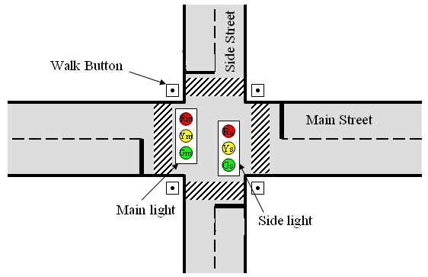

Show the state diagram of your traffic light controller.

Implement your traffic light controller and include your code along with a link for a video demo illustrating its correct functionality.

Write an embedded software that computes the moving average of the last five samples using a circular buffer. Assume that each sample is 4-bit. Whenever a sample is entered by the user, your program should print the average of the last five samples. Use interrupt to indicate that a new sample is entered. Include your code along with a video link illustrating correct functionality of your program for 10 entered samples.

