COE 306, Term 171

Introduction to Embedded Systems

Assignment# 2
Due date: Tuesday, Oct. 24, 2017

- Write a program that implements a decimal up-counter that counts from 0 to 9 and back to 0 (i.e., 0→1→2→…→9→0) and displays the result in a seven-segment display. Check the seven-segment display part number you have and then find out its data sheet to identify the configuration of pints. The MAN72A-like seven-segment display is shown below along with its pin configurations:

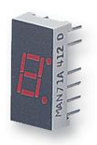 | 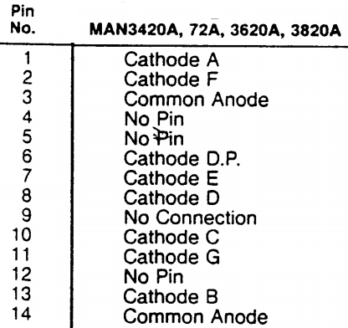

- Add two switches to your implementation and configure them as input and use them based on input polling such that whenever the first switch is pressed the speed of counting is increased by a factor of 2 relative to the latest speed and whenever the second switch is pressed the speed of counting is decreased by a factor of 2 relative to the latest speed. When the program starts initially the speed of counting should have a frequency of around 1 HZ.
- Use the two switches in the same way as used in part (b) to change the speed of counting but based on the use of interrupts instead of using polling. Write two input interrupt handlers, one for each switch, such that whenever any of the switches is pressed the handlers change the value of a global variable that changes the speed of counting.
- Discuss your implementations in part (b) and (c) and which implementation is better and why?
- Include a link for a video demo for your implementations of part (b) and (c) on the LPCXpresso board.

