COE 306, Term 161

Introduction to Embedded Systems

Assignment# 1 Solution
Due date: Thursday, Oct. 13, 2016

Look for a consumer product, e.g. a toy or a small home appliance that incorporates an embedded system. It will be good if you can find a locally available product, and include pictures showing its computer components.

Note: You may need to disassemble the product to be able to verify that it does incorporate an embedded system. If this is the case, please exercise caution and follow safety procedures to avoid any injuries. If unsure about the safety of an action, consult lecture or lab instructors.

  - What feature of the product suggested to you that it may incorporate an embedded system?
  - What is the model number of the microcontroller chip used in this product?
  - What is the architecture of this microcontroller?
  - What are the main specifications of this microcontroller? On-chip memory, integrated peripheral devices, maximum frequency, power rating (volts, amperes, watts), any other notable specifications.
  - Provide the URL of the microcontroller datasheet.
  - Include a picture of the product in its original condition, and another picture of its main board, showing the main microcontroller.

Consider the C code given below:

volatile static int sum = 0; // assume sum is a memory variable
for (int i=0; i<10; i++){
if (i<5)
sum = sum + i;
else
sum = sum + 2*i;
}

- Write the given C code in ARM assembly without the use of conditional instructions except branch. Simulate your program using VisUAL ARM emulator and include a snapshot to show that your program produced the correct result of sum.

mov r3, #0 ; i=0
adr r2, Sum
FOR cmp r3, #4 ; if (i<5)
ldr r1, [r2] ; load sum
add r1, r1, r3 ; sum = sum + i;
ble Skip
add r1, r1, r3 ; sum = sum + 2*i;
Skip str r1, [r2] ; store sum
add r3, r3, #1 ; i++
cmp r3, #10 ; i<10
bne FOR
Sum DCD 0 ; sum declaration

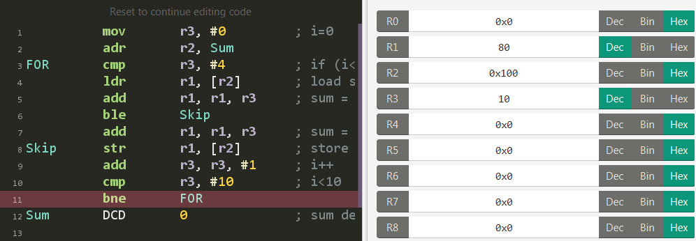

- Write the given C code in ARM assembly with the use of conditional instructions. Simulate your program using VisUAL ARM emulator and include a snapshot to show that your program produced the correct result of sum.

mov r3, #0 ; i=0
adr r2, Sum
FOR cmp r3, #4 ; if (i<5)
ldr r1, [r2] ; load sum
addle r1, r1, r3 ; sum = sum + i;
addgt r1, r1, r3, lsl #1 ; sum = sum + 2*i;
str r1, [r2] ; store sum
add r3, r3, #1 ; i++
cmp r3, #10 ; i<10
bne FOR
Sum DCD 0 ; sum declaration

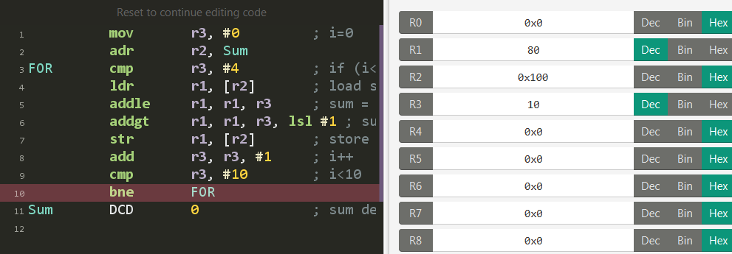

- Compare your assembly codes in part (a) and part (b) in terms of number of instructions in each code and the number of instructions executed in each code.
As one can see, using conditional instructions saves one instruction in the code size and one less instruction to be executed in every loop iteration. More importantly a conditional branch instruction is avoided which could result in flushing pipeline when this is branch misprediction.

- Compile your C program to ARM assembly code and compare your handwritten assembly program in part (b) with the compiler-generated assembly code using LPCXpresso IDE. Explain any differences between the two assembly programs.

The relevant code generated by the compiler is given below, which is identical to our code written for part (b), except for the way data is declared and the address of sum is loaded:

mov r3, #0
ldr r2, .L6
.L4:
cmp r3, #4
ldr r1, [r2]
addle r1, r1, r3
addgt r1, r1, r3, lsl #1
str r1, [r2]
add r3, r3, #1
cmp r3, #10
bne .L4
.L6:
.word .LANCHOR0
.word .LANCHOR0
.LFE0:
.section .bss.sum.3686,"aw",%nobits
.align 2
.set .LANCHOR0,. + 0
sum.3686:
.space 4

Consider the C code given below:

volatile static int x=1; // assume x is a memory variable
x = x * 64449;

- Write the given C code in ARM assembly without the use of multiplication instructions. Simulate your program using VisUAL ARM emulator and include a snapshot to show that your program produced the correct result of sum.
; 64449 = 1023 * 63
adr r0, Xvar
ldr r1, [r0]
rsb r1, r1, r1, lsl #6 ; X = X * 63
rsb r1, r1, r1, lsl #10 ; X = X * 63 * 1023
str r1, [r0]
Xvar DCD 1

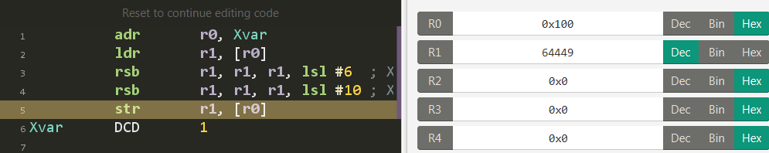

- Compile your C program to ARM assembly code and compare your handwritten assembly program in part (b) with the compiler-generated assembly code using LPCXpresso IDE. Explain any differences between the two assembly programs.

The relevant code generated by the compiler is given below, which is identical to our code, except for the way data is declared and the way the address of X is loaded:

ldr r2, .L2
ldr r3, [r2]
rsb r3, r3, r3, lsl #6
rsb r3, r3, r3, lsl #10
str r3, [r2]
.L2:
.word .LANCHOR0
.LFE0:
.section .data.x.3686,"aw",%progbits
.align 2
.set .LANCHOR0,. + 0
x.3686:
.word 1

