Name: Id#

COE 202, Term 201

Digital Logic Design

Quiz# 6 Solution

Date: Sunday, Nov. 29, 2020

Q1. [7 points] Consider the sequential circuit given below which has input X and output Y:

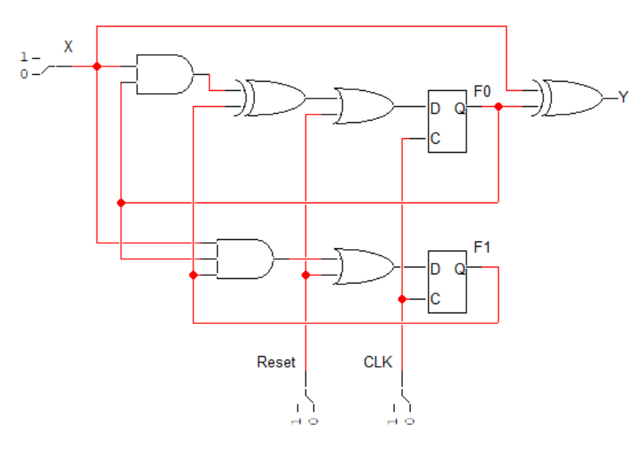

- (2 points) What is the reset state? Is the reset asynchronous or synchronous?
The reset state is F1 F0 = 1 1. The reset is synchronous.

- (1 point) Is the circuit Mealy or Moore? Justify your answer.
It is Mealy because the output depends on the input.

- (4 points) Derive the state table for this sequential circuit.
Present State |  | Input | Next State |  | Output
F1 | F0 | X | F1+ | F0+ | Y
0 | 0 | 0 | 0 | 0 | 0
0 | 0 | 1 | 0 | 0 | 1
0 | 1 | 0 | 0 | 0 | 1
0 | 1 | 1 | 0 | 1 | 0
1 | 0 | 0 | 0 | 1 | 0
1 | 0 | 1 | 0 | 1 | 1
1 | 1 | 0 | 0 | 1 | 1
1 | 1 | 1 | 1 | 0 | 0

Q2. [7 points] Given the state table below of a sequential circuit that has an input X and an output Y:
- (2 points) Derive the output equation of the given sequential state table assuming asynchronous reset with the reset state being F2 F1 F0 = 0 0 0. Note that entries that are not shown represent unused states.
Present State |  |  | Input | Next State |  |  | Output
F2 | F1 | F0 | X | F2+ | F1+ | F0+ | Y
0 | 0 | 0 | 0 | 0 | 0 | 1 | 1
0 | 0 | 0 | 1 | 0 | 1 | 1 | 0
0 | 0 | 1 | 0 | 0 | 1 | 0 | 0
0 | 0 | 1 | 1 | 0 | 1 | 1 | 1
0 | 1 | 0 | 0 | 0 | 1 | 0 | 1
0 | 1 | 0 | 1 | 1 | 0 | 0 | 0
0 | 1 | 1 | 0 | 0 | 1 | 1 | 0
0 | 1 | 1 | 1 | 1 | 0 | 0 | 1
1 | 0 | 0 | 0 | 0 | 1 | 1 | 1
1 | 0 | 0 | 1 | 1 | 0 | 1 | 0
1 | 0 | 1 | 0 | 1 | 0 | 0 | 0
1 | 0 | 1 | 1 | 1 | 0 | 1 | 1

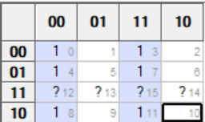
Y = (F0 ⊕ X)’

- (5 points) Complete the given two input/output sequences and then determine the function of the circuit.
Cycle | 0 | 1 | 2 | 3 | 4
Input x | 1 | 1 | 0 | 0 | 0
F2 | 0 | 0 | 1 | 0 | 0
F1 | 0 | 1 | 0 | 1 | 1
F0 | 0 | 1 | 0 | 1 | 1
Output z | 0 | 1 | 1 | 0 | 0

Cycle | 0 | 1 | 2 | 3 | 4
Input x | 0 | 0 | 1 | 0 | 0
F2 | 0 | 0 | 0 | 1 | 0
F1 | 0 | 0 | 1 | 0 | 1
F0 | 0 | 1 | 0 | 0 | 1
Output z | 1 | 0 | 0 | 1 | 0

The circuit is implementing the equation Y= 3X – 3 = 3(X-1).

