Name: Id#

COE 202, Term 201

Digital Logic Design

Quiz# 5 Solution

Date: Sunday, Nov. 8, 2020

Question 1: (9 points)

Given an n-bit signed 2's complement number, X, it is required to design an iterative combinational circuit to compute the 2's complement of X.
- Sow the inputs and outputs of the 1-bit 2's complement iterative cell to be used for designing the n-bit 2's complement circuit. (2 Points)
- Show the truth table of the 1-bit 2's complement cell. (4 Points)
- Obtain simplified equations for the outputs of the 1-bit 2's complement cell using only the following gate types: NOT, AND, OR, XOR. (2 Points)
- Using the 1-bit 2's complement cell, draw a block diagram for a circuit to compute the 2's complement of a 3-bit number X. (1 Point)

We will us a signal (One) that propagates between cells to indicate whether we have got one or not.

1-bit
2's comp.
One_{i-1}
One_{i}
X_{i}
Y_{i}

One_{i-1} | X_{i} | One_{i} | Y_{i}
0 | 0 | 0 | 0
0 | 1 | 1 | 1
1 | 0 | 1 | 1
1 | 1 | 1 | 0

Y_{i} = X_{i} ⊕ One_{i-1} One_{i} = One_{i-1} + X_{i}

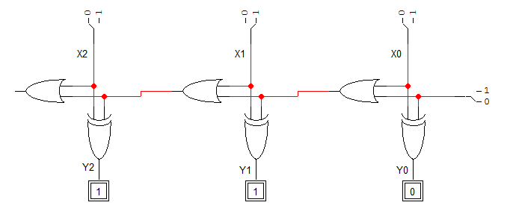

Alternative Solution:

We will us a signal (Cin) that propagates between cells to indicate whether we have carry or not. The 2's complement will be computed as the 1's complement + 1.

1-bit
2's comp.
C_{i-1}
X_{i}
C_{i}
Y_{i}
C_{i-1} | X_{i} | C_{i} | Y_{i}
0 | 0 | 0 | 1
0 | 1 | 0 | 0
1 | 0 | 1 | 0
1 | 1 | 0 | 1

Y_{i} = (X_{i} ⊕ C_{i-1})' C_{i} = C_{i-1} X_{i}'

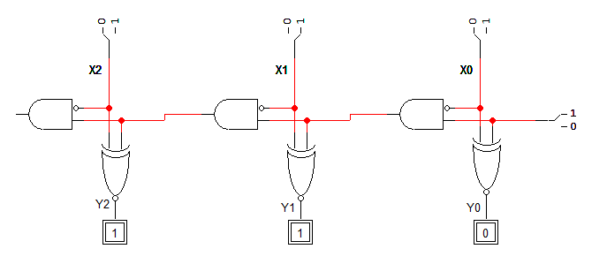

Question 2. (14 Points)

- Fill in all blank cells in the two tables below.

Binary | Equivalent decimal value with the binary interpreted as:
 | Unsigned number | Signed-magnitude number | Signed-1’s complement number | Signed-2’s complement number
1011 1010 | 186 | -58 | -69 | -70

Decimal | Binary representation in 8 bits:
 | Signed-magnitude representation | Signed-1’s complement representation | Signed-2’s complement representation
+ 90 | 0101 1010 | 0101 1010 | 0101 1010
- 90 | 1101 1010 | 1010 0101 | 1010 0110

- Show how the following arithmetic operations are performed using 5-bit signed 2’s-complement system. Check for overflow and mark clearly any overflow occurrences.

(i)  01101 (+13)  - 11100 (-4)  01101 (+13)  + 00100 (+4)  -------------  10001 (-15)  Overflow: Yes/No | (ii)  10010 (-14)  + 11110 (-2)  10000 (-16)  Overflow: Yes/No
(iii)  11111 (-1)  + 11111 (-1)  11110 (-2)  Overflow: Yes/No | (iv)  01011 (+11)  - 11011 (-5)  01011 (+11)  + 00101 (+5)  -------------  10000 (-16)  Overflow: Yes/No

