Name: KEY Id#

COE 202, Term 121

Digital Logic Design

Quiz# 5

Date: Saturday, Dec. 22

Q1. The state table of a sequential circuit which has a single input X and two outputs, which are the flip flop outputs, is given below.

Current State | Next State  X=0 | Next State  X=1
S0 | S0 | S1
S1 | S1 | S2
S2 | S2 | S0

Implement the sequential circuit using D-FFs and the smallest number of gates possible assuming the state assignment: S0=00, S1=01, and S2=10. Minimize your equations using K-map method.

Draw the circuit diagram.

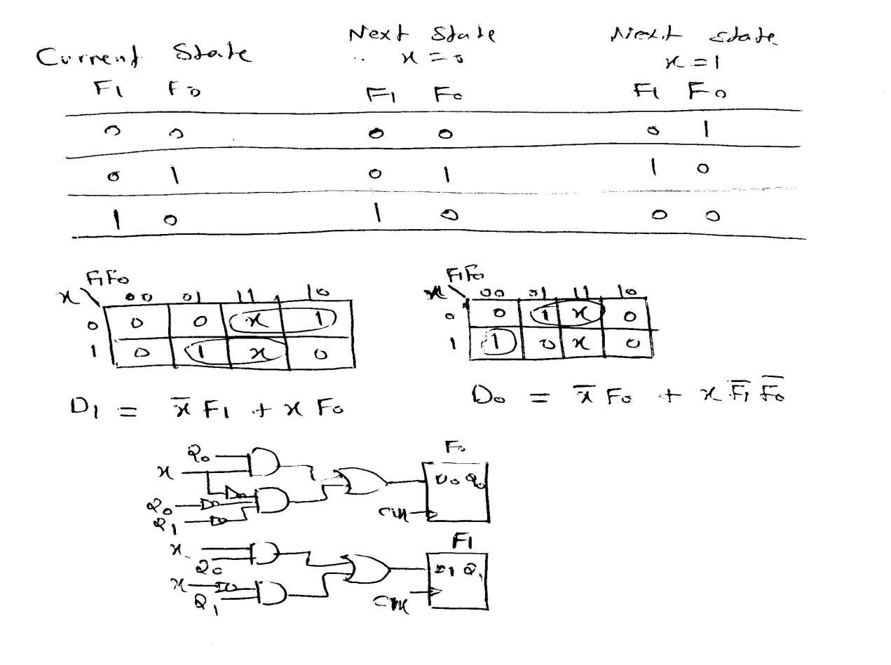

Q2. It is required to design a sequential circuit that receives two unsigned numbers X and Y serially and computes the output Z=X-Y serially, assuming that X ≥ Y. Derive the state diagram for your circuit assuming Mealy model.

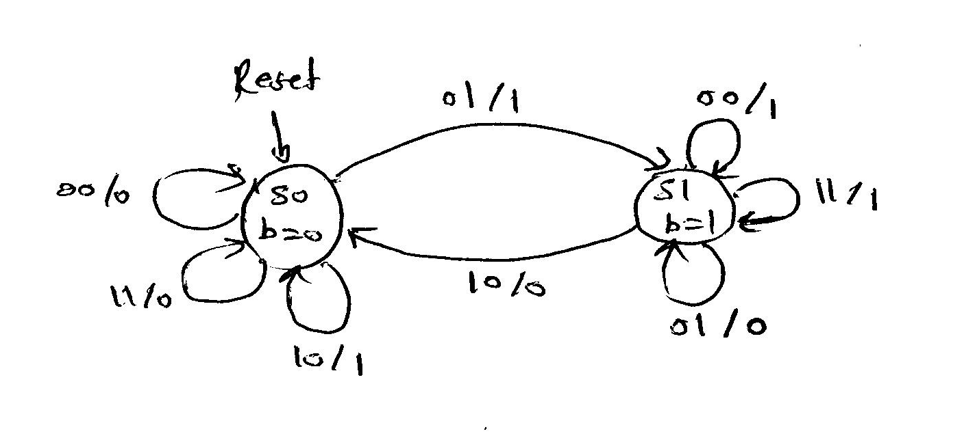

Q3. It is required to design a sequential circuit that receives a serial input X and produces a serial output Z. The output Z will be 1 when the circuit detects the sequence 1010 assuming overlapping sequence detection. Derive the state diagram for your circuit assuming Moore model.

