Name: Id#

COE 202, Term 141

Digital Logic Design

Quiz# 5

Date: Thursday, Nov. 27

Q1 a. Fill in all blank cells in the two tables below.

Binary | Equivalent decimal value with the binary interpreted as:
 | Unsigned number | Signed-magnitude number | Signed-1’s complement number | Signed-2’s complement number | BCD number
10000000

Decimal | Binary representation in 8 bits:
 | Signed-magnitude notation | Signed-1’s complement notation | Signed-2’s complement notation
- 75

b. Using 2’s-complement signed arithmetic in 5 bits, do the following operations in binary. Show all your work, and:
- Verify that you get the expected decimal results.
- Check for overflow and mark clearly any overflow occurrences.

(i)  00111  - 10101 | (ii)  10110  - 10011

c. Consider the signed 2’s complement arithmetic operation A - B in 6 bits. With B = 101100, the largest value allowed for A in order to avoid the occurrence of overflow is (_________)_{2.}

Q2 Assume that the delay of a 2-input XOR gate is 3ns while the delay of other gates is equal to the gate’s number of inputs, i.e. the delay of an inverter is 1ns, the delay of a 2-input AND gate is 2ns, the delay of a 2-input OR is 2ns, the delay of a 3-input AND gate is 3ns, the delay of a 3-input OR gate is 3ns, etc.
- (6 points) A 4-bit Ripple Carry Adder (RCA) is given below:
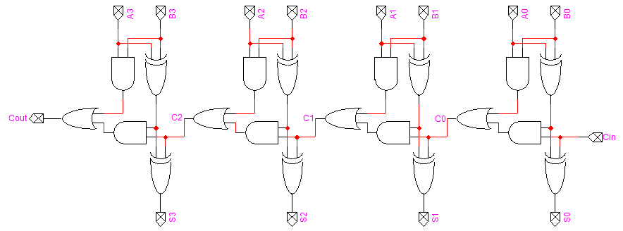

Determine and compute the longest delay in the 4-bit Ripple Carry Adder (RCA).

- (4 points) Show the design of a 2-bit Carry Look-Ahead Adder (CLA) by drawing its logic diagram.

- (3 points) Using the delay assumptions given in the beginning of the question, determine and compute the longest delay in the 2-bit Carry Look-Ahead Adder (CLA).

