Name: Id#

COE 202, Term 201

Digital Logic Design

Quiz# 4 Solution

Date: Thursday, Oct. 22, 2020

Question 1: (14 points)

- (2 points) Given the function f (a, b, c, d) = ∑m(1, 5, 8, 12, 15) + ∑d(4, 10, 13), draw the K-map of f.

f |  | c d
 |  | 0 0 | 0 1 | 1 1 | 1 0
a b | 0 0 |  | 1
 | 0 1 | X | 1
 | 1 1 | 1 | X | 1
 | 1 0 | 1 |  |  | X

- (2 points) Given the function f (a, b, c, d) = (a’ + b)(a + c’ +d)(b + d), draw the K-map of f.

f |  | c d
 |  | 0 0 | 0 1 | 1 1 | 1 0
a b | 0 0 | 0 | 1 | 1 | 0
 | 0 1 | 1 | 1 | 1 | 0
 | 1 1 | 1 | 1 | 1 | 1
 | 1 0 | 0 | 0 | 0 | 0

c) (10 points) Given the following K-map of the function g (a, b, c, d), where X is a don't-care:

g |  | c d
 |  | 0 0 | 0 1 | 1 1 | 1 0
a b | 0 0 | 1 |  |  | 1
 | 0 1 | X | X | X | X
 | 1 1 | 1 | 1
 | 1 0 | X | 1 |  | X

- (5 points) Write the terms of all Prime Implicants of g.
- (1 points) Write the terms of all Essential Prime Implicants of g.
- (2 points) Find ALL minimum Sum-of-Products expressions of g.
- (2 points) Find ALL minimum Product-of-Sums expressions of g.

Solution i:
Five Prime Implicants: ac’, bc’, c’d’, a’d’, b’d’
Solution ii:
One essential prime Implicant: ac’
Solution iii: Two Solutions
g = ac’ + b’d’
g = ac’ + a’d’
Solution iv: Only one solution
g = (a’ + c’) (a + d’)
Question 2: (4 points)

Reimplement the circuit given below using ONLY minimum number of 2-input XOR gates:

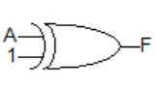
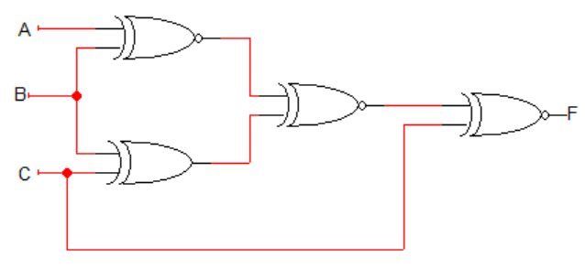
F = [[(A ⊕ B)’ ⊕ (B⊕C)]’ ⊕ C]’ = [[(A ⊕ B) ⊕ (B⊕C)] ⊕ C]’ = [[A⊕C] ⊕ C]’ =[A]’

