Name: KEY Id#

COE 202, Term 142

Digital Logic Design

Quiz# 4

Date: Thursday, April 2, 2015

# 

# **Q1** Convert the AND/OR/NOT logic diagram shown below to a NOR logic diagram.

# 

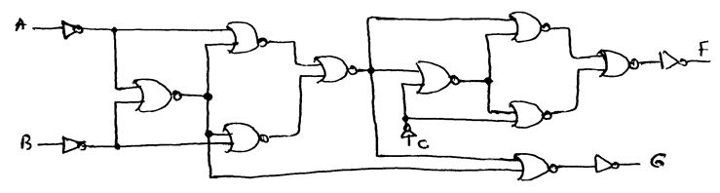

**Q2** A logic circuit has two inputs x & y each is a 2-bit unsigned number. It has an output number z such that z =x2 + y2.



1. What is the minimum number of bits required for the output number ***z***?
2. Construct the truth table of the circuit.
3. Derive the Boolean expressions of the two least significant output bits (***z*0 *, z*1)** using basic logic gates.

