Name: KEY Id#

COE 202, Term 132

Digital Logic Design

Quiz# 4

Date: Tuesday, April 15

Q1. Determine the decimal value of the 7-bit binary number (1011010) when interpreted as:

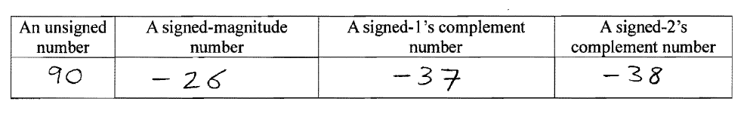

ii. Represent the decimal value (- 21) in binary using a total of 7 bits in the following notations:

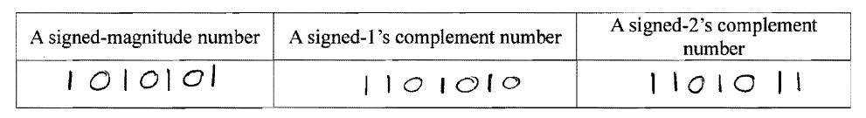
iii. Perform the following signed-2’s complement arithmetic operations in binary using 5 bits. All numbers given are represented in the signed-2’s complement notation. Indicate clearly the carry values from the last two stages. For each of the three operations, check and indicate whether overflow occurred or not.
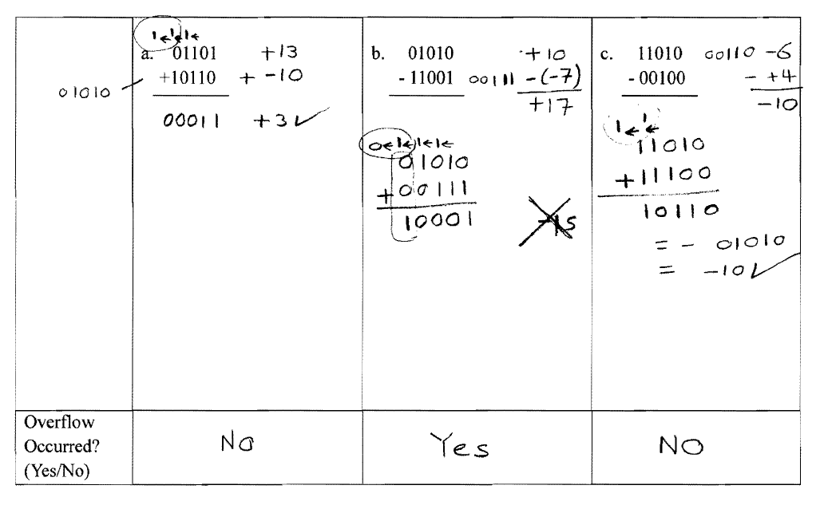

(B) Consider the 2’s complement 4-bit adder/subtractor hardware shown (FA = full adder).

