Name: KEY Id#

COE 202, Term 142

Digital Logic Design

Quiz# 3

Date: Tuesday, March 17

Q1 For the following Boolean function F(A, B, C, D)=Σ m(0, 1, 2, 5, 6, 7, 8, 9, 10, 12, 13)

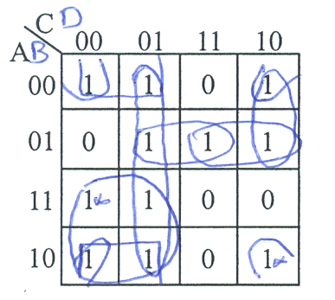

Identify all the prime implicants and the essential prime implicants of F.

Simplify the Boolean function F into a minimal sum-of-products expression.

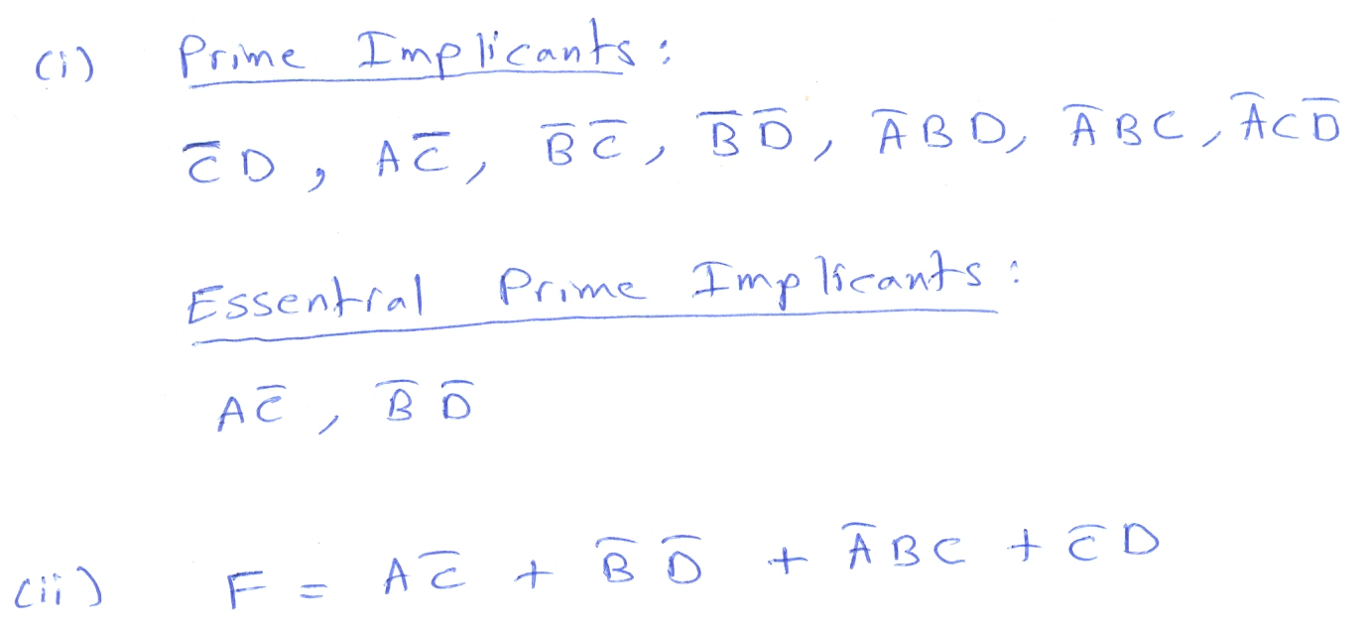
Q2 Consider the following Boolean function F together with the don`t care conditions d

F(A, B, C, D)=Σ m(3, 6, 13), d(A, B, C, D)=Σ m(1, 4, 7, 9, 11, 12, 14, 15)

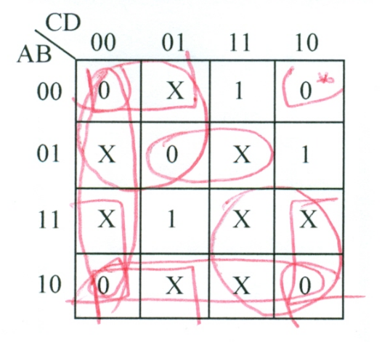

Simplify the Boolean function F together with the don`t care conditions d, into minimal product-of-sums expression.

