Name: KEY Id#

COE 202, Term 141

Digital Logic Design

Quiz# 3

Date: Tuesday, Oct. 28

Q1 For the following Boolean function shown in the K-map:
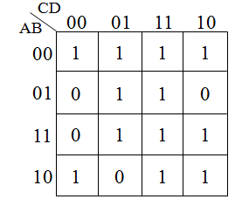

F(A, B, C, D)=Σ m(0, 1, 2, 3, 5, 7, 8, 10, 11, 13, 14, 15)

Identify all possible prime implicants of F and indicate which of these is essential.

Simplify the Boolean function F into a minimal sum-of-products expression.

- Prime Implicants:
A’B’, CD, A’D, BD, AC, B’C, B’D’

Essential Prime Implicants:
BD, AC, B’D’

- F = BD + AC + B’D’ + A’B’ OR F = BD + AC + B’D’ + A’D

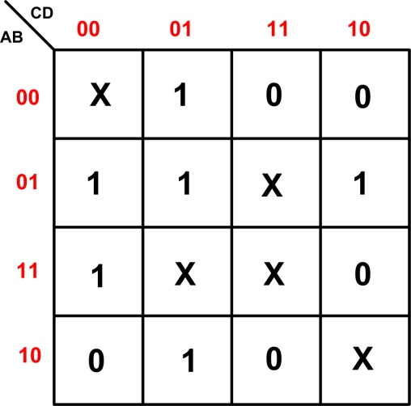
Q2 Shown to the right is the K-Map of the Boolean function G subject to the don’t care conditions D
G(A, B, C, D) = ∑(1, 4, 5, 6, 9, 12)
D(A, B, C, D) = ∑(0, 7, 10, 13, 15)

Derive the minimal POS expression of G.

G’ = B’ D’ + A C + C D

