Name: KEY Id#

COE 202, Term 131

Digital Logic Design

Quiz# 3

Date: Thursday, Oct. 31

Q1. For the Boolean function F(W, X, Y, Z)=Σ m(0, 1, 2, 3, 7, 8, 10), d(W, X, Y, Z)=Σ m(5, 6, 11, 15) shown in the k-map below:

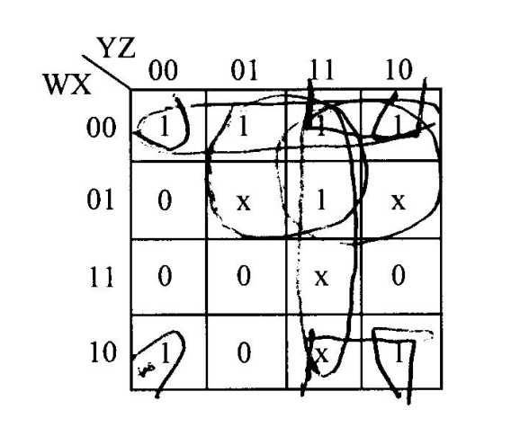

Identify all the prime implicants and the essential prime implicants of F.

Simplify the Boolean function F into a minimal sum-of-products expression.

Simplify the Boolean function F into a minimal product-of-sums expression.

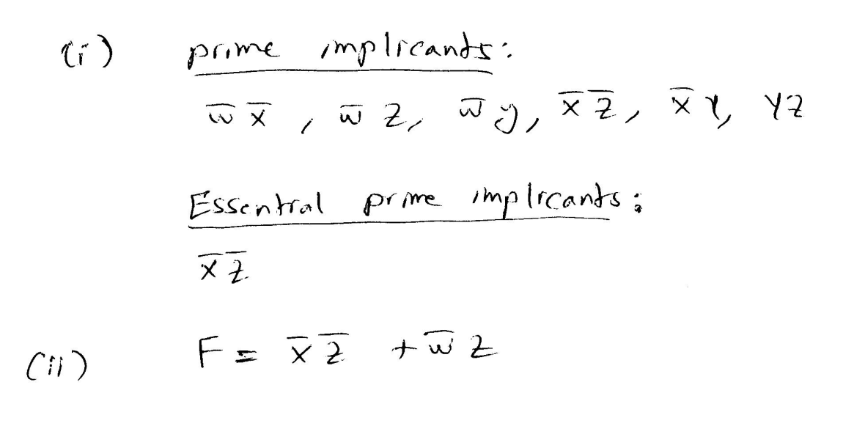

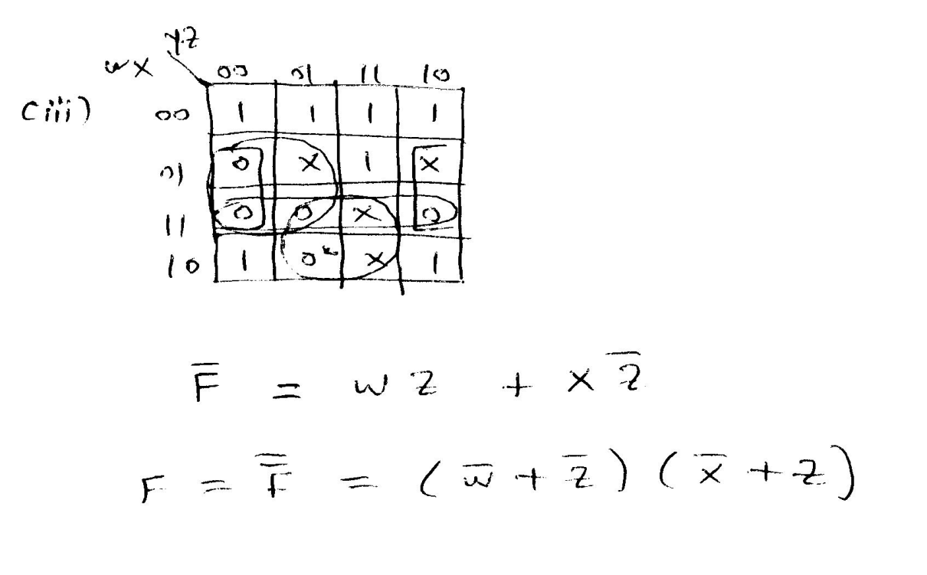

Q2. The following Boolean expression: A’C’ + AC + B’D’ is a simplified version of the expression: A’C’D’ + A’BC’ + ABC + ACD’. Are there any don`t care conditions? If so, what are they?

