King Fahd University of Petroleum and Minerals
College of Computer Science and Engineering
Computer Engineering Department

COE 202: Digital Logic Design (3-0-3)
Term 131 (Fall 2013)
Final Exam
Monday December 30, 2013

7:00 p.m. – 9:30 p.m.

Time: 150 minutes, Total Pages: 11

Name: _____________________________ ID: _____________ Section: ______

Notes:
- Do not open the exam book until instructed
- Calculators are not allowed (basic, advanced, cell phones, etc.)
- Answer all questions
- All steps must be shown
- Any assumptions made must be clearly stated

Question | Maximum Points | Your Points
1 | 13
2 | 12
3 | 10
4 | 10
5 | 10
6 | 10
7 | 15
Total | 80

Question 1. (13 points)
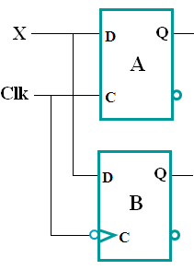
- In the circuit shown, A is a D-type latch and B is a D-type flip flop. For the input waveforms given for the clock signal (Clk) and the input X, accurately draw the resulting waveforms at outputs Q_{A} and Q_{B}.

Assume that both Q_{A} and Q_{B} are initially at 0.

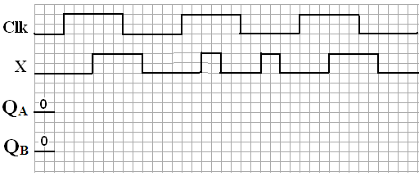
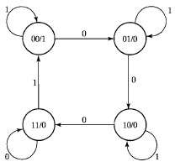

- The state diagram shown is for a sequential circuit that has a single input X and a single output Y. The circuit uses two positive edge triggered D-type flip flops Q1 and Q0.

- Starting with the circuit in state Q1Q0=11, complete the missing waveforms in the timing diagram below.

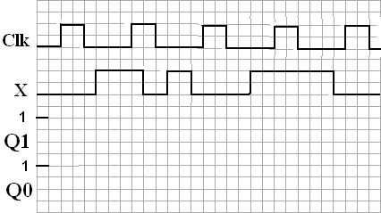

- Let the circuit be in state 00 with input X held permanently at 0. The circuit will end up being stuck at state _______. With the circuit operating at a clock frequency of 2 KHz, this state transition takes a minimum time duration of _______ ms.
Question 2. (12 Points)
Consider the sequential circuit opposite and then answer the following questions:

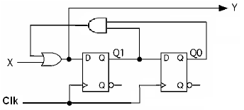
a. Is the circuit Mealy or Moore?

b. Provide logical expressions for the flip flop D inputs and the external output

c. Give both the state table and the state diagram. Use the layout given below for the state diagram. Note: Q0 represents the LSB of the binary value of the state.

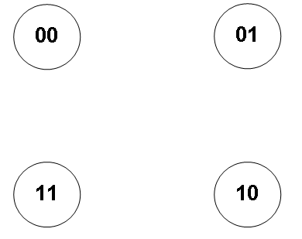

Question 3. (10 Points)

It is required to design a synchronous sequential circuit that receives a serial sequence of 3-bit codes through input X and produces 1 through output Y when the received 3-bit code equals either 010 or 110 (i.e., either 0 followed by 1 followed by 0, or 1 followed by 1 followed by 0). Assume the availability of an asynchronous reset input to reset the machine to a reset state. Draw the state diagram of the circuit assuming a Mealy model with minimum number of states. You are not required to derive the equations and the circuit. The following is an example of an input and output sequence:

Example:
Time

Input | X | 0 1 0 0 0 1 0 0 1 1 0 1 1 1 0
Output | Y | 0 0 1 0 0 0 0 0 0 0 0 0 0 0 1

Question 4. (10 Points)

The following state diagram represents a synchronous sequential circuit having a single input X and a single output Y. Note that the unspecified (missing) transitions in the state diagram do not occur (i.e. don’t care). The states are assigned the following state codes S_0=00, S_1=01, S_2=10 and S_3=11. Assume the existence of an asynchronous reset input to reset the machine to state S_0.

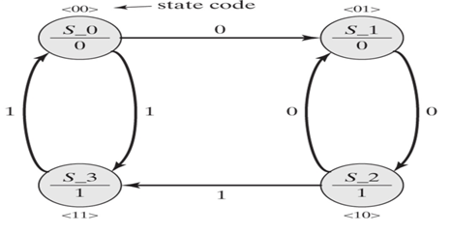

Draw the state transition table for the sequential circuit.

Using D-FFs and minimal combinational logic determine the equations for the D-FFs and output Y for this sequential circuit.

Draw the resulting circuit.

Question 5. (10 Points)
Using only D flip-flop(s), MUX(s), and XOR gate(s), draw the logic diagram for a 4-bit register with 2 mode selection inputs M₁M₀ and 4 load inputs I₃I₂I₁I₀. Note that D flip-flop outputs include both the state and its complement (i.e., $Q$ and $\overline{Q}$) available for use. The register should operate according to the following table:

M₁M₀ | Register operation
00 | No change.
01 | Parallel Load.
1x | Shift right while feeding in an ODD parity bit for the 3 bits that remain in the register after shifting.  (Examples: 1. register content before shifting = 0110,  register content after shifting = 1011  2. register content before shifting = 1001,  register content after shifting = 0100)
You must clearly label the D flip-flop(s) and MUX(s) inputs and outputs.

Question 6. (10 Points)
Consider the following state transition table for a synchronous sequential circuit that detects five consecutive 1’s. The circuit has a single input X, a single output Z, and three state variables Y₀, Y₁, and Y₂. The states are encoded using binary codes 001, 010, 011, 100, and 101.

PS | (Y₂ Y1 Y₀)^{t+1} | Z
(Y₂ Y₁ Y₀)^{t} | X = 0 X = 1 | X = 0 X = 1
0 0 1 | 0 0 1 0 1 0 | 0 0
0 1 0 | 0 0 1 0 1 1 | 0 0
0 1 1 | 0 0 1 1 0 0 | 0 0
1 0 0 | 0 0 1 1 0 1 | 0 0
1 0 1 | 0 0 1 1 0 1 | 0 1

You are required to implement the above circuit using a ROM device and a register. The circuit should be designed such that any unused state should go to the initial state 001.

- What is the minimum size of the register (i.e., number of D flip-flops)? [1 pt]

- What is the minimum size of the ROM (number of memory locations × number of memory bits per location)? [2 pt]

- Draw the block diagram for such an implementation. (Label all components inputs and outputs together with various signals) [3 pts]

- Starting in the initial state 001, what is the sequence of ROM locations addresses that will be accessed as a result of applying an input sequence X = 011 where 0 is applied first. [2 pts]

- Starting from address 0, complete the following table to show the data stored in the first six memory locations in the ROM device [2 pts]

Binary Address | Binary Stored Data

Question 7. (15 Points)
In an assembly line a conveyer belt has a sensor that generates a signal X whenever a cartoon box passes down the belt. Each dozen such boxes are placed in a container. The containers are loaded in trucks whose capacity is 15 containers. A signal Y is to be generated whenever the truck is full to open an automatic gate letting the truck out. You are to design a counting system that generates signal Y and another signal W which equals 1 whenever a container is full.
- Design this counting system using 2 counters; one to keep track of the number of boxes in a container and another to count the number of containers loaded in a truck. Clearly show how the W and Y signals are generated.
Design this system using mod-16 counters with count- enable (CE) and load (Ld) inputs together with the 4 parallel inputs (I₃ I₂ I₁ I₀). In addition, an asynchronous clear (Clr) input is also available. The outputs of the counter are the 4 count bits (Q₃ Q₂ Q₁ Q₀) and a carry-out signal C_{out} which equals 1 when Q₃Q₂Q₁Q₀ = 1111.
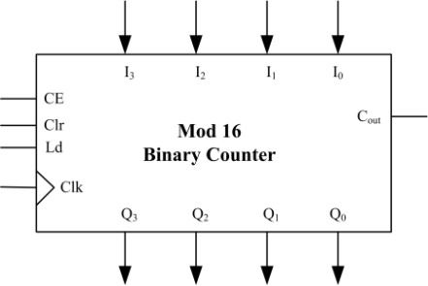

Draw the complete block diagram of the counting system showing all logic components needed / used by the system (6 Pts )

- Modify the counting system you designed in part (I) to make it self-resetting, i.e. whenever the system falls in any unused state, the count is automatically reset to zero. (3 Pts)

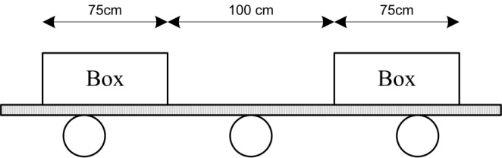
- The carton boxes are 75 cm long, and are placed 100 cm apart on the conveyer belt. Signal X maintains a value of 1 until the full length of the box passes beyond the sensor. Given that the belt moves at a speed of 5 meters/sec;
  - Plot the waveform of signal X (value of X versus time). (2 Pts)

  - Neglecting propagation, setup and hold delays, determine the maximum possible clock frequency. What happens if a higher frequency is used? (2 Pts )

  - Neglecting propagation, setup and hold delays, determine the minimum possible clock frequency. What happens if a lower frequency is used? (2 Pts )

