***King Fahd University of Petroleum and Minerals***

***College of Computer Science and Engineering***

***Computer Engineering Department***

**COE 202: Digital Logic Design (3-0-3)**

**Term 112 (Spring 2012)**

**Major Exam 1**

**Thursday March 1, 2012**

**Time: 90 minutes, Total Pages: 8**

**Name:_KEY____________________________ ID:______________ Section: _______**

**Notes:**

* Do not open the exam book until instructed
* **Calculators are not allowed** (*basic, advanced, cell phones, etc*.)
* Answer all questions
* All steps must be shown
* Any assumptions made must be clearly stated

|  |  |  |
| --- | --- | --- |
| **Question** | **Maximum Points** | **Your Points** |
| **1** | **20** |  |
| **2** | **12** |  |
| **3** | **16** |  |
| **4** | **12** |  |
| **5** | **15** |  |
| **Total** | **75** |  |

**Question 1. (20 points)**

Convert the following numbers from the given base to the other uncrossed bases listed in the table (if needed, express fractions up to 3 digits only). Show your solution steps below the table.

|  |  |  |  |  |
| --- | --- | --- | --- | --- |
| **Decimal** | **Binary** | **Octal** | **Hexadecimal** | **BCD**  **(8421)** |
| 114.67 | 1110010.101 | 162.527 |  | 000100010100.01100111 |
|  | 1011110.10111 | 136.56 | 5E.B8 |  |
| 3930.7617 | 111101011010.11000011 | 7532.606 | F5A.C3 |  |

**Question 2. (12 points)**

Perform the following arithmetic operations in the specified number system.

|  |  |  |  |
| --- | --- | --- | --- |
| Octal  Subtraction  2 7 3 4  -1 7 7 6  _______________  0 7 3 6 | Hexadecimal  Addition  F A 3 B  + 2 F E 9  __________________  1 2 A 2 4 | Binary  Subtraction  1 1 1 0 0 0 1 0  - 1 0 1 1 1 1 1 1  _________________  0 0 1 0 0 0 1 1 | Binary  Multiplication  1011  × 1011  ___________________  1011  1011  0000  1011  1111001 |

**Question 3. (16 points)**

1. Given the function :
2. Draw the logic implementation of the function *F* (*use F as is,* ***do not simplify***):

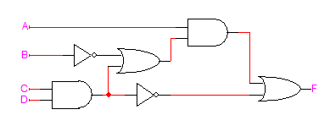

1. Compute the **complement** of the function *F* (*use F as is,* ***do not simplify***):



1. *Using Algebraic manipulation*, simplify the following function to **two** literals:



By taking the dual we get:



By taking the dual again:



1. *Using Algebraic manipulation*, simplify the following function to **three** literals:



**Question 4. (12 points)**

1. Given the Boolean function $F\left(w,x, y, z\right)=(w+\overline{x}y)\overline{z}$
   1. Express the function as a Product of Sum (POS).
   2. Express the function as a sum of minterms.
$F\left(w,x, y, z\right)=\left(w+\overline{x}y\right)\overline{z}=\left(w+\overline{x}\right)\left(w+y\right)\overline{z}$

$F\left(w,x, y, z\right)=\left(w+\overline{x}y\right)\overline{z}=w\overline{z}+\overline{x}y\overline{z}=w\left(\overline{x}+x\right)\left(\overline{y}+y\right)\overline{z}+\left(\overline{w}+w\right)\overline{x}y\overline{z}=w\overline{x}\overline{y}\overline{z}+w\overline{x}y\overline{z}+wx\overline{y}\overline{z}+wxy\overline{z}+\overline{w}\overline{x}y\overline{z}+w\overline{x}y\overline{z}=\sum{m(2, 8, 10, 12, 14)}$

2. Given the function $F\left(A, B,C,D\right)=\sum{m\left(0, 3, 4, 9\right)}$
   1. Give the *algebraic* sum of minterms expression for *F*.
   2. Express $\overline{F}$ as a product of Maxterms.

$F\left(A,B, C, D\right)=\overline{A}\overline{B}\overline{C}\overline{D}+\overline{A}\overline{B}CD+\overline{A}B\overline{C}\overline{D}+A\overline{B}\overline{C}D$

$\overline{F}\left(A,B, C, D\right)=\prod{M(0, 3, 4, 9)}$

**Question 5. (15 points)**

**Fill in the Spaces: (Show all work needed to obtain your answer)**

1. In binary system, the largest value that can be expressed using **n** integral digits and **m** fractional digits is 2n-2-m.
2. Given that an 8-bit register stores the ASCII code of a character in the least significant 7 bits and a parity bit in the most significant bit. Assuming that the register contains the hexadecimal value C5 representing a character, the character stored in the register is E and the parity used is even (i.e. even or odd parity). Note that the ASCII code of character ‘A’ is 41h and the ASCII code of character ‘a’ is 61h.
3. The number of minterms and maxterms in the function  is 7 minterms and 1 maxterm.
4. Given the identity , using the duality principle .
5. Assuming that all gates have the same propagation delay of 2 ns, then the circuit takes 8 ns to produce the correct output.

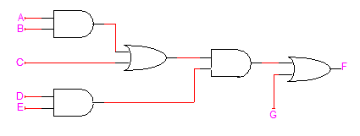

1. The Boolean function implemented by the circuit given below is $F = D \left(C + \overline{AB}\right).$

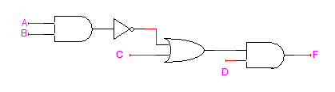

1. The Boolean function implemented by the circuit given below is $F = A \overline{C} + B C$.

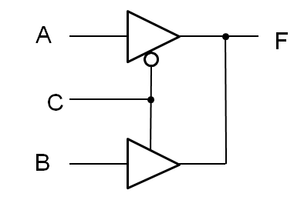

1. Given an inverter with the following parameters VOH=5v VOL=0v, VIH=2.8v, VIL=2.4, the noise margins NMH= VOH- VIH=5-2.8=2.2v and NML= VIL- VOL=2.4-0=2.4v.