King Fahd University of Petroleum and Minerals
College of Computer Science and Engineering
Computer Engineering Department

COE 202: Digital Logic Design (3-0-3)
Term 151 (Fall 2015-2016)
Major Exam 1
Saturday Oct. 10, 2015

Time: 90 minutes, Total Pages: 8

Name:______________________________________ ID:__________________ Section: _______

Notes:
- Do not open the exam book until instructed
- No Calculators are allowed (basic, advanced, cell phones, etc.)
- Answer all questions
- All steps must be shown
- Any assumptions made must be clearly stated

Question | Maximum Points | Your Points
1 | 23
2 | 12
3 | 12
4 | 7
Total | 54

Question 1. (23 points)
Fill in the spaces in the questions below: (Show all work needed to obtain your answer)

- The decimal number (60.875)₁₀ is represented in binary as (____________________)₂.

- The binary number (1100011.001)₂ is represented in decimal as (____________________)₁₀.

- The decimal number (100.75)₁₀ is represented in hexadecimal as (____________________)₁₆.

- The hexadecimal number (AC.A)₁₆ is represented in decimal as (____________________)₁₀.

- The hexadecimal number (B3.5)₁₆ is represented in binary as (____________________)₂.

- The result of performing the following operation in binary (11010100)₂ - (01011011)₂ = (__________)₂

- The result of performing the following operation in hexadecimal (A5)₁₆ + (CE)₁₆ = (_______)₁₆.

- In a base R number system, given that the value (x8)_{R} is equal to (32)₁₀, where x is a single digit in the such base R system, find the proper values of R and x. (Answer : x =_____ and R = ______).

- The largest unsigned decimal value that can be expressed using 3 binary integer digits and 3 binary fractional digits is ___________________.

- The number 25 is represented in BCD as ____________________________________________.

- Given that 80 students have registered in the COE 202 course, and that each of these students should be assigned a unique n-bit binary code. The minimum value of n is _________ and the number of additional students that the code can accommodate is _____________.

- Given that an 8-bit register stores the ASCII code of a character in the least significant 7 bits and a parity bit in the most significant bit. Assuming that the register contains the hexadecimal value E5 representing a character, the character stored in the register is _______ and the parity used is ___________(i.e., even or odd parity). Note that the ASCII code of character ‘A’ is 41h and the ASCII code of character ‘a’ is 61h. Note that other character codes are consecutive, i.e., the ASCII code of character ‘B’ is 42h and the ASCII code of character ‘b’ is 62h.

Question 2. (12 points)

Use Boolean algebra to solve the following questions. Show clearly all your steps.
- Consider the following Boolean function:
F(A,B,C) = AB'C + B'C' + AB'C'+A'C'
Simplify F to a minimum number of literals (in SOP form) using Algebraic manipulations. (4 points)

- Consider the following Boolean function:
F(X,Y,W,Z) = Y + X’Y’WZ + Y’WZ + X’YWZ’ + Y’W’Z + XYWZ’
Simplify F to a minimum number of literals (in SOP form) using Algebraic manipulations. (5 points)

- Find the Dual and the Complement of the following function G: (3 points)
G = (A+B)CD' + E + F'

Question 3. (12 points)
- Given the Boolean function F(A,B,C)=A+B`C
- Determine and express the minterms algebraically. (3 points)
- Determine and express the maxterms algebraically. (3 points)

- Given the Boolean functions E and F shown in the following truth table:
X | Y | Z | F | E
0 | 0 | 0 | 1 | 0
0 | 0 | 1 | 1 | 1
0 | 1 | 0 | 1 | 1
0 | 1 | 1 | 0 | 1
1 | 0 | 0 | 0 | 1
1 | 0 | 1 | 0 | 0
1 | 1 | 0 | 1 | 0
1 | 1 | 1 | 0 | 0
Using the numerical form (i.e. ∑(), ∏() ) show the following:
  - Minterms of F (2 points)
  - Maxterms of F` (2 points)
  - Minterms of G, where G=E+F (2 points)

Question 4. (7 points)
Consider the circuit shown. Assuming the gate propagation delays given in Table I, answer the following:
- What is the longest path delay from an input to the output? (1 point)  - What is the value of this delay? (2 points)  Table I  Gate Delay  Not 1 ns  AND 2 ns  OR 3 ns | 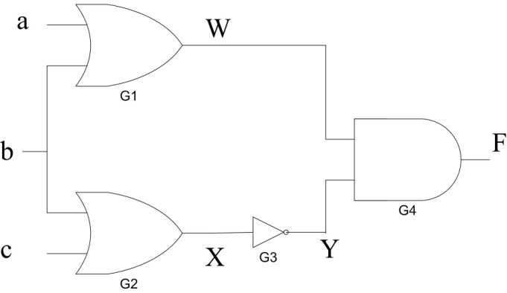

c. Given that signal C is kept constant at 0 value, draw the signals that can be observed at the points W, X, Y, and F for the shown applied inputs. You should properly account for the delay of each gate.  (4 points) | 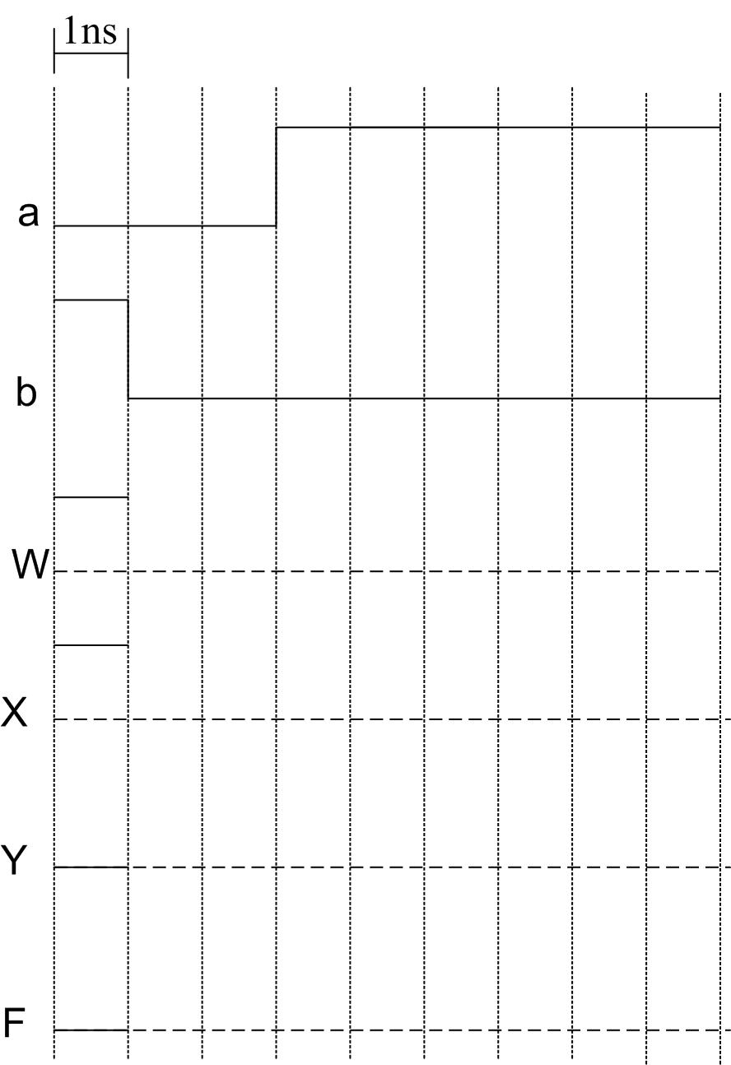

Blank Page

