King Fahd University of Petroleum and Minerals
College of Computer Science and Engineering
Computer Engineering Department

COE 202: Digital Logic Design (3-0-3)
Term 142 (Spring 2014-2015)
Major Exam 1
Saturday February 28, 2015

Time: 90 minutes, Total Pages: 7

Name:_KEY_________________________________ ID:__________________ Section: _______

Notes:
- Do not open the exam book until instructed
- No Calculators are allowed (basic, advanced, cell phones, etc.)
- Answer all questions
- All steps must be shown
- Any assumptions made must be clearly stated

Question | Maximum Points | Your Points
1 | 25
2 | 20
3 | 10
Total | 55

Question 1. (25 points)
- Convert the following numbers from the given base to the other uncrossed bases listed in the table (if needed, express fractions up to 3 digits only). (12 points)
Decimal | Binary | Octal | HEX | EXCESS-3 BCD
109.39 | 1101101.011 | 155.307 |  | 0100 0011 1100. 0110 1100
173.625 | 10101101.101 |  | AD.A
231.281 |  | 347.22 | E7.48

- Perform the following arithmetic operations in the specified number system. (8 points)

Octal Subtraction  4 5 1 2  - 2 5 3 7  _______________  1 7 5 3 | Hexadecimal Addition  F E A 3  + A F 9 D  __________________  1 A E 4 0 | Binary Subtraction  1 1 1 0 0 0 1 0  - 1 0 1 1 1 1 1 1  _________________  0 0 1 0 0 0 1 1 | Binary Addition  11011011  +01110111  ___________________  101010010

- Two number system with radixes $r_{1}$ and $r_{2}$, have the following two relations:
  - ${(69)}_{r_{2}}= {(100)}_{r_{1}}$, and
  - ${(17)}_{r_{2}}= {(21)}_{r_{1}}$

What are the values of $r_{1}$ and $r_{2}$ ? (5 points)

Solution
- $6r_{2}+9=r_{1}^{2}$
- $r_{2}+7={2r}_{1}^{}+1$ $r_{2}={2r}_{1}^{}-6$ substituting in (a)
$r_{1}^{2}-{12r}_{1}^{}+27=0$ $\left(r_{1}-3\right)\left(r_{1}-9\right)=0$ 2 Solutions $\left(r_{1}=3\right) and \left(r_{1}=9\right)$

- $r_{1}=3$ $r_{2}=0$ Infeasible solution
- $r_{1}=9$ $r_{2}=12$ Correct solution

Question 2. (20 points)

Use Boolean algebra to solve the following questions. Show clearly all your steps.
- Simplify each of the following Boolean functions to the specified number of literals in sum-of-products (SOP) representation:

- $F1=x +\overline{x} y$ (2 literals) (1 point)
$=\left(x +\overline{x}\right)\left(x+ y\right)=1 \left(x+y\right)=x+y$

- $F2=x y + \overline{x} z+y \overline{z}$ (3 literals) (4 points)
$$=x y + \overline{x} z+y \overline{z}+y z \left(by consensus of x y and \overline{x} z\right)$$
$$=x y + \overline{x} z+y \left(\overline{z}+ z\right)= x y + \overline{x} z+y \left(by distributive law\right)$$

$$= \overline{x} z+y \left(by absorption xy is absrobed by y\right)$$

- $F3=x \overline{w} \overline{z}+ x \overline{w} \overline{y}+x w+x y z$ (1 literal) (4 points)
$$=x \left(\overline{w} \overline{z}+ \overline{w} \overline{y}+ w+ y z\right) (by distributive law)$$
$$=x \left( \overline{z}+ \overline{w} \overline{y}+ w+ y z\right) (by simplification as w+\overline{w} \overline{z}=w+ \overline{z} )$$
$$=x \left( \overline{z}+ \overline{y}+ w+ y z\right) \left(by simplification as w+\overline{w} \overline{y}=w+ \overline{y} \right)$$
$$=x \left( \overline{z}+ \overline{y}+ w+ z\right) \left(by simplification as \overline{y}+y z= \overline{y}+z\right)$$
$$=x \left(1\right)=x \left(since \overline{z}+ z=1\right)$$

- $F4=\overline{\left(x+\overline{y}\right)} \overline{\left(x y+\overline{x} z\right)}$ (3 literals) (4 points)
$= \overline{x} y \left(\overline{x}+ \overline{y}\right)\left(x+ \overline{z}\right) (by Demorgan^{'}slaw)$
$$= \overline{x} y \left(x+ \overline{z}\right) (by disibutive law)$$
$$= \overline{x} y \overline{z} (by disibutive law)$$
- Given the Boolean function $F\left(X,Y,Z\right)=\left(Y+\overline{Z}\right)\left(\overline{X}+Y\right)$: (5 points)
- Express F as a product-of-maxterms, $F=\prod{M}$.
$F=\prod{M}(1, 4, 5)$
- Find the algebraic sum-of-minterms expression for F.
$F=∑m(0, 2, 3, 6, 7)$

$$=\overline{X} \overline{Y} \overline{Z}+ \overline{X} Y \overline{Z}+\overline{X} Y Z+X Y \overline{Z}+X Y Z$$

- Given the following Boolean function expressed using sum-of-products representation. $F\left(X,Y,Z\right)=X Y+ \overline{X} Z$, express F as a product-of-sums (NOT as product-of-maxterms) representation. (2 points)

$\overline{F}=\left(\overline{X}+\overline{Y}\right)\left(X+ \overline{Z}\right)$ (by Demonrgan\s law)

$= \overline{X} \overline{Z}+X \overline{Y}+ \overline{Y} \overline{Z}$ (by distributive law)

$= \overline{X} \overline{Z}+X \overline{Y}$ (by consensus)

$F=\left(X+ Z\right)\left(\overline{X}+Y\right) (By taking the complement of \overline{F} using Demongan^{'}slaw)$

Question 3. (10 points)
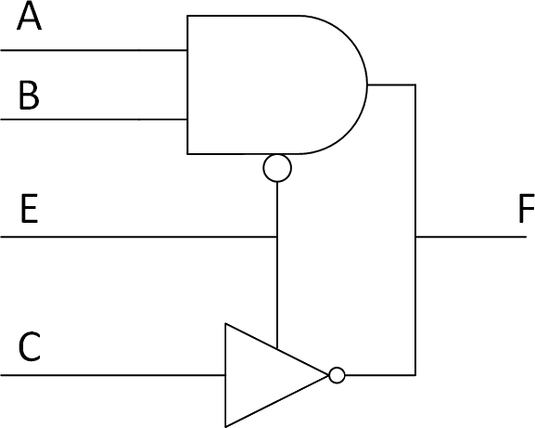
- Without simplification, write the Boolean algebra equation that represents F: (2 points)

F = EC’+ E’AB

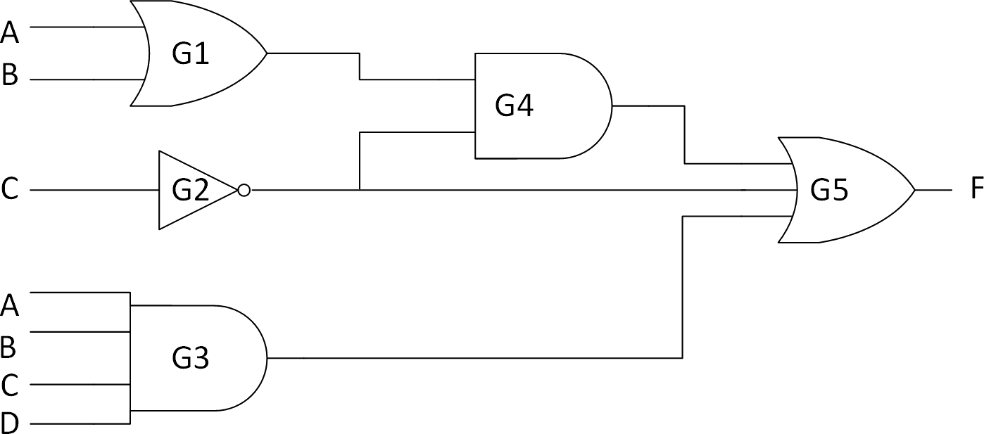
- Fill the table based on the Logic diagram (3 points)
Gate | Delay (ns) | Fan_{in} | Driving Load
G1 | 2 |  | 1
G2 | 1 |  | 2
G3 | 3 | 4
G4 | 2 | 2 | 1
G5 | 2 | 3

- What is the worst-case delay? (1 point)
2+2+2=6ns

- What is the worst-case delay path? (1 point)
G1, G4, G5

  - You are required to mark the V_{IL}, V_{IH}, V_{OL}, V_{OH} parameters on the following diagram given that the values of these parameters are selected from the set {0.5v , 1.0v , 3.5v , 4.2v}*. (2 points)
*(Voltage values are given in ascending order, i.e. not necessarily in the same order of the V_{IL}, V_{IH}, V_{OL}, V_{OH} parameters)
Input voltages |  | Output voltages
 | 4v |  | V_{OH}=4.2v
 | V_{IH}=3.5v
 | 3v
 | 2v
 | V_{IL}=1.0v
 |  |  | V_{OL}=0.5v
 | 0v

  - Calculate the Noise Margin for logic 1 (NM₁)? (1 point)
NM₁= V_{OH} – V_{IH} = 4.2 – 3.5 = 0.7 v

