King Fahd University of Petroleum and Minerals
College of Computer Science and Engineering
Computer Engineering Department

COE 202: Digital Logic Design (3-0-3)
Term 132 (Spring 2013-2014)
Major Exam 1
Saturday March 1, 2014

Time: 90 minutes, Total Pages: 11

Name:________________________________ ID:______________ Section: _______

Notes:
- Do not open the exam book until instructed
- No Calculators are allowed (basic, advanced, cell phones, etc.)
- Answer all questions
- All steps must be shown
- Any assumptions made must be clearly stated

Question | Maximum Points | Your Points
1 | 13
2 | 12
3 | 15
4 | 15
5 | 10
Total | 65

Question 1. (13 points)

Perform the following number base conversion with fraction precision of 3-digit where needed. Show your work in the “Work/ Scratch Area”
Required Conversion | Work / Scratch Area
  - (i) (0.339)₁₀ = ( )₂.

(ii) Convert the above obtained binary result back to decimal. = ( )₁₀

(iii) What is the conversion loss in accuracy?

  - (80.125)₁₀=( )₂

  - (10)₁₃=( )₁₀

  - (F319)₁₆ = ( )₂.

  - (F319)₁₆ = ( )₈.

  - (9403)₁₀ = ( ) _{BCD 8421 code}.

Question 2. (12 points)

  - Compute the following arithmetic operations in the indicated bases (9 Points)

- (A69C – 3F)₁₆ | - (255 + 127)₈
- (1101 1000 - 1001 1111)₂ | - (1101 1000 * 101)₂

II. What is the radix r of the number system for which (24 + 17 = 40)_{r}. (3 Points)

Question 3. (15 points)
Use Boolean algebra to solve the following questions. Show clearly all your steps.

  - $Give the simplest form of F=Y\left(X+Y\right)+\overline{(X+Y)}Z+YZ$ (4 points)

  - Given that C = $A \overline{B}+ \overline{A} B$show that $A \overline{C}+ \overline{A} C=B$ (5 Points)

  - Find the values of the 4 Boolean variables A, B, C, and D by solving the following set of simultaneous Boolean equations: (3 Points)
- $\overline{A}+ B=0$
- $A B = A C$
- $A B+A \overline{C}+ C D= \overline{C} D$

  - Without simplification, write out the complement and dual forms of the following expression:
$\left(x+\overline{y} \overline{z}\right)\left(w \overline{x} z+ \overline{w} y \overline{z}\right)$: (3 Points)

Question 4. (15 points)

A | B | Y | Z
0 | 0 | 0 | 0
0 | 1 | 1 | 1
1 | 0 | 1 | 0
1 | 1 | 0 | 0
- The truth table of a digital circuit which has two inputs (A, B) and two outputs (Y, Z) is shown: (4 points)
  - Write the Boolean expressions of the circuit outputs (Y , Z).

$$Y=\overline{A}B+A\overline{B}$$
$$Z=\overline{A}B$$

  - Draw the logic diagram of this circuit (i.e., its gate-level implementation).

  - Given the Boolean function $F\left(X,Y,Z\right)=\left(X+Y\right)\left(X+Z\right)(\overline{X}+\overline{Z})$: (4 points)
- Express F as a sum-of-minterms, $F=\sum{m}$.
- Find the algebraic product-of-Maxterms expression for F.

  - Given $F(A,B,C)=\sum{m}\left(0,3,5,7\right)$ and $G\left(A,B,C\right)=\prod{M}\left(1,2,4,7\right),$ express the function $F+\overline{G}$ as a sum-of-minterms. (3 points)

  - Given the following two circuits representing the functions F and G. Determine whether the two functions F and G are equivalent or not. Justify your answer. (4 points)

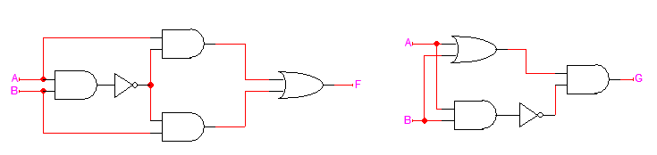

Question 5. (10 points)

    - Assume that the propagation delay of a gate depends only on its number of inputs. Thus, the propagation delay of an Inverter is 1 ns, of a 2-input gate (AND or OR) is 2 ns, and of a 3-input gate is 3 ns. For the circuit shown below;
- What is the longest propagation delay from an input to the output? (2 point)
- If A=0, B=1, C=1, D=1, and F=0, draw the signal waveforms at points G, H, and Y due to the shown applied signal at E by completing the timing diagram given below. (3 points)
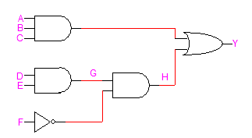

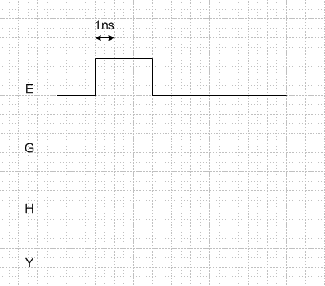

- Given an inverter with the following parameters V_{OH}=5v V_{OL}=0v, V_{IH}=2.8v, V_{IL}=1.6, the noise margins NM_{H}=__________________________ and NM_{L}= __________________________. (2 points)

- The Boolean function implemented by the circuit given below expressed as a sum-of-products is
F = ______________________________________________________________. (3 points)

