King Fahd University of Petroleum and Minerals
College of Computer Science and Engineering
Computer Engineering Department

COE 202: Digital Logic Design (3-0-3)
Term 142 (Spring 2015)
Final Exam
Tuesday May 19, 2015

7:00 p.m. – 9:30 p.m.

Time: 150 minutes, Total Pages: 12

Name: _____________________________ ID: _____________ Section: ______

Notes:
- Do not open the exam book until instructed
- Calculators are not allowed (basic, advanced, cell phones, etc.)
- Answer all questions
- All steps must be shown
- Any assumptions made must be clearly stated
- Mobile phones must be switched off

Question | Maximum Points | Your Points
1 | 13
2 | 18
3 | 10
4 | 6
5 | 8
6 | 12
Total | 67

Question 1 (13 Points)

- The shown sequential circuit has a single input X and three outputs Q₂ Q₁ Q₀.
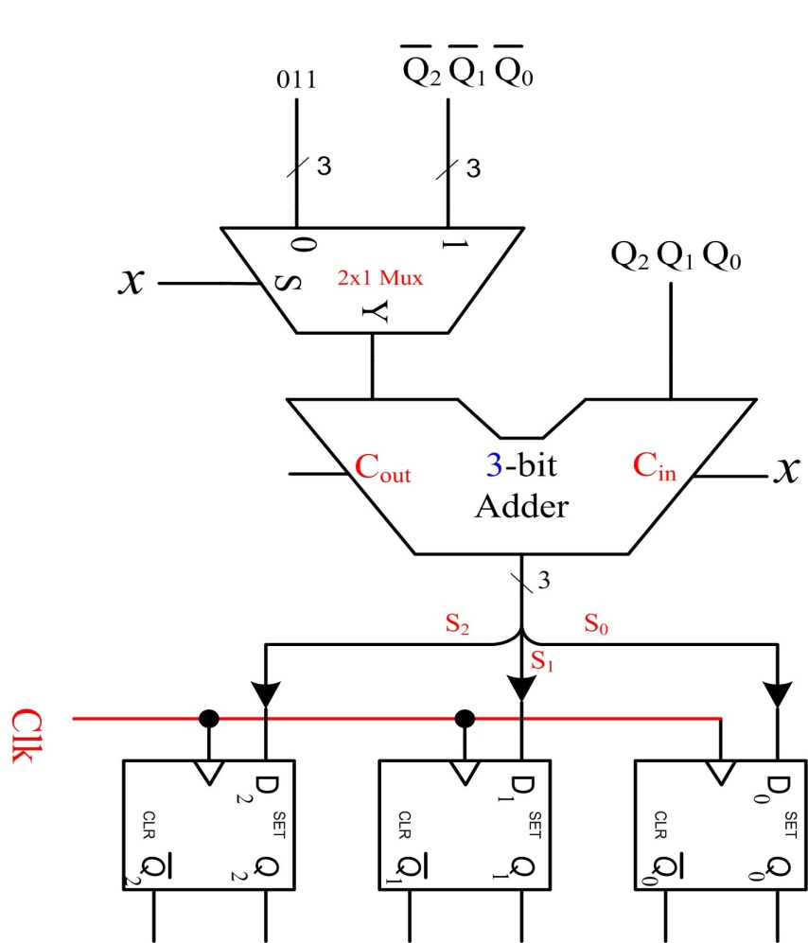
a. Analyze the circuit and derive its state table. (6 points)
b. The circuit should have an asynchronous reset input, which puts the circuit in initial state 010. Show how this can be done? (1 point)
c. Is the circuit Moore or Mealy? (1 point)
d. Briefly describe the function of this circuit. (1 point)

{Note: As shown in the figure, all D-FFs are equipped with asynchronous set (SET) and clear (CLR) inputs}

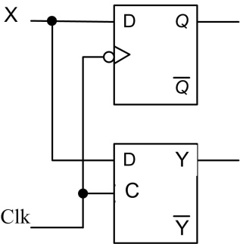
- For the shown D-latch and D-FF, plot the outputs Q and Y for the shown applied signals X and CLK. Assume that the initial state of both memory elements to be 1, and that all delays =0. (4 points)

Question 2 (18 Points)

- The synchronous sequential circuit whose state table is shown has three inputs; reset, x₁, and x₀ together with a single output Z. Assuming state 01 to be the reset state, implement this circuit using D-FFs that have asynchronous set and reset inputs and minimum logic. Draw the detailed logic diagram of your implementation. (10 points)
- If, upon powering the circuit on, the initial state was 00 and assuming that the reset signal is not applied, what would the next state be in case x₁x₀=01 or in case x₁x₀=10? (2 points)
PS | NS (y₁y₀)⁺ |  |  |  | Z
y₁y₀ | x₁x₀ |  |  |  |  | x₁x₀
 | 00 | 01 | 11 | 10 |  | 00 | 01 | 11 | 10
01 | 10 | 01 | 01 | 10 |  | 1 | 1 | 0 | 1
11 | 11 | 10 | 01 | 11 |  | 0 | 0 | 1 | 0
10 | 01 | 10 | 11 | 01 |  | 0 | 0 | 1 | 1

{Note: PS = Present State, and NS = Next State}

- Write a behavioral Verilog model of a 4-bit register which has the function table given below:
(6 points)

Clr_b S₁ S₀ | Clk | Function
0 X X | X | Register Asynchronously cleared
1 0 0 | ↑ | No Change
1 0 1 | ↑ | Parallel Load (Q x)
1 1 0 | ↑ | Shift left ( MSB LSB) , (Q[0] Sin)
1 1 1 | ↑ | Count Up by 1

Use the following module declaration:

module Q2_Reg (output reg [3:0] Q, input [3:0] x , input Clr_b, Clk, S1, S0, Sin) ;

Question 3. (10 Points)
- A sequence detector has a single input X and a single output Z. The circuit below gives a possible implementation of this detector. Assume that the circuit has a reset input that initializes it to the value Q₃Q₂Q₁Q₀=1111.
Answer the following questions:
- The sequence detected by this circuit is __________
- The circuit detects {overlapped / non-overlapped} occurrence of the sequence (circle the correct answer)
- The circuit output is {Mealy / Moore}. (circle the correct answer)

- The circuit below shows an implementation of another sequence detector. Assume that the circuit has a reset input that initializes it to the value Q₂Q₁Q₀=000.

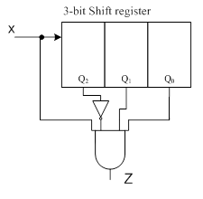
Answer the following questions:
- The sequence detected by this circuit is __________
- The circuit detects {overlapped / non-overlapped} occurrence of the sequence (circle the correct answer)
- The circuit output is {Mealy / Moore}. (circle the correct answer)

- Suggest a Moore circuit that can detect the two sequences 0011 (two 1’s followed by two 0’s) and 0001 (1 followed by three 0’s). What should be the initial state for your circuit to work properly?

Question 4. (6 Points)
Draw the state diagram of a MOORE sequential circuit that receives two serial input numbers (X and Y) starting with the least significant bits (i.e. x₀ y₀ then x₁y₁ then x₂y₂ …x_{n}y_{n}).

Bits of X & Y  received thus far | Z₁Z₀
X = Y | 0 0
X > Y | 1 0
X < Y | 0 1

The circuit has two outputs bits Z₁Z₀ as shown in the table.

Assume the availability of an asynchronous reset input to reset the machine to a reset state. A sample input/output data is given below.
(NOTE: You are only required to draw the state diagram, Nothing MORE)

time
t = 0
Example:

XY | 10 | 11 | 00 | 01 | 10 | 11
output | 00 | 10 | 10 | 10 | 01 | 10

Question 5 (8 Points)
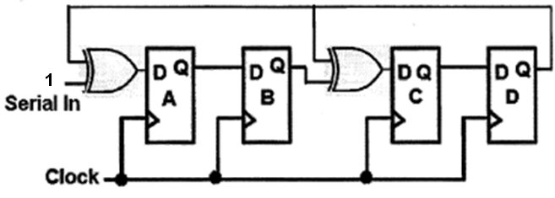
- Consider the shown 4-bit register. If the register contents ABCD = 1001 and the serial input is kept at 1, the register contents after two clock pulses will be ABCD = ________. (2 Points)

- Using only D flip-flop(s) and MUX(s) draw the logic diagram for a 4-bit register with 2 mode selection inputs M₁M₀ and 4 load inputs I₃I₂I₁I₀. The register should operate according to the following table:

M₁M₀ | Register operation
00 | No change.
01 | Parallel Load: (Q₃Q₂Q₁Q₀)⁺= I₃I₂I₁I₀
10 | Rotate left: (Q₃Q₂Q₁Q₀)⁺= Q₂Q₁Q₀Q₃  (Examples: 1. register content before rotation = 0110,  register content after rotation = 1100  2. register content before rotation = 1110,  register content after rotation = 1101)
11 | Reverse the order of bits in the register: (Q₃Q₂Q₁Q₀)⁺= Q₀Q₁Q₂Q₃  (Examples: 1. register content before reversing = 1000,  register content after reversing = 0001  2. register content before reversing = 1101,  register content after reversing = 1011)

You must clearly label the D flip-flop(s) and MUX(s) inputs and outputs. (6 Points)

Question 6 (12 Points)

- It is required to design a mod 16 up counter that has the following control inputs :
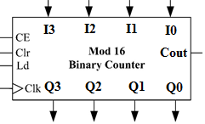
- Clr (synchronous clear),
- Ld (parallel load), together with its associated inputs I₃, I₂, I₁, I₀.
- CE (Count_Enable)

Assume that Clr has the highest priority followed by Ld, as illustrated in the table below. The counter produces an output signal (C_{out}) which equals 1 when its output equals 15. Design the counter using D-FFs and minimal logic gates. (6 Points)

Clr | Ld | $$CE$$ | Counter Next Content after the clock pulse (Q₃Q₂Q₁Q₀)⁺
1 | X | X | 0 0 0 0 (clear)
0 | 1 | X | I3 I2 I1 I0 (load)
0 | 0 | 1 | (Q₃Q₂Q₁Q₀)+1 (increment up by 1)
0 | 0 | 0 | Q₃Q₂Q₁Q₀ (no change)

- Given that the clock frequency of the mod 16 up counter is 1 MHZ, what is the clock frequency of the Q3 output of the counter? (2 Points)

- Using any number of the above mod 16 up counter and other needed logic gates design a mod 4096 up counter, which has the same control inputs: Clr, LD, and CE. (4 Points)

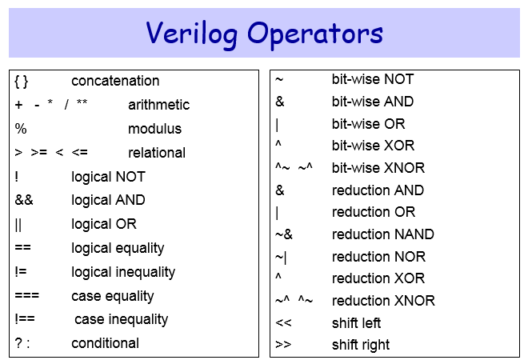

4096= 2¹²

