King Fahd University of Petroleum and Minerals
College of Computer Science and Engineering
Computer Engineering Department

COE 202: Digital Logic Design (3-0-3)
Term 141 (Fall 2014)
Final Exam
Wednesday Dec. 31, 2014

7:00 p.m. – 10:00 p.m.

Time: 180 minutes, Total Pages: 11

Name: _____________________________ ID: _____________ Section: ______

Notes:
- Do not open the exam book until instructed
- Calculators are not allowed (basic, advanced, cell phones, etc.)
- Answer all questions
- All steps must be shown
- Any assumptions made must be clearly stated

Question | Maximum Points | Your Points
1 | 13
2 | 15
3 | 10
4 | 6
5 | 8
6 | 15
Total | 67

Question 1. (13 Points)
- Given the sequential circuit below with a single input X, a single output Z and two D flip-flops:

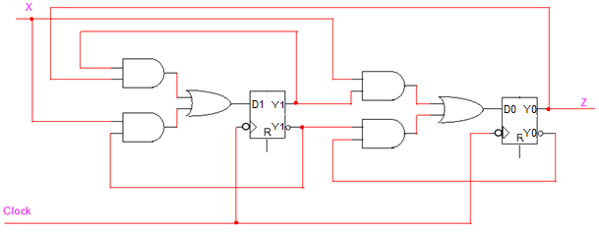

- Is this a rising-edge or falling-edge triggered circuit? (1 Point)

- Is this a Mealy or Moore circuit? (1 Point)

- Obtain the state table of the circuit. (5 Points)

- Given the state table below for a sequential circuit with a single input x and a single output z,

Current State  (q1q0)^{t} | Next State  (q1q0)^{t+1} |  | Output  z
 | x=0 | x=1 | x=0 | x=1
00 | 00 | 01 | 0 | 0
01 | 00 | 10 | 0 | 1
10 | 00 | 10 | 0 | 1
11 | 00 | 01 | 0 | 0

- Draw the state diagram of the circuit. (2 Points)

- Complete the timing diagram below for the values of the two flip flops q1q0 and the output z assuming falling edge triggered flip flops are used and starting from initial state q1q0=00. (4 Points)

Clock

x

q1

q0

z

Question 2. (15 Points)
- Draw a circuit implementing the following state table minimizing the number of used gates. (7 Points)

Current State  (AB) | Input  (x) | Next State  (D_{A}D_{B}) | Output  (z)
00 | 0 | 00 | 0
00 | 1 | 01 | 0
01 | 0 | 00 | 1
01 | 1 | 11 | 0
10 | 0 | 00 | 1
10 | 1 | 10 | 0
11 | 0 | 10 | 1
11 | 1 | 11 | 0

- Choose the correct answer for each of the following: (2 Points)
  - A PLA is made of:
    - Fixed AND array, fixed OR array
    - Fixed AND array, programmable OR array
    - Programmable AND array, Fixed OR array
    - Programmable AND array, programmable OR array
  - A PAL is made of:
    - Fixed AND array, fixed OR array
    - Fixed AND array, programmable OR array
    - Programmable AND array, Fixed OR array
    - Programmable AND array, programmable OR array

- Optimize a solution to program the following programmable logic to implement the following functions: (6 Points)

Question 3. (10 Points)
A Moore Transition Detector synchronous sequential circuit has a single input x and a single output z. The input data is applied serially at the input x and the circuit produces a 1 in the output z whenever a transition from 0 to 1 or from 1 to 0 are detected at the applied input data. Draw the state diagram of this circuit. Assume the existence of an asynchronous reset input to reset the machine to a reset state. A sample input/output data is given below.
(NOTE: You are only required to draw the state diagram Nothing MORE)

t = 0
time
Example:

Input | x | 0 1 1 0 0 1 0 0 0 1 1 1 1 1
Output | z | 0 0 1 0 1 0 1 1 0 0 1 0 0 0

Question 4. (6 Points)
It is required to design a synchronous sequential circuit that receives two serial inputs x and y and produces a serial output z that computes the equation z=2x-y. Draw the state diagram of this circuit assuming a Mealy model. Assume the existence of an asynchronous reset input to reset the machine to a reset state. Two samples of input/output data are given below.
(NOTE: You are only required to draw the state diagram Nothing MORE)

t = 0
time
Examples:

Input | x | 0 0 1 0 0
 | y | 0 1 1 0 0
Output | z | 0 1 0 0 0

t = 0
time

Input | x | 1 0 1 1 0
 | y | 1 1 0 1 0
Output | z | 1 1 1 1 0

Question 5 (8 Points)

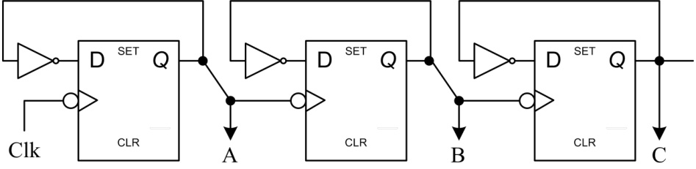

a. The sequential circuit above is clocked _________ (synchronously / asynchronously) (1 Pt)

b. Draw the waveforms of signals A, B, C in response to the shown Clk signal assuming initial ABC value of 000. (4 Points)
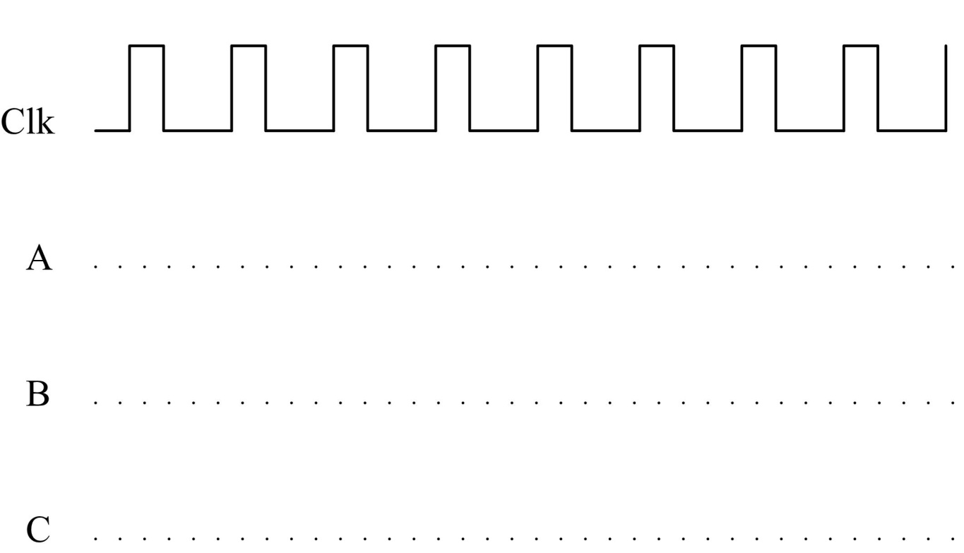

c. Assuming a negligible setup and hold times, an inverter delay of 1 ns and a delay from the clock active edge till the new flip flop output appearing of 4 ns, what is the maximum clock frequency at which the above circuit can operate? (3 Points)

Question 6 (15 Points)
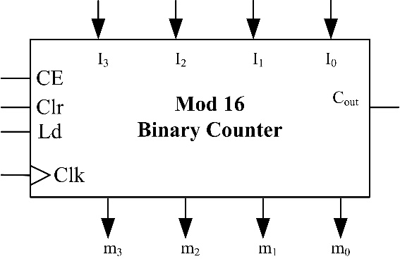
It is required to design a digital calendar that counts days and months of the year. Given a clock signal with frequency 1 pulse/24 hours, you are required to design the following as part of this system:
- Design a mod 12 months counter to count the months of the year (count 0 January up to Count 11 December). Use a mod 16 counter to build this months counter. Assume the mod 16 counter to have the following control inputs :
- CE “Count_Enable,
- Clr (synchronous clear), and
- Ld (parallel load), together with its associated inputs I₀, I₁, I₂, I₃.

The counter should produce an output signal (C_{out}) which equals 1 only during the last month of the year. (3 Points)

- Design a days counter to count the days of the month. The counter has two input signals x₁x₀ which indicate the number of days in the current month as shown in the table below.

x₁ x₀ | # of Days | Months | Month Count
0 0 | 31 | January, March, May, July, August, October, December | 0, 2, 4, 6, 7, 9, 11
0 1 | 30 | April, June, September, November | 3, 5, 8, 10
1 0 | 29 | February in leap years | 1
1 1 | 28 | February in ordinary years | 1
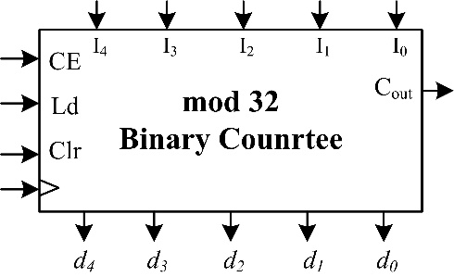
The counter should produce an output signal (C_{month}) which equals 1 only during the last day of the month. Design this days counter using a mod 32 binary counter having the same control inputs as the counter in part (a).
(5 Points)

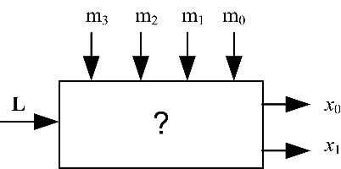
c. Given the output (m₃ m₂ m₁ m₀) of the months’ counter of part (a) and an input signal L that equals 1 only throughout leap years, derive the logic circuits which generate the signals x₁ and x₀ used by the days counter. (3 Points)
(Hint: Use a 4x16 decoder and any other needed parts)

d. Given the clock signal of frequency 1 pulse/24 hours, show how to assemble the parts designed in (a), (b) and (c) to build a synchronous counter which gives the current month of the year and the day of that month. Assume that the counter is reset to 0 at the beginning of each year. This assembled design should produce an output signal (C_{year}) which equals 1 only during the last day of the year. (4 Points)
Note: Use black boxes for the parts designed in (a), (b) and (c) showing only the interface input and output signals, various signal connections and the logic to generate C_{year}

The Gregorian year months are: January, February, March, April, May, June, July, August, September, October, November and December respectively.

