**Chapter 7**

**Electron Configuration and the**

**Periodic Table**

**7.1 Development of the Periodic Table:**

* **1864 -** **John Newlands** - Law of Octaves- every 8th element had similar properties when arranged by atomic masses (not true past Ca)
* **1869 - Dmitri Mendeleev & Lothar Meyer -** independently proposed idea of periodicity (recurrence of properties)
* **1913 - Henry Moseley:** 
  + **Today, elements are arranged in order**

**of increasing atomic number**

**Essential Elements in the Human Body**

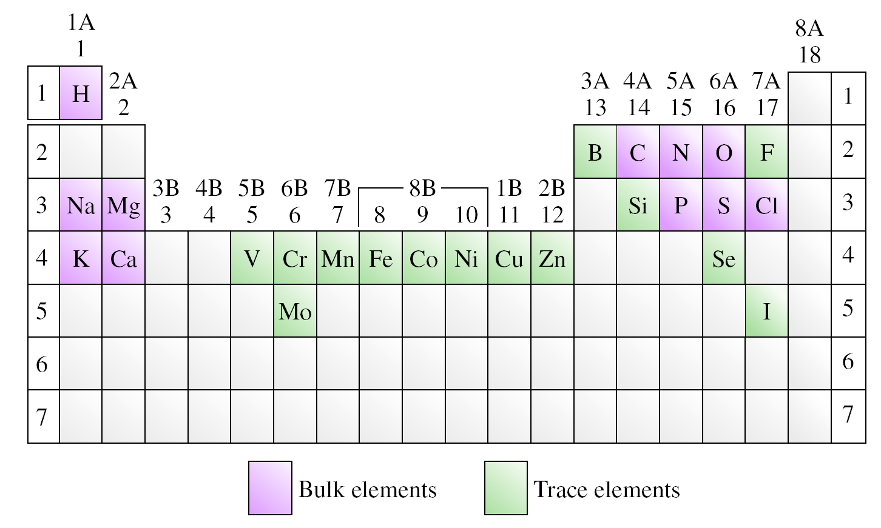

**The Modern Periodic Table**

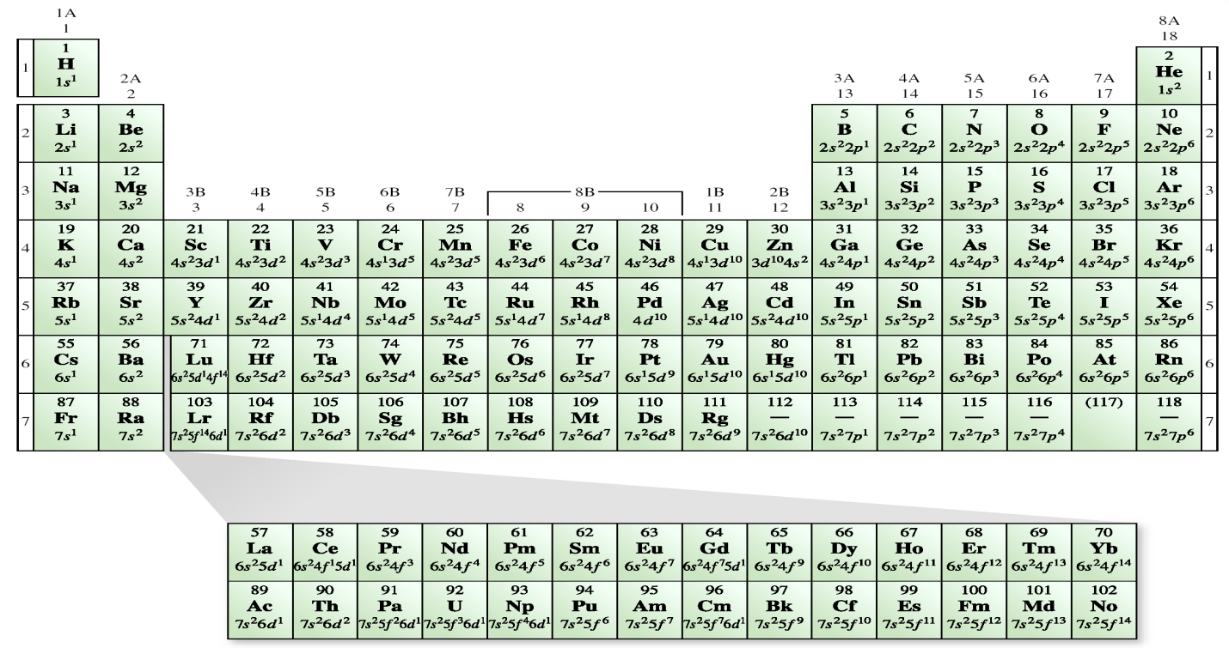

**7.2 The Modern Periodic Table**

* **Classification of Elements** 
  + **Main group elements -** “representative elements” Group 1A-7A
  + **Noble gases - Group 8A** all have *ns*2*np*6 configuration(exception-He)
  + **Transition elements** - 1B, 3B - 8B “***d*-block**”

* + **Lanthanides/actinides - “*f*-block”**



* **Predicting properties:**
  + **Valence electrons** are the outermost electrons and are involved in bonding
  + **Similarity of valence electron** configurations help predict **chemical properties**
  + **Group 1A, 2A and 8A** all have **similar properties** to other members of their respective group
  + **Groups 3A - 7A** show considerable variation among properties from metallic to nonmetallic
  + **Transition metals** do not always exhibit regular patterns in their electron configurationsbut have **some similarities as a whole** such as **colored** compounds and **multiple oxidation states.**
* **Representing Free Elements in Chemical Equations:**
  + **Metals are always represented by their empirical formulas (same as symbol for element)**
  + **Nonmetals** may be written as empirical formula (C) or as polyatomic molecules (H2, N2, O2, F2, Cl2, Br2, I2, and P4).
  + **Sulfur** usually S instead of S8
  + **Noble Gases** all exist as isolated atoms, so use symbols (Xe, He, etc.)
  + **Metalloids** are represented with empirical formulas (B, Si, Ge, etc.)

**7.3 Effective Nuclear Charge:**

* ***Z* (*nuclear charge*)** = the number of protons in the nucleus of an atom
* ***Z*eff (*effective nuclear charge*)** = the magnitude of positive charge “experienced” by an electron in the atom
* ***Z*eff** increases from left to right across a period; changes very little down a column
* **Shielding** occurs when an electron (valence) in a many-electron atom is partially shielded from the positive charge of the nucleus by other electrons (core or inner) in the atom.
* Core electrons (inner electrons) are constant across a period.
  + ***Z*eff = *Z* -** σ
  + **σ** is **shielding constant** (greater than 0 but less than *Z*)

**Example**:

**Li Be B C N**

**Z 3 4 5 6 7**

***Z*eff 1.28 1.91 2.42 3.14 3.83**

**7.4 Periodic Trends in Properties of Elements:**

* **Atomic radius:** distance between nucleus of an atom and its valence shell
* ***Metallic radius*:** half the distance between nuclei of two adjacent, identical metal atoms

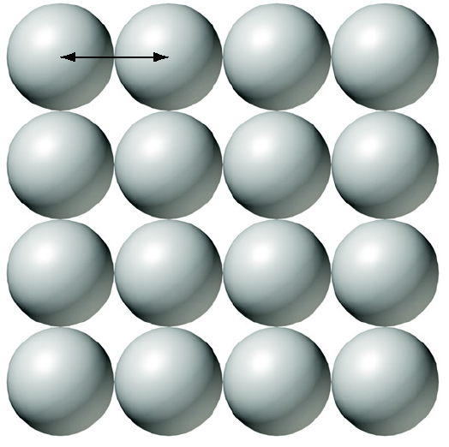

* **Covalent radius:** half the distance between adjacent, identical nuclei in a molecule

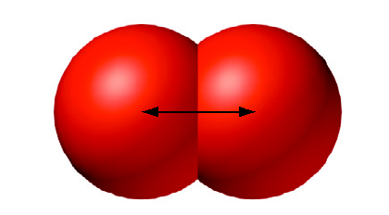

**Atomic Radii (pm) of the Elements**

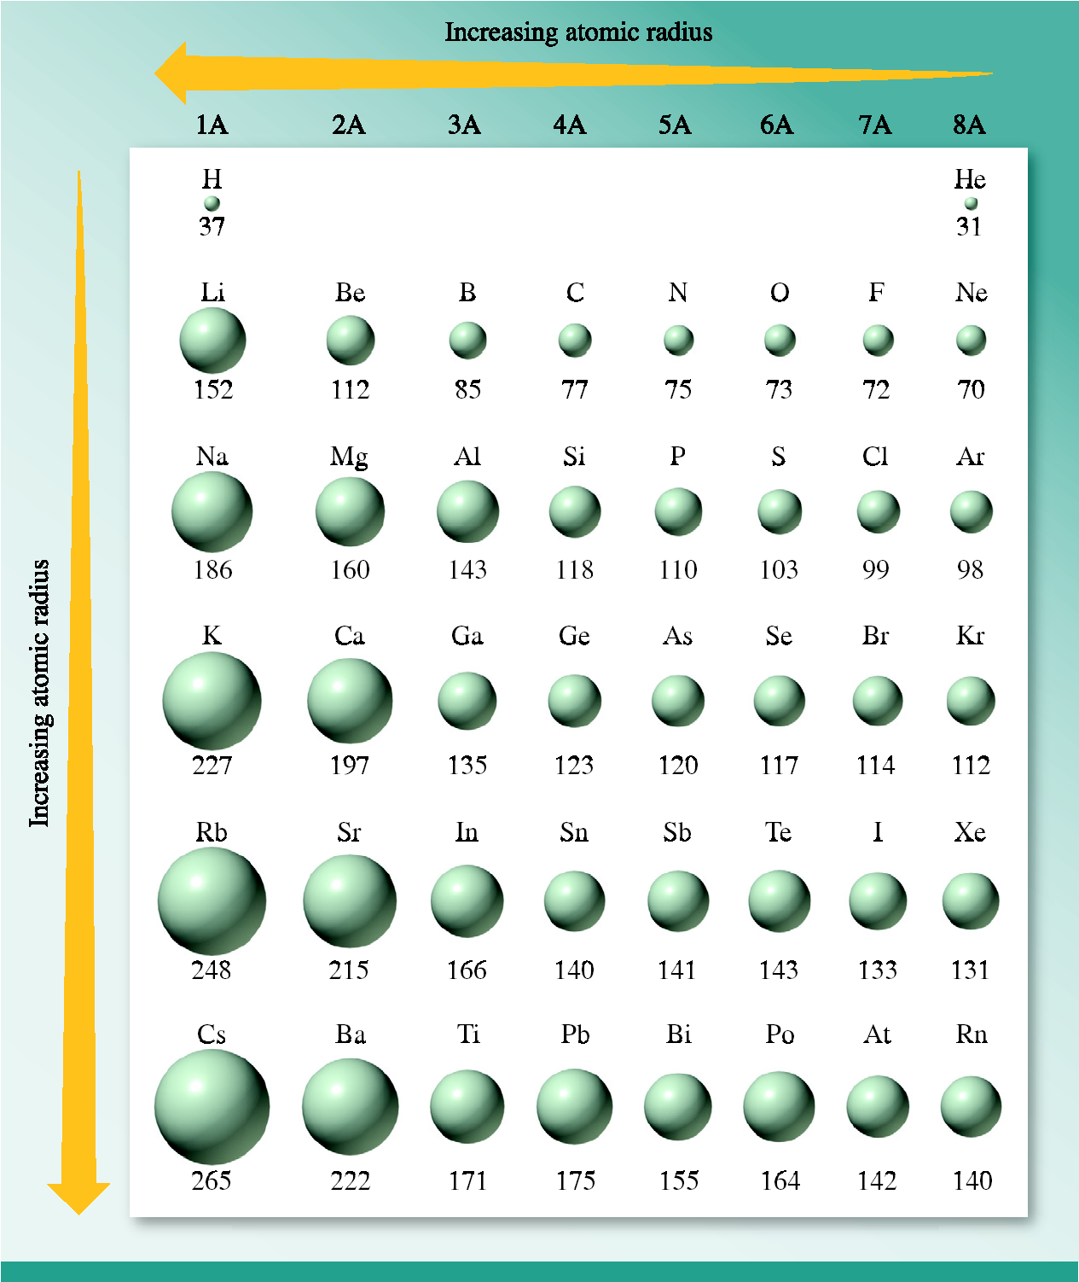

* **Ionization energy (*IE*):** minimum energy needed to remove an electron from an atom in the gas phase

**Na(g)  → Na+(g)  + *e*−**

* + *IE* for this 1st ionization = 495.8 kJ/mol
* **In general, ionization energy** increases as ***Z*eff** **increases**
  + **Exceptions** occur due to the stability of specific electron configurations

***IE*1 (kJ/mol) Values for Main Group Elements**

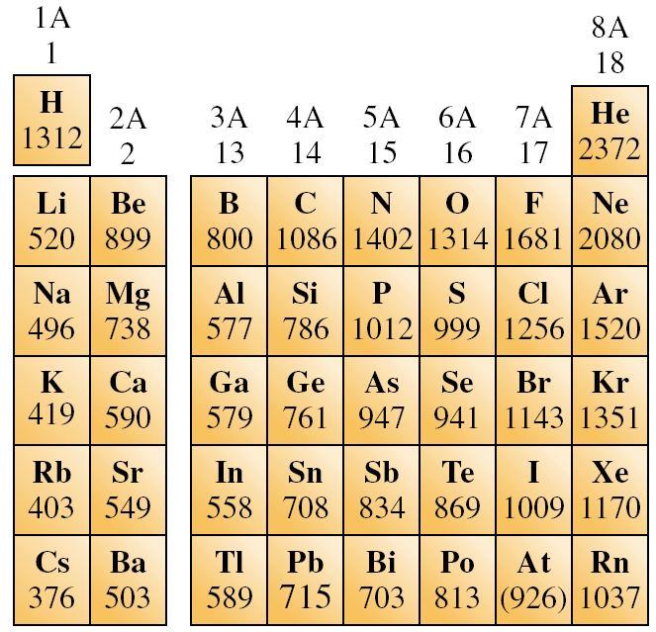

**Exception: in period 2 and 3**

**2A 3A 4A 5A 6A 7A**

Be B C **N O** F

**2** 899 800 1086 ***1402 1314*** 1681

Mg Al Si **P** **S** Cl

**3** 735 580 780 ***1060* *1005*** 1255

**Example:**

**P** : [Ne]3s23p3

**S**: [Ne]3s23p4

The electron–electron *repulsion* between *paired* electrons in 3p4 orbital in S makes it *more* *easily* to *remove* one of the electrons.

* **Multiple Ionizations**: it takes more energy to remove the 2nd, 3rd, 4th, etc. electron and much more energy to remove core electrons
* Why?
  + Core electrons are closer to nucleus and experience greater *Z*eff

***e.g***: **Al** : [Ne]3s23p1

Al(g) → Al+(g) + e- **I1** = 580 kJ/mol

Al+(g) → Al2+ + e- **I2** = 1815 kJ/mol

Al2+(g) → Al3+ + e- **I3** = 2740 kJ/mol

**Note: A jump would occur at I4**

Given the following 1st, 2nd, and 3rd ionization energies for an element:

I1 = 735 kJ/mol I2 = 1445 kJ/mol I3 = 7730 kJ/mol

the element can be

A) **Mg** [Ne]3s2 (jump would occur at I3, Mg is ok)

B) **Na** [Ne]3s1 (jump would occur at I2)

C) **Al** [Ne]3s23p1 (jump would occur at I4)

D) **Si** [Ne]3s23p2 (jump would occur at I5)

E) P [Ne]3s23p3 (jump would occur at I6)

**Electron Affinity (*EA*)**:

It is the energy change when an electron is added to an atom.

Cl(g) + e- → Cl-(g) *ΔH* = -349 kJ/mol

(exothermic process)

***Like ionization energy, electron affinity increases from left to right.***

***Note***:

- Effective nuclear charge Zeff has greater effect on *EA*

than the pairing of electrons.

- The Addition of an electron to empty orbital is easier

than the one to an orbital with unpaired electron.

* **Metallic Character:**
  + **Metals**:
    - Shiny, lustrous, malleable
    - Good conductors
    - Low *IE* (form cations)
    - Form ionic compounds with chlorine
    - Form basic, ionic compounds with oxygen
    - Metallic character increases top to bottom in group and decreases left to right across a period
  + **Nonmetals**:
    - Vary in color, not shiny
    - Brittle
    - Poor conductors
    - Form acidic, molecular compounds with oxygen
    - High *EA* (form anions)
  + **Metalloids**:
    - Properties between the metals and nonmetals

**7.5 Electron Configuration of Ions**:

* Follow ***Pauli*** ***exclusion principle*** and ***Hund’s rule*** as for atoms
* Writing electron configurations helps explain charges memorized earlier
* **Ions of main group elements:**
  + **Noble gases** (8A) almost completely unreactive due to electron configuration
    - *ns*2*np*6 (except He 1*s*2)
  + **Main group** elements tend to gain or lose electrons to become **isoelectronic** (same valence electron configuration as nearest noble gas)

Na: 1*s*22*s*22*p*63*s*1 → Na+ 1*s*22*s*22*p*6

Na: [Ne]3*s*1 → Na+ [Ne]

(Na+ 10 electrons - isoelectronic with Ne)

Cl: 1*s*22*s*22*p*63*s*23*p*5 → Cl− 1*s*22*s*22*p*63*s*23*p*6

Cl: [Ne]3*s*23*p*5 → Cl− [Ar]

(Cl− 18 electrons - isoelectronic with Ar)

* **Ions of *d*-Block Elements**:
  + Recall that the 4*s* orbital fills before the 3*d* orbital in the first row of transition metals
  + Electrons are always lost from the highest “*n*” value (then from *d*)

Fe: [Ar]4*s*23*d*6 → Fe2+: [Ar]3*d*6

Fe: [Ar]4*s*23*d*6 → Fe3+: [Ar]3*d*5

**7.6 Ionic Radius**:

* When an atom gains or loses electrons, the radius changes
* **Cations** are always smaller than their parent atoms (often losing an energy level)
* **Anions** are always larger than their parent atoms (***increased e− repulsions***)

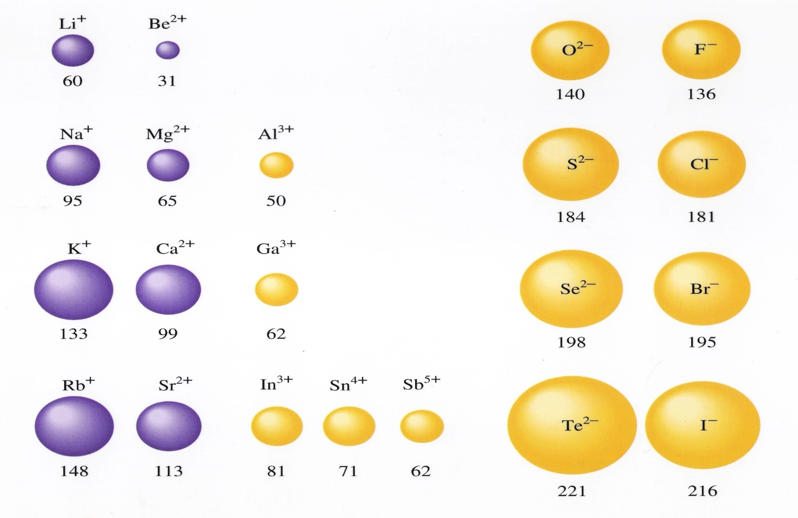

* **Isoelectronic Series**:
  + Two or more species having the same electron configuration but different nuclear charges
  + Size varies significantly:

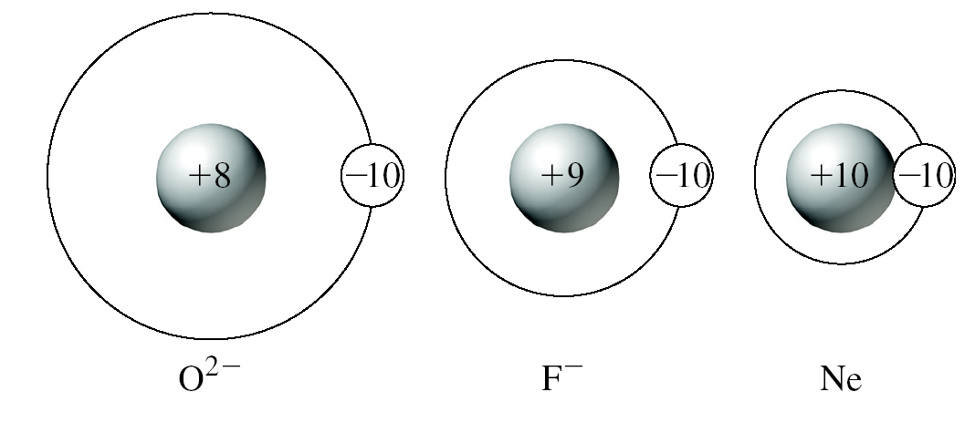

**7.7 Periodic Trends in Chemical Properties of Main Group**

**Elements:**

(Reading assignment)