**Chapter 5**

**Thermochemistry**

**5.1 Energy and Energy Changes:**

* Energy is involved in all types of physical and chemical changes
* **Energy**: the capacity to do work or transfer heat
* All forms of energy are either:
* **Kinetic:** energy of ***motion***
* **Potential:** energy of ***position***
* **Kinetic energy**:

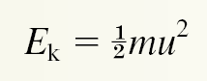

Where ***m*** is **mass** and ***u*** is **velocity**

**(Thermal** energy is form of **kinetic energy**

associated with random motion)

**Monitor** changes via changes in **temperature**

* **Potential energy**:
  + Chemical energy is stored within structural units of chemical substances.

**Electrostatic energy**:

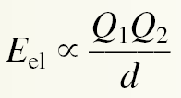

Dependent on charges and distance between charges

(*Q* = charge and *d* = distance)

+ *E*el: repulsive and − *E*el: attractive

* **Law of conservation of energy**:
  + **Energy** may be converted from one form to another.
  + The **total amount** of energy in the **universe** is **constant**.

**Example**:

* + - A chemical reaction (potential) gives off heat (thermal)
* **Energy changes in chemical reactions:**
  + **System** is the part of the universe of interest.

**Example**:

The reactants NaOH and HCl

* + **Surroundings** are the rest of the universe.

**Example**:

When heat is given off from the reaction of NaOH and HCl, the energy is transferred from the system to the surroundings.

* **Thermochemistry*:***
  + The study of the transfer of heat (thermal energy) in chemical reactions.

* + **Exothermic** - transfer of heat from the system to the surroundings

2H2(*g*) + O2(*g*) → 2H2O(*l*) + **energy**

* + **Endothermic** - the transfer of heat from the surroundings to the system

**energy** + 2HgO(*s*) → 2Hg(*l*) + O2(*g*)

**Comparison of Endothermic and Exothermic Processes**

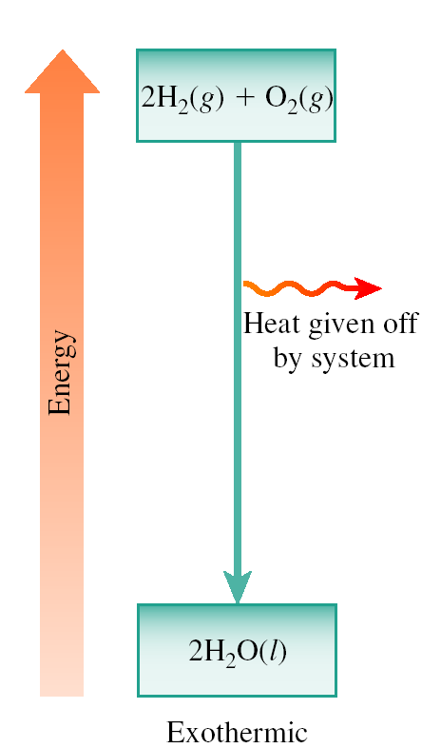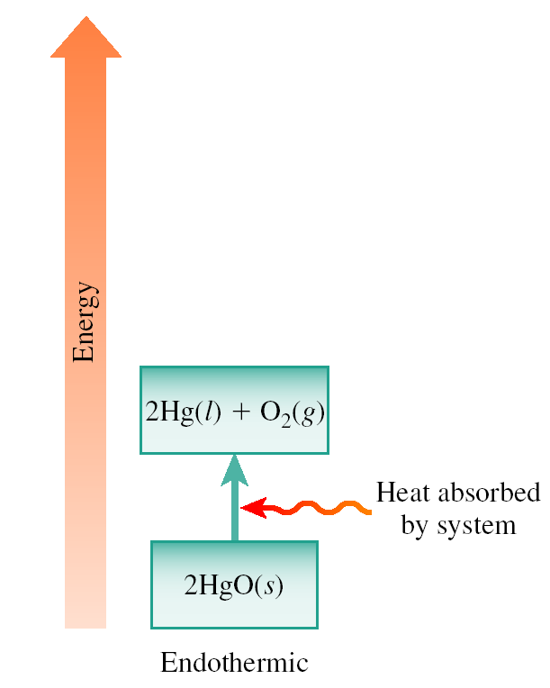

* **Units of Energy:**
  + ***Joule* (J)** is the SI unit for energy.

The amount of energy possessed by a 2 kg mass moving at a speed of 1 m/s

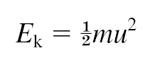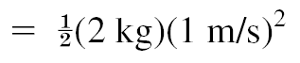



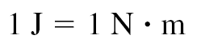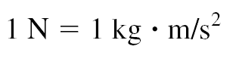

* + ***Calorie* (cal)** - commonly used on food labels
  + 1 cal 4.184 J
  + 1000 cal = 1 Cal = 1 kcal
  + Food calories (Cal) are really 1000 calories (cal).

Calculate the kinetic energy of a neon atom moving at a speed of 98 m/s.

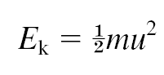



**5.2 Introduction to Thermodynamics**

* **Types of systems**:
  + **open** (exchange of mass and energy)
  + **closed** (exchange of energy)
  + **isolated** (no exchange)

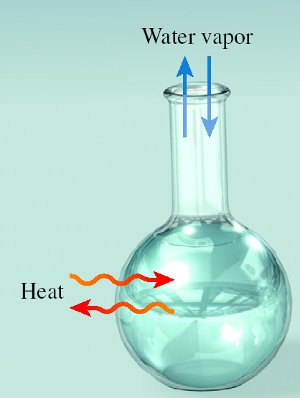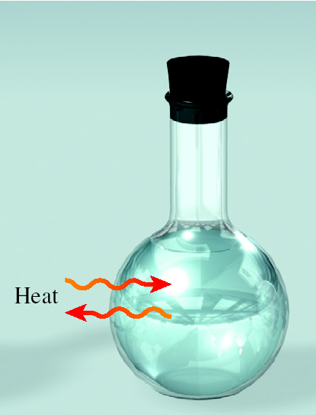

**Open Closed**

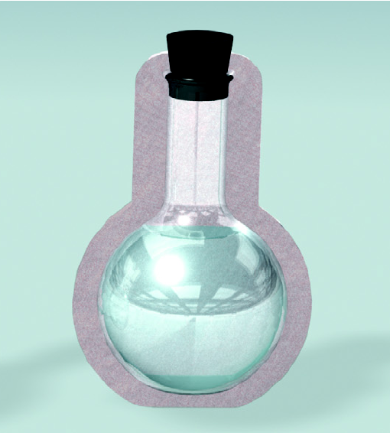

**Isolated**

**State functions:**

depend only on ***initial*** and ***final*** states of the system and ***not*** on how the change was carried out.

**Energy** (*E*)

**Pressure** (*P*)

**Volume** (*V*)

**Temperature** (*T*)

**First Law of Thermodynamics**

“***Energy can be converted from one form to another***

***but cannot be created or destroyed***”.

**Based on the law of conservation of energy:**

**Internal energy (*U*):**

* + **Kinetic energy -** molecular motion
  + **Potential energy -** attractive/repulsive

Interactions

* The change in internal energy of a system

between final (f) and initial (i) states is

defined as:

**Δ*U* = Δ*U*f − Δ*U*i**

* For a chemical system:
  + *Can* calculate the *change* in energy of the system experimentally:

**Δ*U* = Δ*U*(products) − Δ*U*(reactants)**

Consider:

S(*s*) + O2(*g*) → SO2(*g*)

This reaction releases heat, therefore **Δ***U* is negative.

When a system releases heat, some of the chemical energy is released as thermal energy to the surroundings but this does not change ***the total energy of the universe.***

**Δ***U*system + **Δ***U*surroundings  = 0

When a system undergoes a change in

energy, the surroundings must undergo a

change in energy equal in magnitude and

opposite in sign.

**Δ***U*system = − **Δ***U*surroundings

* **Work and heat :**

**Δ***U*sys = *q* + *w*

where *q* is heat and *w* is work

***Work*** is defined as *force* to a *distance*:

*work* = *force* x *distance*

*W* = *F* x Δ*h*

But: *pressure* = *force*/*Area*

*P* = *F*/*A*

or *F* = *P* x *A*

∴ *W* = *P* x *A* x Δ*h*

when *pressure* is applied by *system* to *surroundings*:  *W* = -*P*Δ*V*

∴ **Δ***U*sys = *q* - *P*Δ*V*

(***Note****:* ***1 atm L = 101 J***)

• When *work* is done ***by*** the system the result is an ***expansion*** of the system and the ***work*** is ***negative*** *(*Δ*V is* ***positive****)*

• When *work* is done ***on*** the system, the result is ***compression*** of the system and the ***work*** is ***positive*** *(*Δ*V is* ***negative****)*

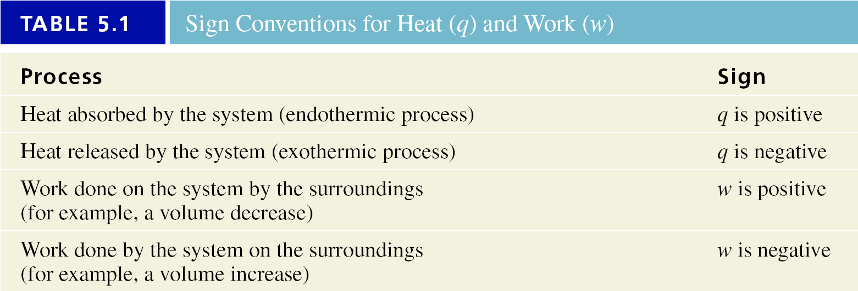

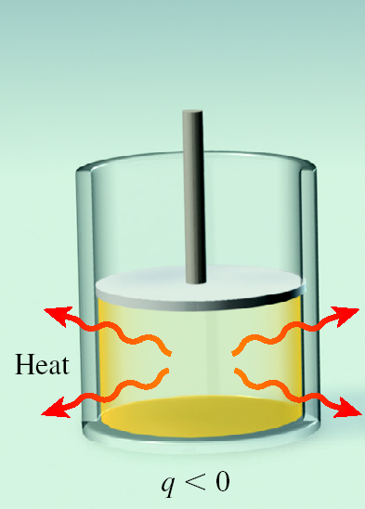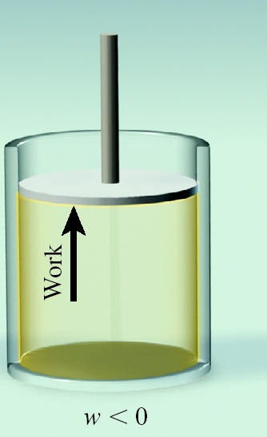

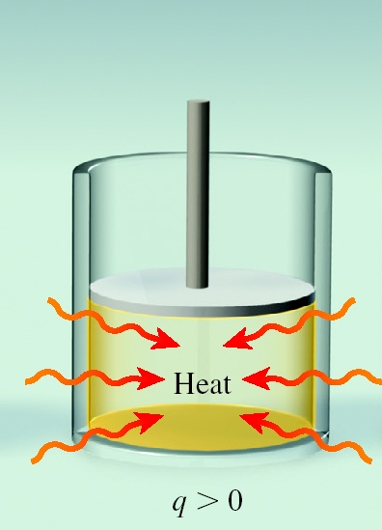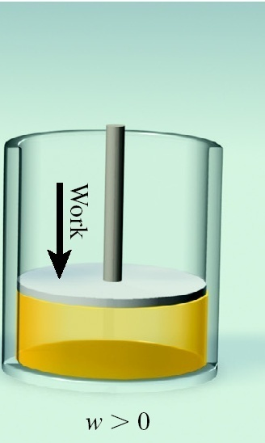

Calculate the overall change in internal energy for a system that absorbs 125 J of heat and does 141 J of work on the surroundings.

*q* is + (heat absorbed)

*w* is − (work done)

Δ*U*sys = *q* + *w* = (+125 J) + (−141J) = −16 J

**5.3.** **Reactions carried out at constant at Volume and Pressure:**

* **Reactions carried out at constant volume**:
  + Pressure-volume work, *w*, done by a system is:

*w* = −*P*Δ*V*

* + **Constant volume**:

Δ*V* = 0

Δ*U* = *q* − *P*Δ*V*

*qv*= Δ*U**(at constant volume)*

* **Reactions carried out at constant pressure**:
  + Δ*U* = *q* + *w*
  + Δ*U* = *qp* − *P*Δ*V*

*qp*= Δ*U* + *P*Δ*V*

* **Enthalpy and enthalpy changes**:
  + **Enthalpy** (*H*) is a state function defined as

*H* = *U* + *PV*

* + **At constant pressure**:

*qp* = Δ*H**(at constant pressure)*

* + **Enthalpy of reaction**:
    - Δ*H* is + for endothermic changes.
    - Δ*H* is − for exothermic changes.
* **Thermochemical Equations**:
  + Equations that represent both mass and enthalpy changes:

H2O(*s*)→ H2O(*l*)Δ*H* = + 6.01 kJ/mol

* + - This is an ***endothermic*** process. It requires 6.01 kJ to melt one mole of ice, H2O(s).
    - The enthalpy value will change if the number of moles varies from the 1:1 reaction stoichiometry.



* + - This is an ***exothermic*** process. It releases

890.4 kJ when one mole of methane, CH4,reacts.

* + - The enthalpy value will change if the number of moles varies from the 1:2:1:2 reaction stoichiometry.

**Comparison of Endothermic and Exothermic Changes**

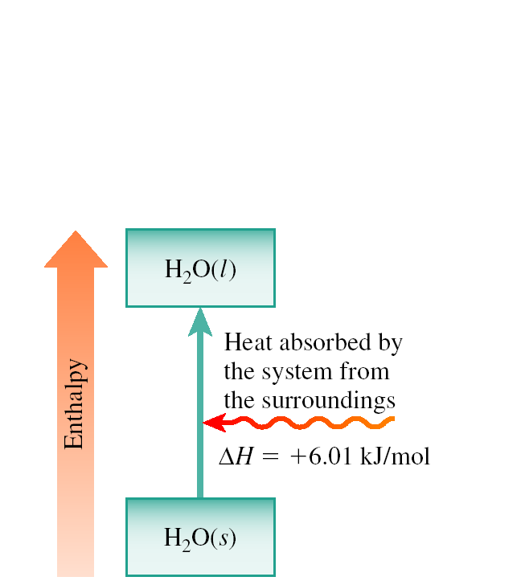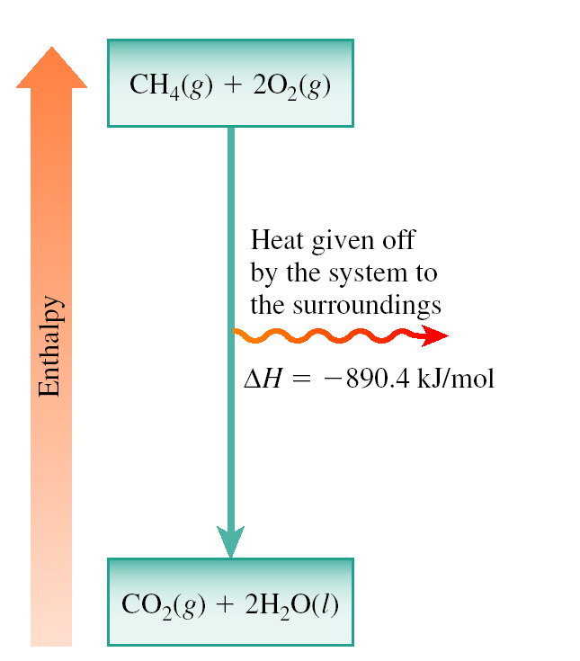

**Given the following equation**:

C6H12O6(*s*) + 6O2(*g*) → 6CO2(*g*) + 6H2O(*l*)

Δ*H* = − 2803 kJ/mol

Calculate the energy released when 45.00 g of glucose (*MM* = 180.2 g/mol) is burned in oxygen:



**5.4 Calorimetry:**

* ***Calorimetry*** is the measurement of heat changes
* **Heat capacity (*C*)** :

It is the amount of heat required to raise the temp of

an object by 1°C.

* + **Units**: J/°C
  + Relation to amount of heat (*q*)

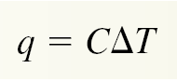

*where q* is heat, *m* is mass, *C* is heat capacity and

Δ*T* = change in temp (Δ*T* = *T*final − *T*initial)‏

Calculate the amount of energy required to heat 95.0 grams of water from 22.5°C to 95.5°C.

Δ*T* = *T*final – *T*initial = 95.5 oC − 22.5oC = 73.0oC and

*q* = (95.0 g) (4.184 J/g°C) (73.0°C)‏ = 2.90 x 104 J or 29.0 kJ

* ***Specific heat* (*s*)**: the amount of heat required to raise the

the temp of 1 g of a substance by 1°C.

* + **Units**: J/g °C
  + Relation to amount of heat (*q*):

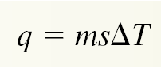

*where q* is heat, *m* is mass, *s* is specific heat

and Δ*T* = change in temp (Δ*T* = *T*final − *T*initial)

* **Constant-Pressure Calorimetry**:

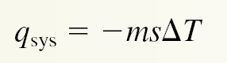

**=** Δ*H* (for good approximation)

* + ***System***: reactants and products
  + ***Surroundings***: water

**Used to measure: Specific heats and Δ*H* values**

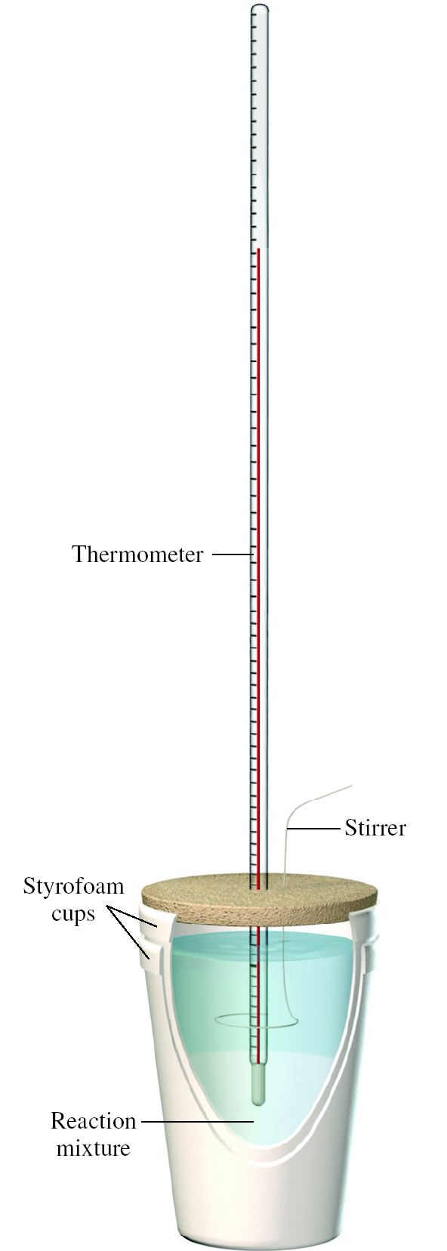

**A metal pellet with a mass of 85.00 grams at an original temperature of 92.5°C (*Ti*, *metal*) is dropped into a calorimeter with 150.00 grams of water at an original temperature of 23.1°C (*Ti*, *water*). The final temperature of the *water* and the *pellet* is 26.8°C (*Tf*). Calculate the heat capacity and the specific heat for the metal**

*q*water = *ms*Δ*T*

*= (150.00 g) (4.184 J/g°C) (3.7°C)*

*= 2300 J (water gained energy)*

*q*pellet *=- q*water *= -2300 J (pellet released energy)*

***Heat capacity*** *of pellet****:***

*q = CΔT*

*and C = q/ΔT*

*= (−2300 J)/(− 65.7°C) = 35 J/°C*

*but* ***Specific heat*** *of pellet is in J/goC:*



* **Constant-Volume Calorimetry** :

For isolated system:





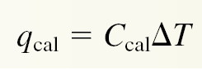

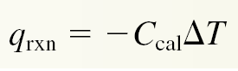

* + Measures Δ*U*  using bomb calorimeter:

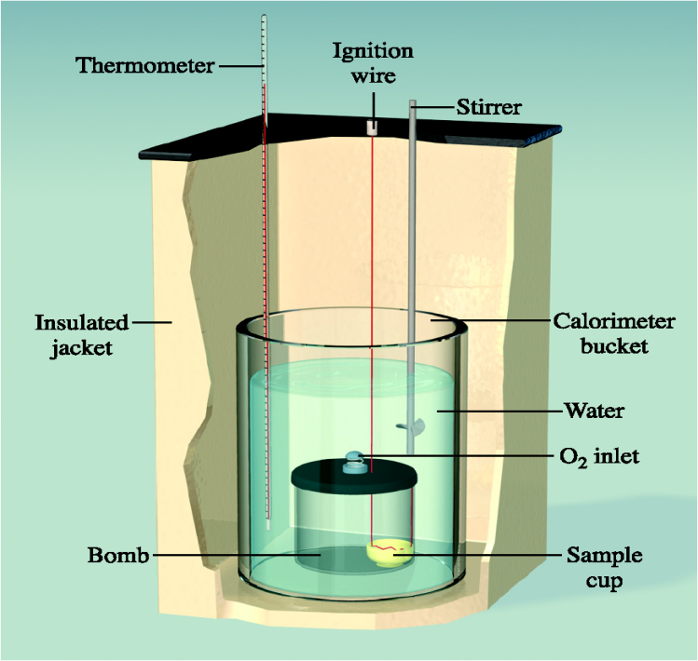

**A snack chip with a mass of 2.36 g was burned in a bomb calorimeter. The heat capacity of the calorimeter 38.57 kJ/°C. During the combustion the water temp rose by 2.70°C. Calculate the energy in kJ/g for the chip.**

*q*rxn = −*C*cal Δ*T*

= −(38.57 kJ/°C) (2.70°C)

= − 104 kJ

***Energy content*** is a ***positive quantity***:

Δ*E = q*v

**Energy content** = 104 kJ/2.36 g

= 44.1 kJ/g (***positive quantity***)

( ***Food Calories: 10.5 Cal/g***)

* 1. **Hess’s Law:**

The change in enthalpy that occurs when reactants are converted to products is the same whether the reaction occurs in one step or a series of steps.

Therefore chemical reactions and their enthalpy

changes can be treated as mathematical equations:

• If a *reaction* is reversed, the *sign* of Δ*H* is also reversed.

e. g: *A* + *B* → *Z* Δ*H = +*231kJ

*A* + *B* ← *Z* Δ*H = -*231kJ

• If the *coefficients* in a balance equation are multiplied by an integer, the *value* of Δ*H* is multiplied by the same integer.

*e. g*: *A* + 1/2*B* → 2*Z* Δ*H = +*231kJ

2*A* + *B* → 4*Z* Δ*H = +*462kJ

• Used for calculating enthalpy for a reaction that

cannot be determined directly.

Calculate Δ*H* for the conversion of *graphite* to

*diamond*:

Cgraphite (s) 🡪 *C*diamond (s) Δ*H* = ?

Making use of their combustion enthalpies:

Cgraphite (s) + O2(g) 🡪 CO2(g) Δ*H*1 = - 394 kJ

Cdiamond (s) + O2(g) 🡪 CO2(g) Δ*H*2 = - 396 kJ

By revesing reaction (2) and add to reaction (1) gives the required reaction:

Cgraphite (s) + O2(g) 🡪 CO2(g) Δ*H*1 = -394 kJ

CO2(g) 🡪 Cdiamond (s) + O2(g) ΔH3 = +396 kJ

______________________________________________

Cgraphite (s) 🡪 Cdiamond (s) Δ*H* = Δ*H*1 + Δ*H*3 = +2 kJ

Since Δ*H is positive the reaction is endothermic.*

**Given the following equations**:

H3BO3(*aq*) → HBO2(*aq*) + H2O(*l*) Δ*H*rxn = −0.02 kJ

H2B4O7(*aq*) + H2O(*l*) → 4 HBO2(*aq*) Δ*H*rxn = −11.3 kJ

H2B4O7(*aq*) → 2 B2O3(*s*) + H2O(*l*) Δ*H*rxn = 17.5 kJ

Find the Δ*H* for this overall reaction.

2H3BO3(*aq*) → B2O3(*s*) + 3H2O(*l)* Δ*H*rxn = ?

2H3BO3(*aq*) → 2HBO2(*aq*) + 2H2O(*l*) **x 2**

Δ*H*rxn = 2(−0.02 kJ) = **−0.04 kJ**

2HBO2(*aq*) →1/2H2B4O7(*aq*) + 1/2H2O(*l*) **reverse, ÷2**

Δ*H*rxn = +11.3 kJ/2 = **5.65 kJ**

1/2H2B4O7(*aq*) → B2O3(*s*)+ 1/2H2O(*l*) **÷** **2**

Δ*H*rxn = 17.5 kJ/2 = **8.75 kJ**

2H3BO3(*aq*) → B2O3(*s*) + 3H2O(*l)*

Δ*H*rxn = **14.36 kJ**

* 1. **Standard Enthalpies of Formation:**

***Standard enthalpy of formation***

* + **Symbol**: Δ*H*f°
  + The enthalpy change that results when 1 mole of a compound is formed from its elements in their standard states.
* Δ*H*f° for an element in its standard state is defined as zero.

* + **Standard state**: 1 atm, 25°C
  + Values found in reference tables
  + Used to calculate the Δ*H*°rxn
* Defining equation for enthalpy of reaction:

**Δ*H*o*reaction* =** Σ ***np* Δ*H*o*f* (*products*) –** Σ ***nr* Δ*H*o*f* (*reactants*)**

where *np* and *nr* are the coefficients of the products and

the reactants in the balance equation

**Note**: The *enthalpy* of *formation* of an element in its *standard state* is *zero*. (e.g: H2(g), O2(g), N2(g), Cgraphite(s), F2(g), Cl2(g), Br2(l), I2(s), metals(s) and Hg (l).

Calculate the Δ*H*°rxnfor the following reaction from the table of standard values:

CH4(*g*) + 2O2(*g*)→ CO2(*g*)+ 2H2O(*l*)

Δ*H*rxn° =Σ*np*Δ*H*f° (products) - Σ*nr*Δ*H*f°(reactants)

= [1(−393.5) + 2(−285.8)] − [1(−74.8) + 2(0)]

= −890.3 kJ/mol (*exothermic*)