**CHEM 102 Recitation Ch 25 Name**

|  |  |  |  |  |  |
| --- | --- | --- | --- | --- | --- |
| **Q1.** | Which one of these structures represents an "**ester**" functional group? | | | | |
| A) |  | B) | C) | D) |

**Q2.** Identify all the **functional groups** present in the following organic compound.

1)ketone, 2) hydroxy, 3) amide, 4) alcohol, 5) carboxy, 6) ester, 7) amine, 8)carbonyl

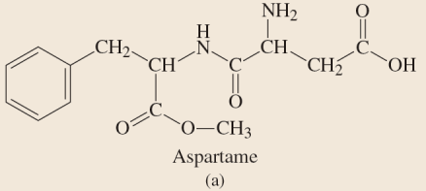

A) 2, 6,7,8

B) 2, 5,8

C) 3, 4,5,7

D) 3,6,7,8

**Q3.** Which of the following has a double C-O bond and a single C-O bond?

A) ketone

B) ester

C) alcohol

D) aldehyde

|  |  |  |
| --- | --- | --- |
| **Q4.** | Name the compound | |
| A) | 4-Ethyl-5-methyl-2-hexanol |
| B) | 4-Ethyl-2-hydroxy-5-methylhexane |
| C) | 4-Ethyl-4-isopropyl-2-butanol |
| D) | 3-Ethyl-2-methyl-5-hexanol |

|  |  |  |
| --- | --- | --- |
| **Q5.** | Choose the correct **IUPAC name** for the following chemical structure: | |
| A) | 6-chloro-7-keto-5-methyl-3-nitro-2-octanol |
| B) | 6-amino-3-chloro-4-methyl-7-hydoxy-2-octanone |
| C) | 3-chloro-6-hydroxy-4,6-dimethyl-6-nitro-2-hetanone |
| D) | 3-chloro-7-hydroxy-4-methyl-6-nitro-2-octanone |

**Q6.** Draw five **isomers** for the molecular formula **C3H6O**