
College of Environmental Design
Department of Construction Engineering & Management

CEM-600
Master of Engineering Report

SCRUM - AND ITS USE IN CONSTRUCTION PROJECT MANAGEMENT

Adviser
Dr. Sadi Assaf

By

Faisal H. Al-Muhammadi

May 2007
TABLE OF CONTENTS

- ABSRTACT 1
- INTRODUCTION 2
- LITERATURE REVIEW 6
- BACKGROUND 10
  - History 10
  - Benefits 11
  - Advantages / Disadvantages 13
- WORKING OF A SCRUM 15
- REUQIREMENTS OF A SCRUM 27
  - Necessary 27
  - Concise 28
  - Implementation 28
  - Attainable 29
  - Complete 29
  - Consistent 29
  - Unambiguous 30
  - Verifiable 30
- MANAGING WITH A SCRUM 31
  - Managing a Sprint 32
  - Managing Releases 34
- SCRUMS AND THE CONSTRUCTION ENGINEERING MANAGEMENT 35
  - Construction Engineering Management 37
  - Trends of Modern Construction Project Management 41
  - Strategic Planning of Construction Project 45
  - Leaders and Motivation for Project Team 51
  - Innovation and Economic Feasibility 61
- THE FUTURE OF SCRUMS IN CONSTRUCTION ENGINEERING 64
- CONCLUSION 65
- REFEREVCES 67
I. ABSTRACT

With the high competition in the construction industry in Saudi Arabia, many local contractors in Saudi Arabia are trying to enhance the performance of their project teams in order to be competitive and to deliver their best to many reputable clients. This study will explain a Project Management technique ‘SCRUM’ which is being implemented in wide areas including the software and the broadcasting industry, etc.
This will give an idea of how to enhance performance in the construction industry and in order to give the contractors a clear idea about how they should increase their project teams’ performance through this technique. The study shows the impact and affects of SCRUM on performance of software industry and will also explain how it can be useful in construction industries.
In this report there is an effort to explain the way in which the construction project management can be carried out to give best results to the client. This will help the construction contractors in utilising their project team to perform well in the market to make an identity in the construction industry of Saudi Arabia.

II. INTRODUCTION

This is a report on research project with a subject that is becoming increasingly important topic in construction engineering management - SCRUMS. Scrums are an iterative, incremental process for developing any product or managing any work. Scrum is a set of interrelated practices and rules that optimize the development environment, reduce organizational overhead, and closely synchronize market requirements with iterative prototypes. Based in modern process control theory, Scrum causes the best possible software to be constructed given the available resources, acceptable quality, and required release dates. Useful product functionality is delivered every thirty days as requirements, architecture, and design emerge, even when using unstable technologies.
Scrums act as a wrapper to the engineering processes. Scrum focuses organisations on maximising Return on Investment through avoidance of unnecessary features, business value focus and reduced whole-of-life costs. It is a proven method of delivering highly appropriate and useful outcomes on schedule and within budget through rapid incremental delivery, systematic risk reduction and ongoing customer control.

Purpose

The specific purpose of my report is to describe and evaluate the emerging source in construction engineering through scrums. In addition, attention will be paid on its benefits, advantages, disadvantages and the future of scrums in construction engineering management. The initial use of Scrum is intimidating for any member of senior management (project managers and above). It's a significant departure from methodologies that have become the norm throughout the industry, and thus requires a change in mindset for management. Most management is used to directing the project, telling the team what to do and then ensuring that they do it. Scrum and XP rely on self-organization, with the team deciding what to do while management runs interference and removes roadblocks. This report will also throw light on the following questions:
- What type of training, resources, or tools would best help you successfully employ Scrum in the future?
- Scrum and Extreme Programming are sometimes used together. What must be considered when this is done?
- How do you cause the accuracy of Product Backlog estimates to improve? To what degree does their accuracy matter?
- How do you cause the accuracy of what a team commits to for a Sprint to what the team actually delivers?

What is Scrum?

Scrum is a process that can manage and control software or product development. It is a project management process. Instead of promoting the traditional analysis, design, code, test and deploy approach; Scrum follows iterative and incremental practices. Scrum requires very few artifacts, unlike the usual "artifact-driven" projects, where large documentation on Requirements, Specifications, Design, etc. is needed. Scrum concentrates on what’s important: “Managing a project that can produce business value.”

Scrum is an iterative, incremental process for developing any product or managing any work. It produces a potentially shippable set of functionality at the end of every iteration. Its attributes are:
- Scrum is an agile process to manage and control development work..
- Scrum is a wrapper for existing engineering practices.
- Scrum is a team-based approach to iteratively, incrementally develop systems and products when requirements are rapidly changing.
- Scrum is a process that controls the chaos of conflicting interests and needs.
- Scrum is a way to improve communications and maximize co-operation.
- Scrum is a way to detect and cause the removal of anything that gets in the way of developing and delivering products.
- Scrum is a way to maximize productivity.
- Scrum is scalable from single projects to entire organizations. Scrum has controlled and organized development and implementation for multiple interrelated products and projects with over a thousand developers and implementers.
- Scrum is a way for everyone to feel good about their job, their contributions, and that they have done the very best they possibly could.
Scrum naturally focuses an entire organization on building successful products. Without major changes -often within thirty days - teams are building useful, demonstrable product functionality. Scrum can be implemented at the beginning of a project or in the middle of a project or product development effort that is in trouble. [1]

III. LITERATURE REWIEW

Agile project management with Scrum derives from best business practices in companies like Fuji-Xerox, Honda, Canon, and Toyota. Toyota routinely achieves four times the productivity and 12 times the quality of competitors. Can Scrum do the same for construction engineering purposes? This paper analyzes and recommends best practices for construction engineering management purposes through the use of SCRUMS.
Scrum is an Agile project development process designed to add energy, focus, clarity, and transparency to project teams developing software systems. It leverages artificial life research
- By allowing teams to operate close to the edge of chaos to foster rapid system evolution.
- It capitalizes on robot consumption architectures by enforcing a simple set of rules that allows rapid self organization of software teams to produce systems with evolving architectures.
A properly implemented Scrum is designed to increase speed of development, align individual and organization objectives, create a culture driven by performance, support shareholder value creation, achieve stable and consistent communication of performance at all levels, and enhance individual development and quality of life. This paper will further expose you to how best results can be derived from SCRUMS implementation in the construction engineering field.
The usual inspiration for methodologies is engineering disciplines such as civil or mechanical engineering. Such disciplines put a lot of emphasis on planning before you build. Such engineers will work on a series of drawings that precisely indicate what needs to be built and how these things need to be put together. Many design decisions, such as how to deal with the load on a bridge, are made as the drawings are produced. The drawings are then handed over to a different group, often a different company, to be built. It's assumed that the construction process will follow the drawings. In practice the constructors will run into some problems, but these are usually small.
Since the drawings specify the pieces and how they need to be put together, they act as the foundation for a detailed construction plan. Such a plan can figure out the tasks that need to be done and what dependencies exist between these tasks. This allows for a reasonably predictable schedule and budget for construction. It also says in detail how the people doing the construction work should do their work. This allows the construction to be less skilled intellectually, although they are often very skilled manually.
So what one comes across here are two fundamentally different activities. Design which is difficult to predict and requires expensive and creative people, and construction which is easier to predict. Once the design is completed, the construction is easy to plan. Once the plan for the construction is ready, then dealing with construction is a much more predictable way. In civil engineering construction is much bigger in both cost and time than design and planning.
So the approach for software engineering methodologies looks like this: needed is a predictable schedule that can use people with lower skills. To do this separate design from construction. Therefore it is needed to figure out how to do the design for software so that the construction can be straightforward once the planning is done.
So what form does this plan take? For many, this is the role of design notations such as the UML (Unified Modling Language).If one can make all the significant decisions using the UML, he can build a construction plan and then hand these designs off to coders as a construction activity.
But here lies the crucial question. Can you get a design that is capable of turning the coding into a predictable construction activity? And if so, is cost of doing this sufficiently small to make this approach worthwhile?
All of this brings a few questions to mind. The first is the matter of how difficult it is to get a UML-like design into a state that it can be handed over to programmers. The problem with a UML-like design is that it can look very good on paper, yet be flawed when you actually have to program the thing. The models that civil engineers use are based on many years of practice that are enshrined in engineering codes. Furthermore the key issues, such as the way forces play in the design, are amenable to mathematical analysis. The only checking that can be done of UML-like diagrams is peer review. While this is helpful it leads to errors in the design that are often only uncovered during coding and testing. Even skilled designers, such as I consider myself to be, are often surprised when we turn such a design into software.
Another issue is that of comparative cost. When you build a bridge, the cost of the design effort is about 10% of the job, with the rest being construction. Even if you lump in all testing as part of construction, then design is still 50% of the work. This raises an important question about the nature of design in software compared to its role in other branches of engineering.
These kinds of questions led to suggest that in fact the source code is a design document and that the construction phase is actually the use of the compiler and linker. Indeed anything that you can treat as construction can and should be automated.
This thinking leads to some important conclusions:
- In software: construction is so cheap as to be free
- In software all the effort is design, and thus requires creative and talented people
- Creative processes are not easily planned, and so predictability may well be an impossible target.
- We should be very wary of the traditional engineering metaphor for building software. It's a different kind of activity and requires a different process.
So what had to be done finally, the answer to this is SCRUMS. Now as you move further this report will expose you to the implementation of scrums in the construction engineering.

IV. BACKGROUND

- HISTORY OF SCRUM:
A majority of project management methods and techniques are very narrow or rigid as they follow a fixed sequence of events and offer little in the way of flexibility. Newer and less mature methods usually claim to be a solution; however they lack any definitive proof or track history.
Scrum is an agile method for project management. The approach was first described by Takeuchi and Nonaka in "The New Product Development Game" (Harvard Business Review, Jan-Feb 1986). They noted that projects using small, dys-functional teams historically produce the best results, and likened these high-performing teams to the scrum formation in Rugby. In 1991, DeGrace and Stahl, in "Wicked Problems, Righteous Solutions" referred to this approach as Scrum. Ken Schwaber used an approach that led to Scrum at his company, Advanced Development Methods, in the early 1990's. At the same time, Jeff Sutherland, John Scumniotales, and Jeff McKenna developed a similar approach at Easel Corporation and were the first to call it Scrum. Jeff Sutherland and Ken jointly presented a paper describing Scrum at OOPSLA'96 in Austin, its first public appearance. Ken and Jeff collaborated during the following years to merge the above writings, their experiences, and industry best practices into what is now known as Scrum. Although Scrum has a theoretical basis in empirical process control, its practices have all been empirically derived from extensive Scrum practice. [5]

B. BENEFITS OF SCRUM:

Scrum is an agile project management method that directly addresses some of the biggest challenges in business-driven projects, including software development.

Scrum has been proven to deliver the following benefits to projects:
- Avoidance of Unnecessary Features - Avoids waste on the 64% of features in computer systems that are never or seldom used.
- Business Agility - Offers a path to increased agility and productivity across all areas of the organisation - not just software development.
- Business Goal and User Needs Alignment - Provides regular inspect-adapt loops to ensure that deliverables continue to meet needs as the project progresses.
- Business Value Focus - Delivers outcomes in priority order.
- Collaboration - Facilitates close and constant collaboration between stakeholders and project teams.
- Complexity Reduction - Systematically cuts through the complexity of modern systems and large projects.
- Continuous Improvement - Motivates teams to self-optimise.
- Exceeded Expectations - Creates teams that deliver more than expected.
- Flexibility - Adapts quickly, turning requirements change from a problem into an opportunity.
- Estimation - Motivates teams to improve their estimates.
- Managed Financial Commitment - Provides control through budget and priority reviews every 2-4 weeks.
- Openness and Visibility - Improves communication and early issue identification.
- Productivity Breakthroughs - Minimises overheads and empower teams to become up to 900% more productivity.
- Rapid Incremental Delivery - Delivers a quality-verified outcome every 2-4 weeks.
- Return On Investment - Realises better outcomes for your investment early and throughout the project through Rapid Incremental Delivery, Avoidance of Unnecessary Features etc.
- Risk Reduction - Eliminates major risks early, thereby greatly reducing the likelihood of project failure.
- Scalability - Scales to large projects, including multiple inter-related projects.
- Process Simplification - Uses a simple empirical process to minimise overheads and encourage creativity.
- Team Building and Communication - Encourages team cohesion and improves communication between all participants.
- Whole-of-Life Costs - Reduces costs across the whole lifecycle through Process Simplification, improved maintainability etc.

Scrum is the choice of a large and growing number of the world's most successful and innovative organisations including some software development organisations like Microsoft, Oracle, HP, Sun Microsystems, Yahoo, Google, SAP, Etc. In the areas of product development organisations like General Electric Healthcare, British Broadcasting Commission, U.S Federal Reserve.
Scrum has proven that it meets the rigorous needs of complex organisations and that it scales to the co-ordination needs of large projects, yet it equally delivers complex, inter-related projects.
Scrum focuses organisations on maximising Return on Investment through avoidance of unnecessary features, business value focus and reduced whole-of-life costs. It is a proven method of delivering highly appropriate and useful outcomes on schedule and within budget through rapid incremental delivery, systematic risk reduction and ongoing customer control.
C. ADVANTAGES AND DISADVANTAGES OF SCRUM:
Advantages
- Productivity increases
  - Some Scrum teams have recorded a 4x increase in productivity
  - Most improve productivity by 10-20% depending on management commitment
- Continuous improvement
  - Scrum enables continuous, rapid, bottom-up reengineering
- Leverages the chaos
  - The product becomes a series of manageable chunks
  - Progress is made, even when requirements are not stable
  - Everything is visible to everyone
  - Team communication improves
  - The team shares successes along the way and at the end
  - Customers see on-time delivery of increments
  - Customers obtain frequent feedback on how the product actually works
  - A relationship with the customer develops, trust builds, and knowledge grows
  - A culture is created where everyone expects the project to succeed
Disadvantages
- Requires hand-on management, but not micromanagement
  - Management must be willing to make changes to help Scrum teams succeed
  - Scrum requires constant monitoring both quantitatively and qualitatively
- Requires management to delegate decision-making authority to the Scrum team
  - Managers must let Scrum teams make their own decisions, even allowing them to fail if necessary
- Scrum is new and different
  - People are resistant to change
  - Some workers are not comfortable with the responsibility Scrum enables[3]

V. WORKING OF SCRUM:

Traditionally, we followed a cycle involving requirements gathering, analysis, design, develop, test, deploy with each stage being completed before moving on. This was known as the waterfall approach. At the same time as there is a place for the waterfall approach, it has been the subject of a torrent of abuse in recent years. Most notably, the waterfall approach promotes the creation of up-front documentation before any real business value is created. This is confounded by the fact that product development is started downstream, or much later in the project’s expected timeframe. This has the obvious disadvantage of delaying the point at which business value can be realised.
But it gets worse: the customer/user endeavour to ensure that all of their requirements are documented during the early stages, thus the feature set is top-heavy. Failure to prioritize the feature-set often results in low quality systems that are overloaded with features that the customer/user does not actually require. About 80% of a product’s value comes from 20% of its features".
With this in mind, a product that provides 20% of the feature set can conceivably be built. It has to be done it iteratively. Deliver "version 1" with 20% of the features, then, a little later, "version 2" with a further collection of features. The beauty of this approach is that development of 20% of the features should not take 100% of the project’s expected schedule and budget. We can realise business value much earlier in the cycle.
Scrum embraces the opposite of the waterfall approach whereby we start working on the analysis as soon as we have some requirements, as soon as we have some analysis we start working on the design, and so on. In other words, we work on small pieces at a time. This approach can be called iterative. Each iteration consists of some requirements gathering, some analysis, some design, some development and some testing culminating in an iterative release cycle (many deployments).[5]

Scrum Basics

Scrum revolves around the ethos of simplicity, resulting in delivery of something that moves the project forward. It achieves this by proposing the following questions (referred to as Scrum’s three questions).
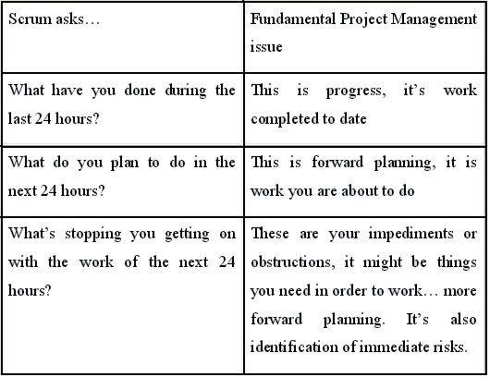
Scrum Roles
Scrum uses three "roles": Product Owner, ScrumMaster and Project Team.
The Product Owner is possibly a Product Manager or Project Sponsor, a member of Marketing or an Internal Customer. The ScrumMaster is key, he or she "represents management to the project". Such a role usually filled by a Project Manager or Team Leader. They are responsible for enacting Scrum values and practices. Their main job is to remove impediments, i.e. project issues that might slow down or stop activity that moves the project forward.
The Project Team should consist of between 5-10 members. The team itself should be cross-functional, involving individuals from a multitude of disciplines: QA, Programmers, UI Designers, etc.

Scrum is best described in the figure 1. Most projects have a list of requirements (type of system, planning items, type of application, development environment, user considerations, etc.) Scrum records requirements in a Product Backlog. Requirements need not be precise nor do they need to be described fully. As with most projects, the requirements are sourced from the expected users or "the business". The Product Owner prioritizes the Product Backlog: items of importance to the project/business, i.e. those items that add immediate and significant business value, are bubbled up to the top.
The Project Team responsible for doing the actual work then creates a Sprint Backlog: this comprises of Product Backlog items that they believe can be completed within a 30 day period. The Project Team may coordinate with the Product Owner and others in order to expand item(s) on the Sprint Backlog. After 30 days have elapsed, the team should have a "potentially shippable product increment". The make-up of the Project Team is discussed later in this article, under the topic: Scrum Roles.
The Product Owner, the Scrum Master and the Project Team will make an initial pass over the Product Backlog items where they work out roughly how long each item will take. Initially, these are estimates, best guesses. As time progresses, well within 30 days, we’ll know if the estimate was even close.
Scrum lets us refine our estimates on-the-fly: if we believe that a task will take longer than envisaged, we have the ability to say so before the tasks starts. By only ever working with small work packages (time-boxed to 30 days), any schedule/requirement issues are dealt with as soon as they are identified, not much further downstream where the cost of recovery is considerably higher.
What does this "potentially shippable product increment" actually mean? Putting simply, every 30 days, the team should provide something of value to the business, something they can use or something that provides considerable direction.
The beauty of the 30 days approach is that: if the Product Owner, customer or the business likes what they see at the 30 day interval, they can then re-prioritise the Product Backlog. This is important as it means that we are only ever producing goods that will be used by the business.

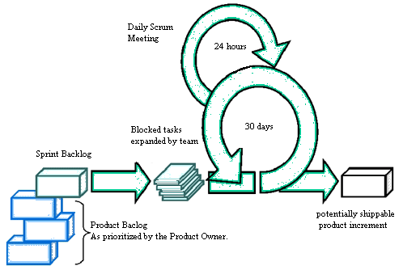
Figure: 1, the Scrum Process
Daily Scrum Meeting

One of Scrum’s primary practices is the 24 hour cycle shown in figure, the Daily Scrum meeting.
If you are in the corporate environment, meetings seem to be the norm and often they have little business value apart from to act as a caffeine injection mechanism. Folks who sit down at meetings get too comfortable: they attend meetings for the coffee and doughnuts, not for the project’s sake. Once relaxed, those same folks often stray off the meeting agenda and start discussing items that are either on the project periphery or are not even project related.
Scrum resolves these issues using two simple approaches.
Firstly, Scrum-managed project meeting rooms are devoid of chairs. Attendees have to stand up. This might sound cruel, but it focuses the mind and those folks who are capable of sitting in (often unproductive) meetings for hours on end are soon discouraged.
Secondly, Scrum-managed meetings are time-boxed or time limited. The Daily Scrum meeting is typically time-boxed to 15 minutes. Only extraordinary projects should require more than 15 minutes. Here is the crux: if you can’t say what you have to say succinctly in a short space of time, you’re waffling, get your coat. Keeping it time-boxed focuses folks’ minds and helps keep agenda items targeted at what’s important: Moving the project forward towards delivery of "something"… and identifying and removing obstacles that prevent this goal being met.
The purpose of the Daily Scrum meeting is to answer Scrum’s three questions:
1. What did you do yesterday?
2. What will you do today?
3. What are the obstacles in doing the work?
The ScrumMaster and the Project Team are the only people who are allowed to talk. Outsiders may listen in, but are removed or silenced should they say anything. This is all about who is committed to the project or not. Outsiders tend to volunteer items that are important to them, but not necessarily to the project and its immediate goal: delivery business value within the 30 day sprint.

Scrum work of art:
Scrum has remarkably few artefacts. There are three artefacts, each of which can be managed using nothing more than an Excel spreadsheet. More advanced / complicated tools exist; many are expensive, web-based or are still under development. Web-based tools are great, but they are not much good if there is no "off-line" operation.
Figure 1 hints at Scrum’s artifacts: there is a Product Backlog and a Sprint Backlog. The Product Backlog is a prioritised list of first cut refinements. Because the Product Owner is free to adjust the order in which Product Backlog items are development, they are even free to add new items this is the spirit of "agile".
Graphical feedback that can be printed out and displayed in a public place makes progress reporting very visible. Scrum encourages this kind of reporting and offers Burndown Charts as a means of graphically displaying a project’s progress or not as the case may be. We will take a look at burndown charts later in this article.
Scrum’s artifacts can be managed by nothing more than a spreadsheet. Indeed, the Product Backlog can be represented using an Excel worksheet. Each Sprint Backlog then occupies another sheet within the same workbook.
Figure 2 presents a sample Product Backlog. Keeping with the ethos of Scrum and "agile", you shouldn’t be planning more than one sprint into the future. Indeed, the contents of a Sprint are usually defined during a "Sprint planning meeting".
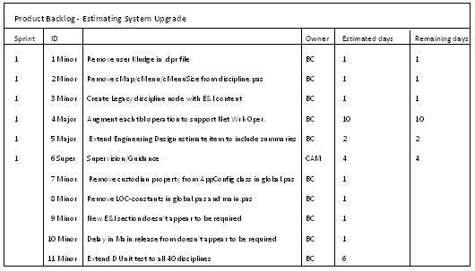
Figure 2 – A sample Product Backlog
Using the information in Figure 2, we can derive another worksheet, the Sprint Backlog (Sprint 1). Figure 3 presents a sample Sprint Backlog: it contains a list of the things that will be "done" during the Sprint. Each Sprint item has an estimate of how long it should take to complete, usually measured in hours. Looking at figure 3 again, you can see that none of the six tasks have been worked on.
During the Sprint’s 30 day period, the Project Team must update the Sprint Backlog. For example, if BC spent four hours on item 1, Remove user kludge in .dpr file, on Tuesday 2nd (November in this case), he would enter ‘4’ into Sprint day 2’s Backlog item 1 column/row combination.
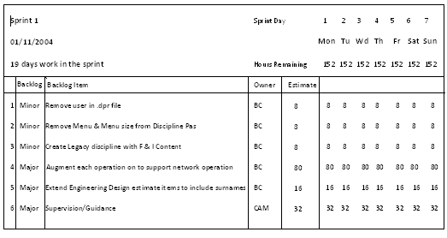
Figure 3 – Sprint 1 at inception
Keeping the Sprint Backlog updated is key: not only does it allow us to work out how fast a team can work (their velocity), it is an early warning indicator.
What is useful about the Sprint Backlog is its ability to be displayed graphically. Scrum uses burndown charts to represent "work done". Figure 4 presents a burndown chart where no work as been performed in the sprint. The idea behind burndown charts is that they should demonstrate a steady drive to zero hours remaining: it represents a pace of work that should be sustainable. In reality however, some work takes longer than others, and some are even shorter, so the burndown graph may not be a perfect straight line.
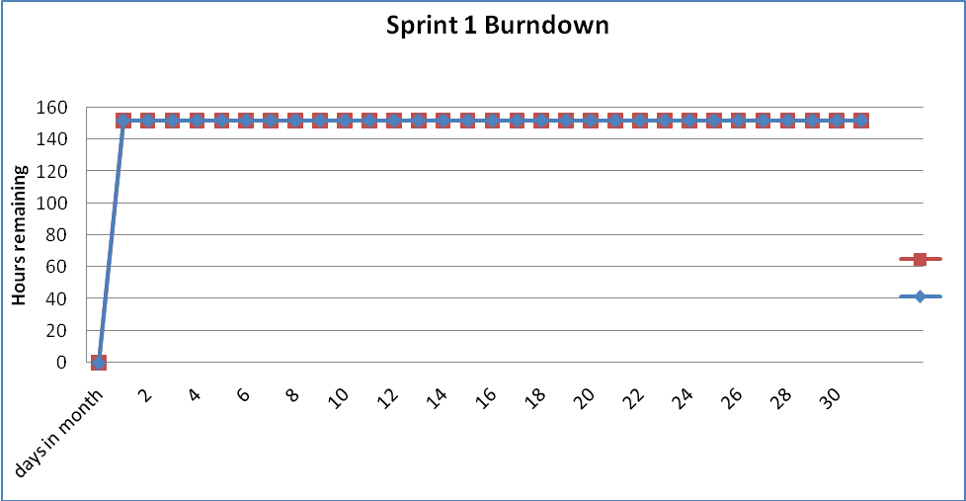
Figure 4 – Sprint Burndown, no work performed
Figure 5 presents a Sprint backlog that has been updated after work has been performed. Following the "Remove user kludge in .dpr file" item through, BC performed 4 hours work on Wednesday 3rd, followed by 2 hours work on Thursday 4th and finished the task on Friday by spending 2 hours on it.
You will also notice that on the same Wednesday, BC spent 4 hours on "Remove cMap/cMenu…". Assuming a working day of 8 hours, BC has split his time between two tasks.
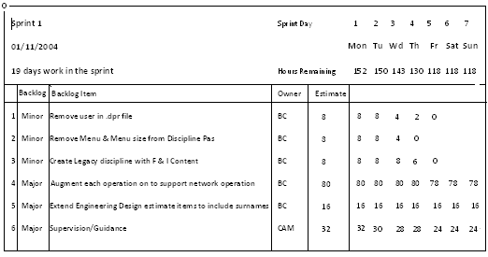
Figure 5 – Sprint 1 after work has been performed
The beauty of the Sprint Backlog is its simplicity. By recording the hours of actual work completed versus the estimated hours to complete, we are able to plot equally simple, but powerful Burndown Chart that should provide you with the confidence that progress is being made. If the Burndown Chart does not indicate that progress is being made, then it has served another good purpose: it gives you an early warning that this sprint contains either too much work or too little.
Figure 6 presents a Burndown Chart based of Figure 5’s Sprint Backlog. Ideally, the Burndown Chart should indicate a level velocity, i.e. work is performed at a steady rate. In reality, we need to factor in weekends and other week-day distractions. As we will see shortly, if a Project Team or individual is distracted for a few hours, Burndown Charts are a great way of identifying the distraction very early in the project.
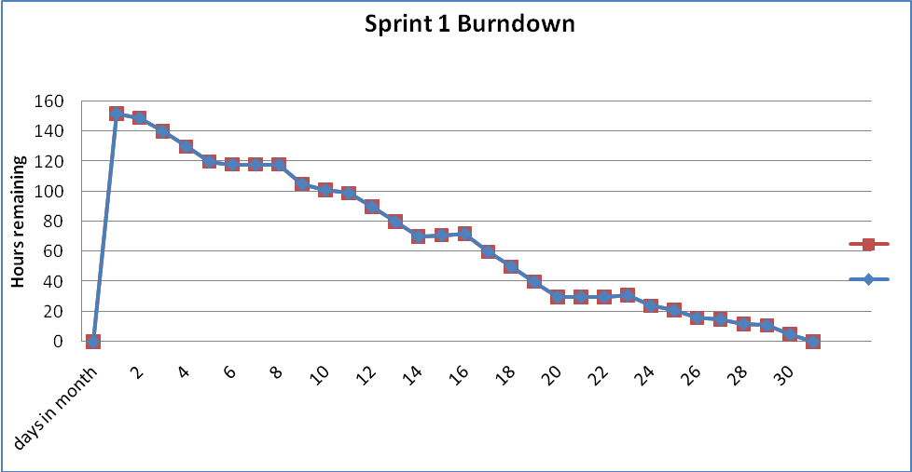
Figure 6 – Sprint Burndown after work has been performed
Figure 7 presents a burndown chart demonstrating that progress is being made, however by no means fast enough. The Burndown Chart gives us a clue that there is something wrong within 2 to 3 days of starting and confirms that work is not progressing at a good speed by days 7 through to 14.
There are a few reasons why this shape of Burndown Chart appears:
- The Team, or individuals are being distracted from their work
- The Sprint Backlog is not being updated
- The Sprint Backlog items are too difficult
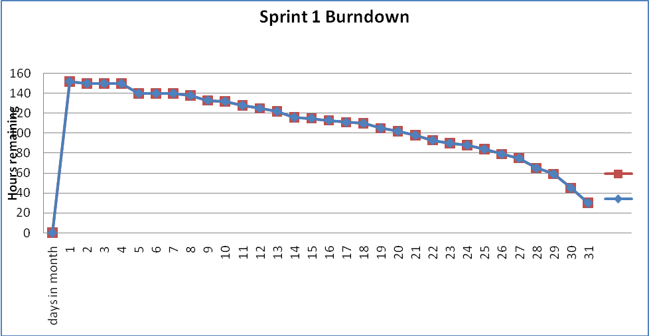
Figure 7 – Sprint Burndown after work has been performed, but not fast enough
Of course, Burndown Charts can reveal that the Sprint Backlog might finish early. For example, if a sprint does not contain enough work, you might end up with a burndown chart similar to figure 8. There are other reasons why a Sprint Backlog might appear to finish early:
Excessive working: if the Project Team works more that an 8 hour day (in this case), work might be completed "ahead of schedule". In reality, excessive working only ever appears to have short-term gain – the project will pay for it either in a loss of product quality and/or tiredness downstream resulting in loss of productivity.
Sprint Backlog item estimates may be incorrect: we may have to revisit our initial estimates as the work is being completed well within the existing estimates. This kind of exception can be caught if the Project Team know to announce the fact that the have completed a task ahead of schedule – the Sprint Backlog simply requires that a task is marked as having "0" hours remaining to indicate that it is complete.
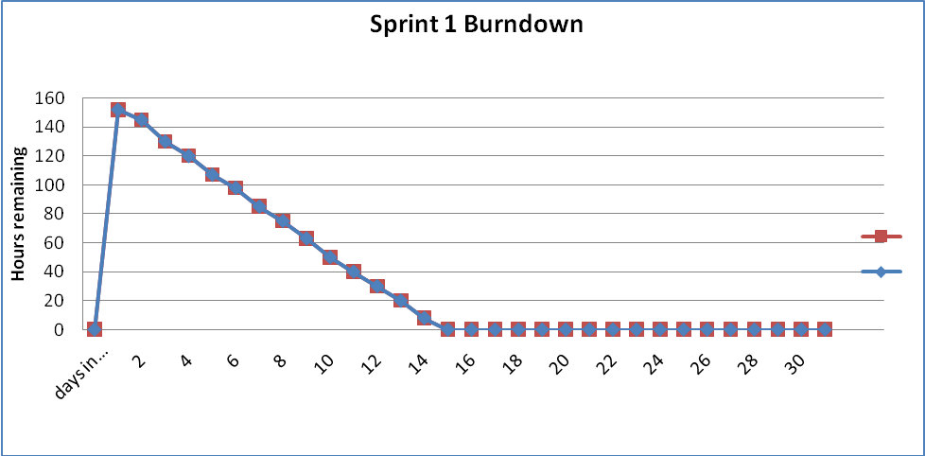
Figure 8 – Sprint Burndown after work has been performed, but too fast (not enough work)
In reality of course, we notice burndown charts that have their ups and downs whilst still meeting their target. If the ups or downs are dramatic, then alarm bells can ring indicating that something is wrong with either the sprint’s scope or the sprint’s Project Team. Either way, you’ll get an early warning indicating that this sprint (less than 30 days of work) is about to encounter a problem. It’s better to encounter and solve project issues as soon as they arise: Scrum’s burndown charts put the project issues into context, better that you "lose" 30 days early in the project than you have to find time later in the project to fix mistakes made early on.
Sprint Backlogs and Burndown Charts are early warning indicators, they highlight "lack of progress". Similarly, they highlight scenarios where there is not enough work or work is too easy". However, their use does assume that everybody is committed to keeping the Sprint Backlog up to date and that is a job for the ScrumMaster.[3]
VI. REQUIREMENTS OF A SCRUM

Necessary:
As explained in the earlier portion of the report, it is the basic necessity of SCRUM to have a project team. It is in turn necessary for the project team to have a project lead or a team leader who has to carryout the meetings all through the project be it the daily, monthly or an occasional meeting like the one between the client and the project manager.
It is necessary for the team to meet frequently and discuss the three basic and major questions:

1. What has been done till date?
2. What has to be done in the coming phase?
3. What are the obstacles in completing the given task?

In a construction project is it very necessary for the project team to execute check if the task (client’s requirement) is being done on the standards of the Saudi Building Code. The project lead or the team leader has to check if the task are being completed in the sprint. He has to check if there are any backlogs in the sprint.

If there are any backlogs then it is necessary for the team to work together to complete sprint. As the sprint or the project phase is completed the team has to sit together and to discuss the imperfections, if any. This will be helpful to deliver a better product next time.

Concise:
The discussions in a scrum meeting need to be concise (to the point) on the whole. This will help the team to be clear about the task assigned to them and the way they have to execute the task.
A construction project has many different phases. The basic generic phases it passes through are:

- Briefing – during this the project requirements are identified.
- Designing – during this the design solutions are proposed and agreed.
- Specifying – during this the production requirements are defined for the physical realization of the design.
- Tendering – during this prices for the production are determined and agreed.
- Constructing – during this the production is carried out.
- Maintaining – during this the completed project is managed for its useful life.

Keeping all these phases in mind there can be more than one team working simultaneously and with this it is important for the team itself to be concise.

Implementation:
The issues discussed in the scrum meeting have to be kept in mind and these have to be implemented in the execution of the sprint.
The execution of all the given tasks has to be done in the given time parameter.
The scrum team has to take care of the implementation of the strategy presented by the project manager or the client.

Attainable:
It is very basic requirement of the scrum team to look to it that the task being assigned to any team or a member of its team is attainable or unattainable. It has to see that the time allotted for the completion of that particular task is enough or less. The time given to each task must be in such a way that it should not be hectic for the team or the member of that team. If all this is kept in mind then the flow of the project will not be affected.

Complete:
The scrum team has to be complete by itself. By this it means that the team itself should have all the people who deal with the different phases of the project or the different tasks of the project assigned.
This will help in avoiding the problems caused due to the imprecise planning and commissioning of the sprint or the phase of project. This can be a major issue which can affect the budget of the project.

Consistent:
The scrum team has to be certain that it is consistent by itself. This means that the team has to be reliable, steady and should be having members who are very clear of the tasks assigned to them and they should also be clear of what they can deliver to the client.
In majority of the cases it is seen that the clients requirements need to be altered, due to the limited resources of the project team. to avoid these situations the project team needs to be sure of its consistency.

Unambiguous:
It is an important requirement of the scrum team to be clear and unmistaken of the parameters in which it has to execute the project, be it any phase of the project. The team has to clear of the tasks it has to perform during that phase of the project.
This is very important as once the task is made to order then it is not feasible to revert it. If the team is unmistakable the results will be good and the flow of the project will be smooth. This can avoid the unexpected expenses at both the sides be it client side or the contractor side.

Verifiable:
The projects that the team works on and completes should be developed in the parameters which are demonstrable or certifiable.

It should be kept in mind that the team should not perform on any requirement of the client which is not verifiable. If the team does not work strictly on this then it will lead to huge losses and the company or client will have to end up paying the penalties.

VIII. MANAGING WITH SCRUM
Sprint
Once the Scrum team, Scrum Master, and Product Owner are comfortable with enough items on the Product Backlog, it is time to start a Sprint. The Scrum team chooses the highest priority features from the Product Backlog, with input from the Product Owner, and makes this subset the Sprint Backlog. This is the amount of work the Scrum team thinks it can finish in the Sprint.
The Scrum team is given full authority to do whatever it needs to do to complete the Backlog by the end of the Sprint within the project’s constraints on budget, schedule, delivered functionality, and delivered quality. The Scrum team should be cross-functional, having all the skills necessary to complete the Sprint’s goals. Generally the team size is seven plus or minus two. Any more than this, and the group should be split to form two Scrum teams; any less and most of the group dynamic is lost.
Sprints are usually one month long (30 calendar days). A Sprint begins with creating the Sprint Backlog. The Scrum team expands the Backlog into tasks that are 4-16 hours in length. These are sometimes called miniature milestone or inch-pebbles. The remaining time on the tasks is updated each day. The Sprint ends with a demonstration of the system to all involved stakeholders (users, management, Product Owner, etc.) and a review meeting. Both of these are usually held on the same day.
The most important thing about the Sprint is that no outside influence can interfere with the Scrum team until the end of the Sprint. The team maintains equilibrium during each increment, insulated from outside disturbance. Increments are punctuated every thirty days so that the team and management can evaluate what should be done during the next increment; this decision is based on what the team has accomplished and what the environment dictates is the next most important thing to do.
Product Owners and the Development Team finalize features and identify related tasks to be completed within the Sprint, and provide task estimates as part of planning. When applicable, the Release Plan will be referred to during the Sprint Planning Meeting. Risks and issues are also discussed at the Sprint Planning Meeting. The resulting Sprint consists of condensed Planning, Development, Testing and Release Project Lifecycle tasks and activities. [5]
A. Managing a Sprint
There are two sources of data for managing a Scrum team. The quantitative source is a sum of the time remaining on all backlog tasks. The team should be updating their estimated time remaining on each task each day, and the sum of this time remaining is the estimated number of hours of work remaining for the Sprint. Once a task is complete, the Scrum team enters 0 for the task estimate. This allows the estimate to be updated daily, giving an accurate picture of the current Scrum team’s position.
The burn-down chart is used to visually display the time remaining in the backlog tasks.

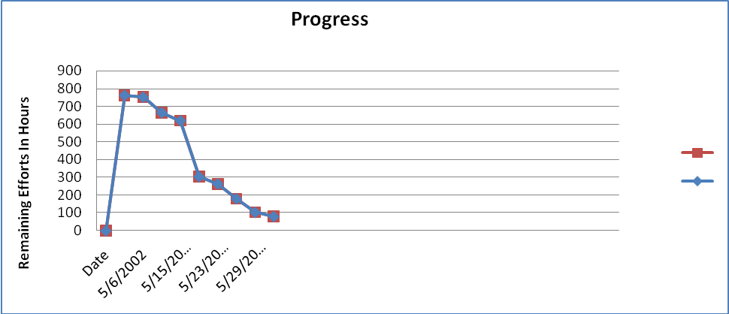
The chart will bounce up and down as new information is discovered each day, as shown above. By calculating the current slope in the number of hours remaining, an end date can be estimated. Note that the axes of the graph are days (x axis) and hours (y axis).
If the end date is significantly earlier than the Sprint completion date, then more work is added from the Product Backlog. If the end date is significantly later than the Sprint completion date, then enough of the lowest priority tasks are removed from the Sprint backlog to meet the date. It is extremely important that the Sprint completion date does not change!
The qualitative source of data is the Daily Scrum meeting. If what goes on in the Daily Scrum does not support the burn-down chart, something is wrong and must be investigated. If the two support each other, then the picture is relatively accurate.

B. Managing Releases
                - The burn-down chart can also be applied to Release Planning. It usually takes several Sprints to get the product to a releasable state. Using the Product Backlog, a burn-down chart can be created that shows the estimated amount of time to release. The axes for the Product burn-down chart are months (x axis) and days (y axis). The change in units of measurement from the Sprint burn-down chart is intended to show the increased level of uncertainty associated with the longer-term estimate.
Summing the estimates for all features in the Product Backlog provides a very rough estimate of the final product completion date. The Product Backlog is not used very often, except for short-term products where there are few releases.

A Release Plan is to deliver larger initiatives across multiple sprints with the highest priority first. The Release Plan is similar to the traditional Project Schedule in that it identifies product features and the corresponding timeframes (possibly phases) in which features will be delivered, albeit at a higher level than traditional Project Plans. Quality-related features, risks, dependencies, constraints, assumptions and issues may also be identified and documented as part of the Release Plan, which is generated by the Product Owner and Development Team.[5]

VIII. SCRUMS AND THE CONSTRUCTION ENGINEERING MANAGEMENT

Scrums in Construction Project:
SCRUM is an agile project management technique which has been implemented for the software development projects and has proved itself to be very much helpful in various commercial project developments also. As explained in the preceding part of this report, it has been adapted by some major organizations like Microsoft, Yahoo, Google, BBC, etc.
Scrum involves regular meetings between the team members of all teams that are involved in a project. A construction has many different teams like the Design team, Value Estimation team, Procurement team, Engineering team, Etc. Each team should have scrums implemented in their team to perform well. As we know the scrum team is lead by a Scrum-Master. Scrum-Master(s) of each team can meet to discuss the issues of their own team and solve problems of the project.

Before we involve ourselves in the core of construction project management let us discuss the roles of the project management team in the Construction Project Management process. In the basic structure of any construction project management team a Project Manager is the vital part. He is like the backbone of the whole project. It is not possible to change or replace this position as it has to play the key role from the initiation to the completion of the project.

The basic role of the project manager is to follow-up regarding the progress of the project. To do this he needs to meet the engineers and the other members of the team frequently. The project manager’s interaction with the team members is a basic need of the management process as it creates an environment in which each member has his own goals, which have been allotted a time slot and he has to execute and complete them within that defined time slot.

The major role that the project manager has to play is to be a mediator between the project client and the project team. The team has to be instructed by their manager to work and complete the task according to the client’s requirement. The manager can also do the same at client’s side, he can explain to the client about the time and the effort needed to complete his requirement.

As explained above it is very important that the project team meets regularly so that they can update the Project Manager or the Project Engineer with the requirements, status and the developments of the tasks allotted to them. This will be helpful for team members to update themselves according to the project’s requirements.

In Scrums technique it is a normal practice for the team to meet on daily basis. This can be at any time in the working hours. But as we know that the work in construction projects is dependent on the physical presence of the engineers and other project team members, it is not possible for the project team members to meet at the same location (consultant’s office) daily. So it would be practical if the team members congregate at the location (Site) or the location where their presence would help to physically view and understand the developments or requirements of the project-phase. This would help the team members to know the status and the problems, if any. These meetings will create an environment in which there are less chances of committing mistakes, due to which there can be a huge loss on the client side as well as for the construction contracting company.

As we all know that the construction has to be done on the standards set by the Saudi Building Code (SBC). It is will be of great value if the team meets regularly and discusses the proceedings of the project. In the meeting the Project Manager can specify the standards set by the SBC, and the different phases can be completed in accordance with the standards set by the building code.

What is Construction Project Management?
The management of construction projects requires knowledge of modern management as well as an understanding of the design and construction process. Construction projects have a specific set of objectives and constraints such as a required time frame for completion. While the relevant technology, institutional arrangements or processes will differ, the management of such projects has much in common with the management of similar types of projects in other specialty or technology domains such as aerospace, pharmaceutical and energy developments.
Generally, project management is distinguished from the general management of corporations by the mission-oriented nature of a project. A project organization will generally be terminated when the mission is accomplished. According to the Project Management Institute, the discipline of project management can be defined as follows:
Project management is the art of directing and coordinating human and material resources throughout the life of a project by using modern management techniques to achieve predetermined objectives of scope, cost, time, qualities and participation satisfaction.
By contrast, the general management of business and industrial corporations assumes a broader outlook with greater continuity of operations. Nevertheless, there are sufficient similarities as well as differences between the two so that modern management techniques developed for general management may be adapted for project management.
The basic ingredients for a project management framework may be represented schematically in Figure 2-1. A working knowledge of general management and familiarity with the special knowledge domain related to the project are indispensable. Supporting disciplines such as computer science and decision science may also play an important role. In fact, modern management practices and various special knowledge domains have absorbed various techniques or tools which were once identified only with the supporting disciplines. For example, computer-based information systems and decision support systems are now common-place tools for general management. Similarly, many operations research techniques such as linear programming and network analysis are now widely used in many knowledge or application domains. Hence, the representation in Figure 2-1 reflects only the sources from which the project management framework evolves. [7]
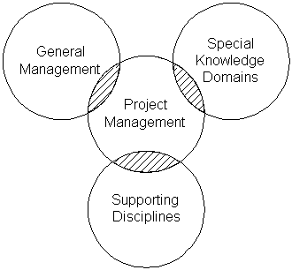
Figure 2-1: Basic Ingredients in Project Management
Specifically, project management in construction encompasses a set of objectives which may be accomplished by implementing a series of operations subject to resource constraints. There are potential conflicts between the stated objectives with regard to scope, cost, time and quality, and the constraints imposed on human material and financial resources. These conflicts should be resolved at the onset of a project by making the necessary tradeoffs or creating new alternatives. Subsequently, the functions of project management for construction generally include the following:
- Specification of project objectives and plans including delineation of scope, budgeting, scheduling, setting performance requirements, and selecting project participants.
- Maximization of efficient resource utilization through procurement of labour, materials and equipment according to the prescribed schedule and plan.
- Implementation of various operations through proper coordination and control of planning, design, estimating, contracting and construction in the entire process.
- Development of effective communications and mechanisms for resolving conflicts among the various participants.
The Project Management Institute focuses on nine distinct areas requiring project manager knowledge and attention:
- Project integration management to ensure that the various project elements are effectively coordinated.
- Project scope management to ensure that all the work required (and only the required work) is included.
- Project time management to provide an effective project schedule.
- Project cost management to identify needed resources and maintain budget control.
- Project quality management to ensure functional requirements are met.
- Project human resource management to development and effectively employ project personnel.
- Project communications management to ensure effective internal and external communications.
- Project risk management to analyze and mitigate potential risks.
- Project procurement management to obtain necessary resources from external sources.
These nine areas form the basis of the Project Management Institute's certification program for project managers in any industry. SCRUM can be implemented in all the areas of Construction Project Management to improve the performance of the project team.[8]

Trends in Modern Management
Major developments in management reflect the acceptance to various degrees of the following elements: (1) the management process approach, (2) the management science and decision support approach, (3) the behavioural science approach for human resource development, and (4) sustainable competitive advantage. Scrums can be implemented in each of these elements. These four approaches complement each other in current practice, and provide a useful groundwork for project management. The management process approach emphasizes the systematic study of management by identifying management functions in an organization and then examining each in detail. There is general agreement regarding the functions of planning, organizing and controlling. A major tenet is that by analyzing management along functional lines, a framework can be constructed into which all new management activities can be placed. Thus, the manager's job is regarded as coordinating a process of interrelated functions, which are neither totally random nor rigidly predetermined, but are dynamic as the process evolves. Another tenet is that management principles can be derived from an intellectual analysis of management functions. By dividing the manager's job into functional components, principles based upon each function can be extracted. Hence, management functions can be organized into a hierarchical structure designed to improve operational efficiency. The basic management functions are performed by all managers, regardless of enterprise, activity or hierarchical levels. Finally, the development of a management philosophy results in helping the manager to establish relationships between human and material resources. The outcome of following an established philosophy of operation helps the manager win the support of the subordinates in achieving organizational objectives.
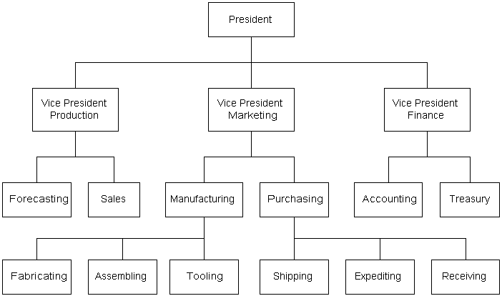
Figure 2-2: Illustrative Hierarchical Structure of Management Functions
The management science and decision support approach contributes to the development of a body of quantitative methods designed to aid managers in making complex decisions related to operations and production. In decision support systems, emphasis is placed on providing managers with relevant information. In management science, a great deal of attention is given to defining objectives and constraints, and to constructing mathematical analysis models in solving complex problems of inventory, materials and production control, among others. A topic of major interest in management science is the maximization of profit, or in the absence of a workable model for the operation of the entire system, the sub-optimization of the operations of its components. The optimization or sub-optimization is often achieved by the use of operations research techniques, such as linear programming, quadratic programming, graph theory, queuing theory and Monte Carlo simulation. In addition to the increasing use of computers accompanied by the development of sophisticated mathematical models and information systems, management science and decision support systems have played an important role by looking more carefully at problem inputs and relationships and by promoting goal formulation and measurement of performance. Artificial intelligence has also begun to be applied to provide decision support systems for solving ill-structured problems in management.
The behavioural science approach for human resource development is important because management entails getting things done through the actions of people. An effective manager must understand the importance of human factors such as needs, drives, motivation, leadership, personality, behaviour, and work groups. Within this context, some place more emphasis on interpersonal behaviour which focuses on the individual and his/her motivations as a socio-psychological being; others emphasize more group behaviour in recognition of the organized enterprise as a social organism, subject to all the attitudes, habits, pressures and conflicts of the cultural environment of people. The major contributions made by the behavioural scientists to the field of management include: (1) the formulation of concepts and explanations about individual and group behaviour in the organization, (2) the empirical testing of these concepts methodically in many different experimental and field settings, and (3) the establishment of actual managerial policies and decisions for operation based on the conceptual and methodical frameworks.
Sustainable competitive advantage stems primarily from good management strategy. As Michael Porter of the Harvard Business School argues:
Strategy is creating fit among a company's activities. The success of a strategy depends on doing many things well - not just a few - and integrating among them. If there is no fit among activities, there is no distinctive strategy and little sustainability.
In this view, successful firms must improve and align the many processes underway to their strategic vision. Strategic positioning in this fashion requires:
- Creating a unique and valuable position.
- Making trade-offs compared to competitors
- Creating a "fit" among a company's activities.
Project managers should be aware of the strategic position of their own organization and the other organizations involved in the project. The project manager faces the difficult task of trying to align the goals and strategies of these various organizations to accomplish the project goals. For example, the owner of an industrial project may define a strategic goal as being first to market with new products. In this case, facilities development must be oriented to fast-track, rapid construction. As another example, a contracting firm may see their strategic advantage in new technologies and emphasize profit opportunities from value engineering
The construction industry also has some distinct features in the way that it goes about its business, which means it cannot exactly be compared with manufacturing industries in practice. These differences impact upon the “Team-working” and “How and why it is applied”.
The construction industry as a whole is very fragmented. Its products are only needed when its customers in the form of individual clients ask for them. These individual clients then need them to be produced as fast and cheaply as possible, with regards to a specific quality standard to meet the particular clients own business needs. Being able to form ‘teams’ of not only people but also organizations as rapidly as possible in order to perform to the highest standard in the fastest time is therefore vital to the very nature of the construction project.

The notion of working together better and all the benefits that it should bring to the client, design and construction organizations alike is the heart of the current desire to understand and apply ‘team-working’ to the construction project process.
There is nothing new about human beings working together in teams to achieve a common goal.
“When early man started hunting for something bigger than any single person could handle he started to do it with others”. These early teams produced their own leaders by virtue of one who was the strongest and the dedicated amongst them.[6]

Strategic Planning and Project Programming

Scrums can be implemented in all the phases of the construction project be it the strategic planning or the project programming. The programming of capital projects is shaped by the strategic plan of an organization, which is influenced by market demands and resources constraints. The programming process associated with planning and feasibility studies sets the priorities and timing for initiating various projects to meet the overall objectives of the organizations. However, once this decision is made to initiate a project, market pressure may dictate early and timely completion of the facility.
Among various types of construction, the influence of market pressure on the timing of initiating a facility is most obvious in industrial construction. Demand for an industrial product may be short-lived, and if a company does not hit the market first, there may not be demand for its product later. With intensive competition for national and international markets, the trend of industrial construction moves toward shorter project life cycles, particularly in technology intensive industries.
In order to gain time, some owners are willing to forego thorough planning and feasibility study so as to proceed on a project with inadequate definition of the project scope. Invariably, subsequent changes in project scope will increase construction costs; however, profits derived from earlier facility operation often justify the increase in construction costs. Generally, if the owner can derive reasonable profits from the operation of a completed facility, the project is considered a success even if construction costs far exceed the estimate based on an inadequate scope definition. This attitude may be attributed in large part to the uncertainties inherent in construction projects. It is difficult to argue that profits might be even higher if construction costs could be reduced without increasing the project duration. However, some projects, notably some nuclear power plants, are clearly unsuccessful and abandoned before completion, and their demise must be attributed at least in part to inadequate planning and poor feasibility studies.
The owner or facility sponsor holds the key to influence the construction costs of a project because any decision made at the beginning stage of a project life cycle has far greater influence than those made at later stages, as shown schematically in Figure 2-3. Moreover, the design and construction decisions will influence the continuing operating costs and, in many cases, the revenues over the facility lifetime. Therefore, an owner should obtain the expertise of professionals to provide adequate planning and feasibility studies. Many owners do not maintain an in-house engineering and construction management capability, and they should consider the establishment of an ongoing relationship with outside consultants in order to respond quickly to requests. Even among those owners who maintain engineering and construction divisions, many treat these divisions as reimbursable, independent organizations. Such an arrangement should not discourage their legitimate use as false economies in reimbursable costs from such divisions can indeed be very costly to the overall organization.

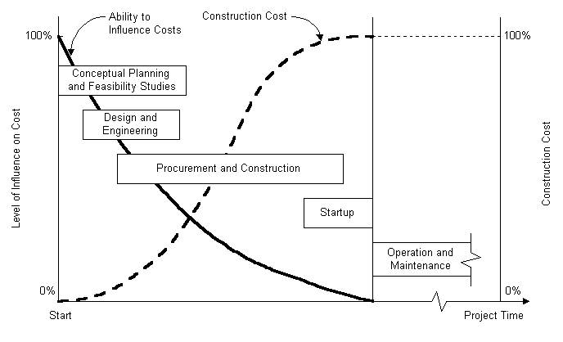

Figure 2-3: Ability to Influence Construction Cost Over Time

Finally, the initiation and execution of capital projects places demands on the resources of the owner and the professionals and contractors to be engaged by the owner. For very large projects, it may bid up the price of engineering services as well as the costs of materials and equipment and the contract prices of all types. Consequently, such factors should be taken into consideration in determining the timing of a project.
Setting priorities for projects
A department store planned to expand its operation by acquiring 20 acres of land in the southeast of a metropolitan area which consists of well established suburbs for middle income families. An architectural/engineering (A/E) firm was engaged to design a shopping center on the 20-acre plot with the department store as its flagship plus a large number of storefronts for tenants. One year later, the department store owner purchased 2,000 acres of farm land in the northwest outskirts of the same metropolitan area and designated 20 acres of this land for a shopping center. The A/E firm was again engaged to design a shopping center at this new location.
The A/E firm was kept completely in the dark while the assemblage of the 2,000 acres of land in the northwest quietly took place. When the plans and specifications for the southeast shopping center were completed, the owner informed the A/E firm that it would not proceed with the construction of the southeast shopping center for the time being. Instead, the owner urged the A/E firm to produce a new set of similar plans and specifications for the northwest shopping center as soon as possible, even at the sacrifice of cost saving measures. When the plans and specifications for the northwest shopping center were ready, the owner immediately authorized its construction. However, it took another three years before the southeast shopping center was finally built.
The reason behind the change of plan was that the owner discovered the availability of the farm land in the northwest which could be developed into residential real estate properties for upper middle income families. The immediate construction of the northwest shopping center would make the land development parcels more attractive to home buyers. Thus, the owner was able to recoup enough cash flow in three years to construct the southeast shopping center in addition to financing the construction of the northeast shopping center, as well as the land development in its vicinity.
While the owner did not want the construction cost of the northwest shopping center to run wild, it apparently was satisfied with the cost estimate based on the detailed plans of the southeast shopping center. Thus, the owner had a general idea of what the construction cost of the northwest shopping center would be, and did not wish to wait for a more refined cost estimate until the detailed plans for that center were ready. To the owner, the timeliness of completing the construction of the northwest shopping center was far more important than reducing the construction cost in fulfilling its investment objectives. [14]

Resource Constraints for Mega Projects

A major problem with mega projects is the severe strain placed on the environment, particularly on the resources in the immediate area of a construction project. "Mega" or "macro" projects involve construction of very large facilities such as the Alaska pipeline constructed in the 1970's or the Panama Canal constructed in the 1900's. The limitations in some or all of the basic elements required for the successful completion of a mega project include:
- Engineering design professionals to provide sufficient manpower to complete the design within a reasonable time limit.
- Construction supervisors with capacity and experience to direct large projects.
- The number of construction workers with proper skills to do the work.
- The market to supply materials in sufficient quantities and of required quality on time.
- The ability of the local infrastructure to support the large number of workers over an extended period of time, including housing, transportation and other services.
To compound the problem, mega projects are often constructed in remote environments away from major population centers and subject to severe climate conditions. Consequently, special features of each mega project must be evaluated carefully.

Leadership and Motivation for the Project Team
In the scrum team there are members of the team who are lead by the team lead or the Scrum-master. Usually the Project Manager is referred as the Scrum-master. The project manager, in the broadest sense of the term, is the most important person for the success or failure of a project. The project manager is responsible for planning, organizing and controlling the project. In turn, the project manager receives authority from the management of the organization to mobilize the necessary resources to complete a project.
The project manager must be able to exert interpersonal influence in order to lead the project team. The project manager often gains the support of his/her team through a combination of the following:
- Formal authority resulting from an official capacity which is empowered to issue orders.
- Reward and/or penalty power resulting from his/her capacity to dispense directly or indirectly valued organization rewards or penalties.
- Expert power when the project manager is perceived as possessing special knowledge or expertise for the job.
- Attractive power because the project manager has a personality or other characteristics to convince others.
In a matrix organization, the members of the functional departments may be accustomed to a single reporting line in a hierarchical structure, but the project manager coordinates the activities of the team members drawn from functional departments. The functional structure within the matrix organization is responsible for priorities, coordination, administration and final decisions pertaining to project implementation. Thus, there are potential conflicts between functional divisions and project teams. The project manager must be given the responsibility and authority to resolve various conflicts such that the established project policy and quality standards will not be jeopardized. When contending issues of a more fundamental nature are developed, they must be brought to the attention of a high level in the management and be resolved expeditiously.
In general, the project manager's authority must be clearly documented as well as defined, particularly in a matrix organization where the functional division managers often retain certain authority over the personnel temporarily assigned to a project. The following principles should be observed:
- The interface between the project manager and the functional division managers should be kept as simple as possible.
- The project manager must gain control over those elements of the project which may overlap with functional division managers.
- The project manager should encourage problem solving rather than role playing of team members drawn from various functional divisions.
Interpersonal Behavior in Project Organizations
While a successful project manager must be a good leader, other members of the project team must also learn to work together, whether they are assembled from different divisions of the same organization or even from different organizations. Some problems of interaction may arise initially when the team members are unfamiliar with their own roles in the project team, particularly for a large and complex project. These problems must be resolved quickly in order to develop an effective, functioning team.
Many of the major issues in construction projects require effective interventions by individuals, groups and organizations. The fundamental challenge is to enhance communication among individuals, groups and organizations so that obstacles in the way of improving interpersonal relations may be removed. Some behavior science concepts are helpful in overcoming communication difficulties that block cooperation and coordination. In very large projects, professional behavior scientists may be necessary in diagnosing the problems and advising the personnel working on the project. The power of the organization should be used judiciously in resolving conflicts.
The major symptoms of interpersonal behavior problems can be detected by experienced observers, and they are often the sources of serious communication difficulties among participants in a project. For example, members of a project team may avoid each other and withdraw from active interactions about differences that need to be dealt with. They may attempt to criticize and blame other individuals or groups when things go wrong. They may resent suggestions for improvement, and become defensive to minimize culpability rather than take the initiative to maximize achievements. All these actions are detrimental to the project organization.
While these symptoms can occur to individuals at any organization, they are compounded if the project team consists of individuals who are put together from different organizations. Invariably, different organizations have different cultures or modes of operation. Individuals from different groups may not have a common loyalty and may prefer to expand their energy in the directions most advantageous to themselves instead of the project team. Therefore, no one should take it for granted that a project team will work together harmoniously just because its members are placed physically together in one location. On the contrary, it must be assumed that good communication can be achieved only through the deliberate effort of the top management of each organization contributing to the joint venture.[14]
Organization of Project Participants
The top management of the owner sets the overall policy and selects the appropriate organization to take charge of a proposed project. Its policy will dictate how the project life cycle is divided among organizations and which professionals should be engaged. Decisions by the top management of the owner will also influence the organization to be adopted for project management. In general, there are many ways to decompose a project into stages. The most typical ways are:
- Sequential processing whereby the project is divided into separate stages and each stage is carried out successively in sequence.
- Parallel processing whereby the project is divided into independent parts such that all stages are carried out simultaneously.
- Staggered processing whereby the stages may be overlapping, such as the use of phased design-construct procedures for fast track operation.
It should be pointed out that some decomposition may work out better than others, depending on the circumstances. In any case, the prevalence of decomposition makes the subsequent integration particularly important. The critical issues involved in organization for project management are:
- How many organizations are involved?
- What are the relationships among the organizations?
- When are the various organizations brought into the project?
There are two basic approaches to organize for project implementation, even though many variations may exist as a result of different contractual relationships adopted by the owner and builder. These basic approaches are divided along the following lines:
- Separation of organizations. Numerous organizations serve as consultants or contractors to the owner, with different organizations handling design and construction functions. Typical examples which involve different degrees of separation are:
  - Traditional sequence of design and construction
  - Professional construction management
- Integration of organizations. A single or joint venture consisting of a number of organizations with a single command undertakes both design and construction functions. Two extremes may be cited as examples:
  - Owner-builder operation in which all work will be handled in house by force account.
  - Turnkey operation in which all work is contracted to a vendor which is responsible for delivering the completed project
Since construction projects may be managed by a spectrum of participants in a variety of combinations, the organization for the management of such projects may vary from case to case. On one extreme, each project may be staffed by existing personnel in the functional divisions of the organization on an ad-hoc basis as shown in Figure 2-4 until the project is completed. This arrangement is referred to as the matrix organization as each project manager must negotiate all resources for the project from the existing organizational framework. On the other hand, the organization may consist of a small central functional staff for the exclusive purpose of supporting various projects, each of which has its functional divisions as shown in Figure 2-5. This decentralized set-up is referred to as the project oriented organization as each project manager has autonomy in managing the project. There are many variations of management style between these two extremes, depending on the objectives of the organization and the nature of the construction project. For example, a large chemical company with in-house staff for planning, design and construction of facilities for new product lines will naturally adopt the matrix organization. On the other hand, a construction company whose existence depends entirely on the management of certain types of construction projects may find the project-oriented organization particularly attractive. While organizations may differ, the same basic principles of management structure are applicable to most situations.

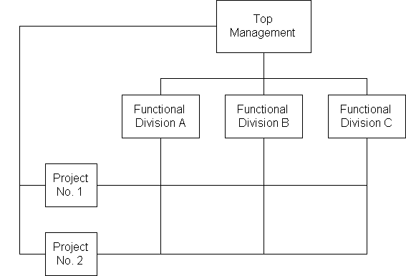
Figure 2-4: A Matrix Organization

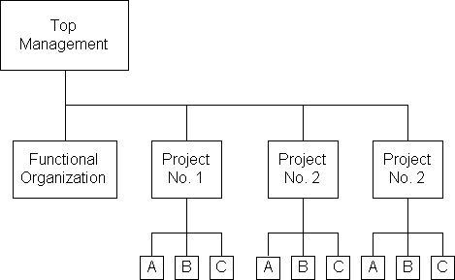
Figure 2-5: A Project-Oriented Organization
To illustrate various types of organizations for project management, we shall consider two examples, the first one representing an owner organization while the second one representing the organization of a construction management consultant under the direct supervision of the owner.[15]
Matrix Organization of an Engineering Division
The Engineering Division of an Electric Power and Light Company has functional departments as shown in Figure 2-6. When small scale projects such as the addition of a transmission tower or a sub-station are authorized, a matrix organization is used to carry out such projects. For example, in the design of a transmission tower, the professional skill of a structural engineer is most important. Consequently, the leader of the project team will be selected from the Structural Engineering Department while the remaining team members are selected from all departments as dictated by the manpower requirements. On the other hand, in the design of a new sub-station, the professional skill of an electrical engineer is most important. Hence, the leader of the project team will be selected from the Electrical Engineering Department. [15]

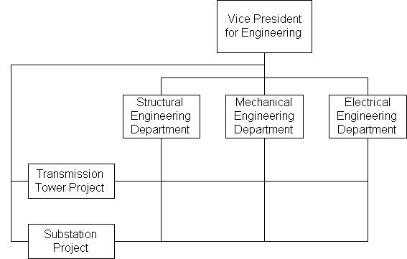
Figure 2-6: The Matrix Organization in an Engineering Division
Construction Management Consultant Organization
When the same Electric Power and Light Company in the previous example decided to build a new nuclear power plant, it engaged a construction management consultant to take charge of the design and construction completely. However, the company also assigned a project team to coordinate with the construction management consultant as shown in Figure 2-7.
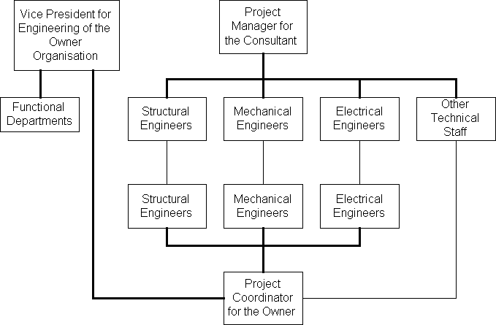
Figure 2-7: Coordination between Owner and Consultant
Since the company eventually will operate the power plant upon its completion, it is highly important for its staff to monitor the design and construction of the plant. Such coordination allows the owner not only to assure the quality of construction but also to be familiar with the design to facilitate future operation and maintenance. Note the close direct relationships of various departments of the owner and the consultant. Since the project will last for many years before its completion, the staff members assigned to the project team are not expected to rejoin the Engineering Department but will probably be involved in the future operation of the new plant. Thus, the project team can act independently toward its designated mission.

Innovation and Economic Feasibility
Innovation is often regarded as the engine which can introduce construction economies and advance labor productivity. This is obviously true for certain types of innovations in industrial production technologies, design capabilities, and construction equipment and methods. However, there are also limitations due to the economic infeasibility of such innovations, particularly in the segments of construction industry which are more fragmented and permit ease of entry, as in the construction of residential housing.
Market demand and firm size play an important role in this regard. If a builder is to construct a larger number of similar units of buildings, the cost per unit may be reduced. This relationship between the market demand and the total cost of production may be illustrated schematically as in Figure 2-8. An initial threshold or fixed cost F is incurred to allow any production. Beyond this threshold cost, total cost increases faster than the units of output but at a decreasing rate. At each point on this total cost curve, the average cost is represented by the slope of a line from the origin to the point on the curve. At a point H, the average cost per unit is at a minimum. Beyond H to the right, the total cost again increases faster than the units of output and at an increasing rate. When the rate of change of the average cost slope is decreasing or constant as between 0 and H on the curve, the range between 0 and H is said to be increasing return to scale; when the rate of change of the average cost slope is increasing as beyond H to the right, the region is said to be decreasing return to scale. Thus, if fewer than h units are constructed, the unit price will be higher than that of exactly h units. On the other hand, the unit price will increase again if more than h units are constructed.
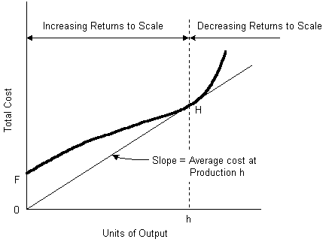
Figure 2-8: Market Demand and Total Cost Relationship
Nowhere is the effect of market demand and total cost more evident than in residential housing. The housing segment in the last few decades accepted many innovative technical improvements in building materials which were promoted by material suppliers. Since material suppliers provide products to a large number of homebuilders and others, they are in a better position to exploit production economies of scale and to support new product development. However, homebuilders themselves have not been as successful in making the most fundamental form of innovation which encompasses changes in the technological process of homebuilding by shifting the mixture of labor and material inputs, such as substituting large scale off-site prefabrication for on-site assembly.
There are several major barriers to innovation in the technological process of homebuilding, including demand instability, industrial fragmentation, and building codes. Since market demand for new homes follows demographic trends and other socio-economic conditions, the variation in home building has been anything but regular. The profitability of the homebuilding industry has closely matched aggregate output levels. Since entry and exist from the industry are relatively easy, it is not uncommon during periods of slack demand to find builders leaving the market or suspending their operations until better times. The inconsistent levels of retained earnings over a period of years, even among the more established builders, are likely to discourage support for research and development efforts which are required to nurture innovation. Furthermore, because the homebuilding industry is fragmented with a vast majority of homebuilders active only in local regions, the typical homebuilder finds it excessively expensive to experiment with new designs. The potential costs of a failure or even a moderately successful innovation would outweigh the expected benefits of all but the most successful innovations. Variation in local building codes has also caused inefficiencies although repeated attempts have been made to standardize building codes.
In addition to the scale economies visible within a sector of the construction market, there are also possibilities for scale economies in individual facility. For example, the relationship between the size of a building (expressed in square feet) and the input labor (expressed in labor hours per square foot) varies for different types and sizes of buildings. As shown in Figure 2-9, these relationships for several types of buildings exhibit different characteristics. The labor hours per square foot decline as the size of facility increases for houses, public housing and public buildings. However, the labor hours per square foot almost remains constant for all sizes of school buildings and increases as the size of a hospital facility increases. [14]

IX. FUTURE OF SCRUMS IN CONSTRUCTION MANAGEMENT

Presently Construction Project Management is a process which involves a large no of activities. There are many phases of the construction project. Each phase has its own team; these teams can be designed as scrum teams individually. These scrum teams have their own team leads and all the team leads can join as members of a main scrum team and it is clear that the scrum management technique is a technique that involves extensive team work.
As we all know that construction industry in Saudi Arabia is an evergreen field. The projects are expanding day by day and the construction companies are always ready to take up new projects. As the need of construction is increasing there is a proportional increase in the competition of construction industry.
It should be kept in view that as the projects are coming up there is an increase in the requirements of the clients. The demand of the client is for quality product. As we know that the construction industry is on a boom in the whole GCC, the Saudi Construction Industry has to adapt the techniques implemented by the companies in the other dynamically developing countries of the GCC, Ex: UAE, Qatar, etc.
SCRUM’s is project management technique which will enhance the performance of any construction company. If Scrums is implemented throughout the Saudi Construction Industry then the day is not far when the Saudi Construction Industry will mark itself as the most productive and fastest growing industry. As it has been noticed that it is the same project management technique, which is implemented for the project management of other industries (Software, Broadcast, Automobile, Etc).
X. CONCLUSION

As can be readily determined from the above, Scrum strongly advocates self-managing teams in which the Scrum Master acts primarily as a facilitator helping the team solidify its tasks as well as ‘running interference’ regarding any obstacles that may have a negative impact on team productivity. Self-managing teams require time to evolve; they do not happen overnight. Since Scrum documentation is relatively light on how to prepare a team to become self-sufficient, it is recommended that formal team-related coaching be provided prior to implementing Scrum.
For Construction Project Managers, the transition from leader to facilitator may be a difficult mindset to change, especially if the transition is fairly sudden. The traditional Project Manager may be compared with the captain of a ship who is chartered with steering the course, anticipating and overcoming difficulties, and ultimately safely delivering the cargo and passengers on schedule. In contrast, the Scrum Master acts mainly as an enabler to the Scrum Team since the entire team is responsible for the outcome of each Sprint. Whereas the Scrum Master primarily utilizes facilitation skills during the course of a Sprint, facilitation is a subset of the entire skill set required to be a successful PM. Experience and knowledge regarding requirements definition, time management, estimating, negotiating, budget oversight, and anticipating risk are all expected of the seasoned Project Manager. How these attributes may be best leveraged in Scrum - if at all - and to what extent the Scrum Master is free to tap into them is yet to be determined.[16]

This report provides a flavour of what Scrum is and how it can help you manage a Construction Project and help you deliver Product incrementally instead of "big bang".

Keep asking these questions:
- What is the simplest thing that can move the project forward?
- Will what is being done right now to move the project forward?
- Are there any impediments that are preventing progress?

Where does Construction Project appear? Scrum lets us move our projects from "top right" towards "bottom left". Those Construction Projects that try to implement 100% of the requirements move themselves into anarchy; they try to do too much. By doing less work, accepting that 80% of a product’s value does come from 20% of its features means you can move through complex and complicated towards simple.

XI. REFERENCES

- Scrum: It’s About Common Sense http://www.controlchaos.com
- http://www.craigmurphy.com/sd/WhyScrumWorks.zip
- http://www.scrumalliance.org : Pay your £1, $1, €1 late-comer fee via this site!
- Software by Numbers: Low-Risk, High-Return Development, By Mark Denne, Jane Cleland-Huang. Prentice Hall PTR, 2003, ISBN 0131407287
- Agile Project Management with Scrum, Ken Schwaber, Microsoft Press, 2004, ISBN 073561993X
- Construction Management Teams – Making them and working profitably, Tim Cornick & James Mather.MPG Books Limited, 1999, ISBN:0727727451.
- Construction Project Administration – Second Edition, Edward R. Fisk,John Wiley & Sons, 1982, ISBN 0-471-09186-3
- Construction Project Administration – Fifth Edition, Edward R. Fisk, Prentice-Hall , 1997, ISBN 0-471-09186-3
- Barrie, Donald S. and Boyd C. Paulson, Jr., Professional Construction Management, McGraw-Hill Book Company, 2nd Ed., 1984.
- Halpin, Daniel W. and Ronald W. Woodhead, Construction Management, John Wiley and Sons, 1980.
- Hodgetts, R.M., Management: Theory, Process and Practice, W.B. Saunders Co., Philadelphia, PA, 1979.
- Kerzner, H. Project Management: A Systems Approach to Planning, Scheduling and Controlling. 2nd. Ed., Van Nostrand Reinhold, New York, 1984.
- Levitt, R.E., R.D. Logcher and N.H. Quaddumi, "Impact of Owner-Engineer Risk Sharing on Design Conservatism," ASCE Journal of Professional Issues in Engineering, Vol. 110, 1984, pp. 157-167.
- Moolin, F.P., Jr., and F.A. McCoy: "Managing the Alaska Pipeline Project," Civil Engineering, November 1981, pp. 51-54.
- Murray, L., E. Gallardo, S. Aggarwal and R. Waywitka, "Marketing Construction Management Services," ASCE Journal of Construction Division, Vol. 107, 1981, pp. 665-677.
- Project Management Institute, A Guide to the Project Management Body of Knowledge, Newtown Square, Pennsylvania, 2000.

