Structural Mechanics I
CE 203-KFUPM-021
Summary of lecture 34-37
- Stresses in Thin-walled Pressure Vessels
- Compound Normal and Shear Stresses.

Stresses in Thin-walled Pressure Vessels:
Pressure Vessels: carry internal pressure p_{int}, and resist by developing stresses in the thickness t of the vessel. Thin-walled vessels usually have thickness to radius ratio t/r much less than 10 otherwise it is called a thick-walled pressure vessel. We study here only thin-walled vessels.

Types of Vessels: Cylinderical and spherical vessels. Each has an internal radius r, and wall thickness t, as shown in the following two Figures.
Sec. -1
Sec. -2

Resistance: the vessel resists the effect of internal pressure p_{int} by developing circumferential (hoop) stress σ_{h} and longitudinal stress σ_{l}.

Computing Hoop and Longitudinal Stresses:
- Cylinderical vessel: using section 1, the principle of equilibrium between internal force effect F_{int}, and the resistance developed in the wall thickness R gives:
R = F_{int ===>} p π r² = σ_{l} π [r_{e}² – r_{i}²] = σ_{l} π [r_{e} – r_{i}] [r_{e} + r_{i}]
= σ_{l} π [t] [2r] _{===>} σ_{l} = [r/(2t)] p.
And from the section 2:

R = F_{int ===>} p l (2r) = σ_{h} (2 l ) [t] = σ_{h} (2 l t)
_{===>} σ_{h} = [r/(t)] p.
Note: σ_{h} = 2 σ_{l} . This means that the hoop stress is more damaging than the longitudinal stress.

- Spherical vessel: using section 1, the principle of equilibrium between internal force effect F_{int}, and the resistance developed in the wall thickness R, it is easily seen that

R = F_{int ===>} p π r² = σ_{l} π [r_{e}² – r_{i}²] = σ_{l} π [r_{e} – r_{i}] [r_{e} + r_{i}]
= σ_{l} π [t] [2r] _{===>} σ_{l} = [r/(2t)] p.
This value is independent of the cut and is easily seen that σ_{h} = σ_{l} for spherical vessels.
Note: The stresses in spherical vessels are much less than in cylinderical vessels. Therefore from a design point of view (that is: selecting appropriate material), spherical vessels should be used to save material for more economical design.

The following example illustrates the applications of the above equations for a typical pressure vessel.

Example: A cylinderical pressure vessel is to be made from a set of wooden pieces shaped together to form a cylinder with internal radius r. A set of steel belts are also used to ensure the integrity of the cylinder under internal pressure as shown in Fig. P-1 below. If the information for the problem are:
- p_{int} = 294 kPa
- r = 1.5 m
- A_{belt} = 300 mm²
- σ_{all} = 100 MPa
- Spacing between belts (unknown) s.

Determine the required spacing of the belts.
Sec. -1
Sec. -2
s
s
F_{int}
R/2 by the belt
Fig. P-1:

From equilibrium offered by the resistance of one belt (see the FBD above):

F_{int} = R; then: p (s)(2r) = 2*σ_{all} (A_{belt})

The spacing s = σ_{all} (A_{belt}) / (p r)
= 100.E06 (300.E-06)/[ 294.E03 (1.5)] = 0.0680 m

Conclusion:

A proper design will indicate the use of the indicated belts at spacing of not more than 7 cm measured from center to center of each two consecutive belts.

Compound Normal and Shear Stresses:
For a general state of loading there are usually three internal forces (N; V_{y}; V_{z}) and three internal moments (M_{x} = Torsion moment T; M_{y} = Bending moment about y-axis; M_{z} = Bending moment about z-axis that might act on a particular cross section. Each one of theses six internal actions will give a stress of its type to be either normal stress σ or shear stress τ. The following Fig. 1 illustrates the forces and the stresses in a given point on a given cross section.
τ_{yx}
τ_{zx}
σ_{x} = σ_{p}
Fig. 1:
T
M_{z}
M_{y}
N
V_{y}
V_{z}

Based on the above illustration, the total stress at a point on the cross section defined by coordinate (y_{p}; z_{p}), the total (compont) normal and shear stresses at the point p are computed by linaer superposition from the effects of the individual actions as follows:

- Compound normal stress σ_{p} = σ_{p} ^{(N)} + σ_{p} ^{(My)} + σ_{p}^{(Mz)}
= N/A + M_{y} z_{p}/ I_{yy} + M_{z} y_{p}/ I_{zz}.

- Compound shear stress τ_{p} = τ_{p} ^{(T)} + τ_{p} ^{(Vy)} + τ_{p}^{(Vz)}
= [Tr/J or T t/J_{eq} depending on the type of c/s] + V_{y} Q_{zz}/ I_{zz} t_{zz} + V_{z} Q_{yy}/ I_{yy} t_{yy}
Notes:
- The summation of τ_{p} is done vectorially as the stresses from the given actions might not be collinear.
- The moments of inertia I_{yy} and I_{zz} are with respect to the centroidal axes.
- The thicknesses t_{yy} and t_{zz} are the dimensions for a rectangular c/s or the width of the appropriate cut made on the c/s.

Additional notes and clarifications are included in the following pages.

Applications:

The analysis of compound normal and shear stresses are illustrated by the following examples.

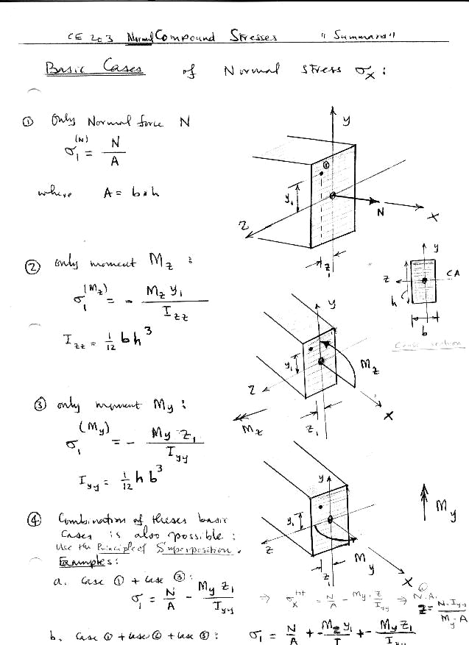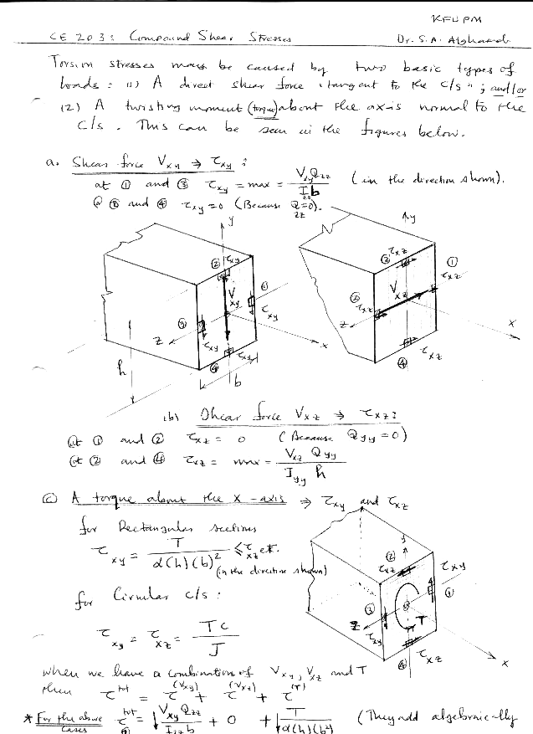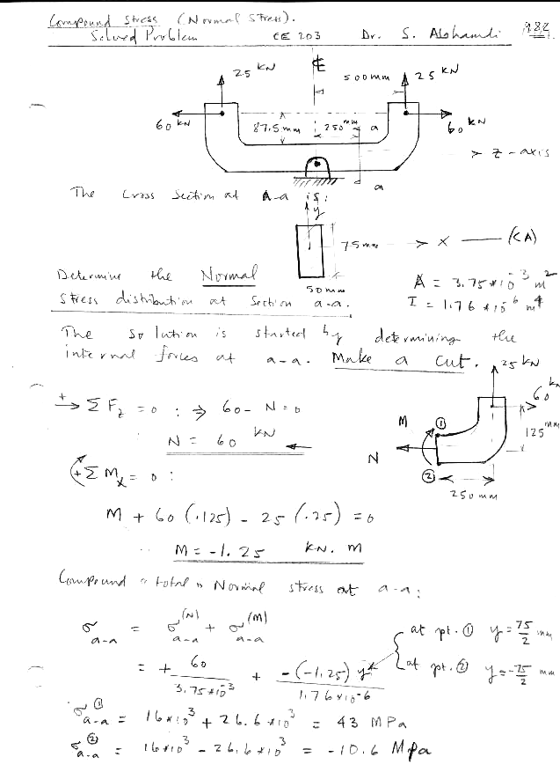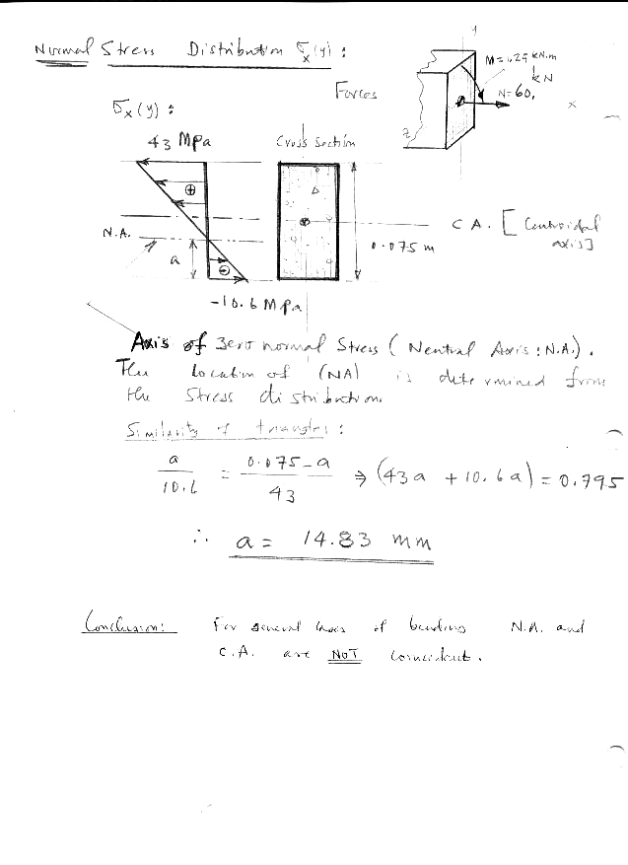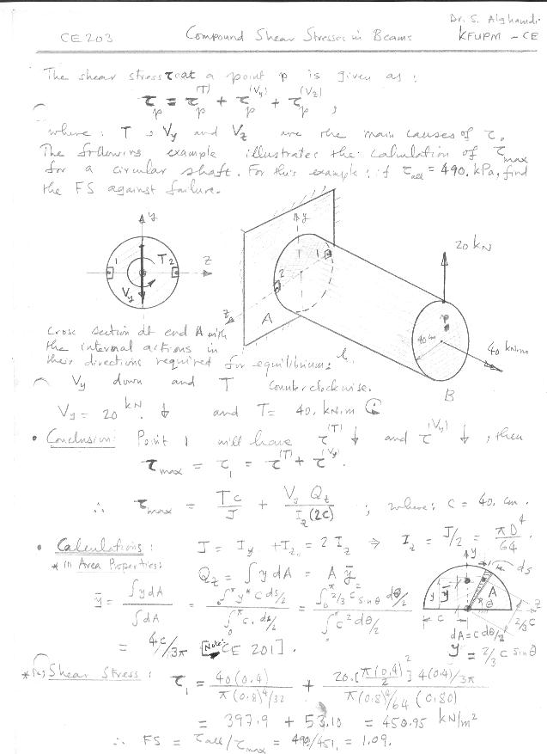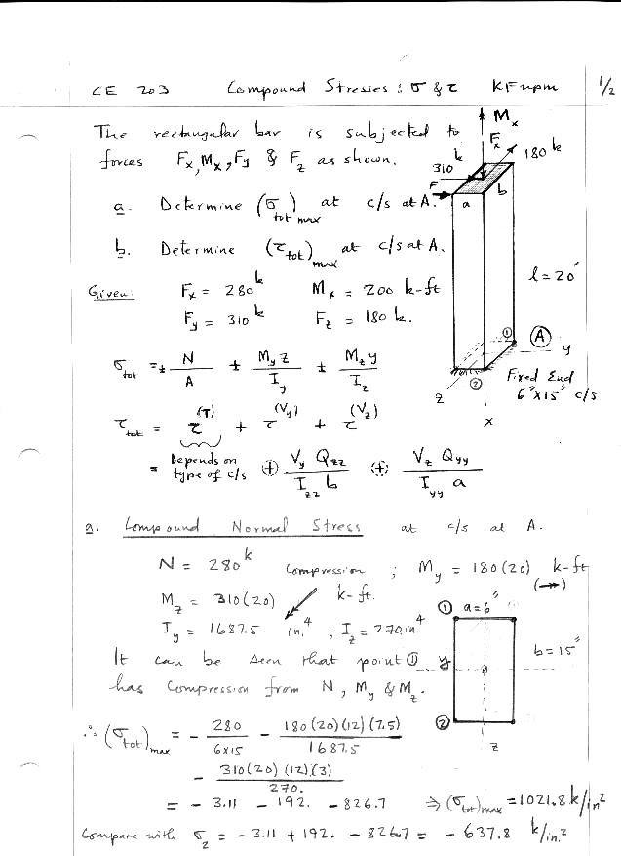

Analysis of Compound Normal and Shear Stresses for a General State of Loading

The 3-D bar shown in the Fig. P-2, is loaded by three forces of 20 kN, 10 kN and 40 kN acting respectively at points A, B, and C. The bar has a rectangle cross section of 20 cm by 15 cm. The cross section at D is fixed to the footing and the three segments of the bar has lengths of 6 m, 4 m, and 5 m.
Determine:
- All internal actions (forces and moments) at section D using vector equilibrium equations.
- The maximum compound normal stress at c/s D.
- The maximum compound shear stress at c/s D.
A
Coordinates of points:
A( 5, 4, -6) m.
B( 5, 4, 0) m.
C( 5, 0, 0) m.
D(0,0,0) m.
20 kN
10 kN
40 kN
5 m
4 m
B
C
x
y
z
D
6 m
corner 1
Fig. P-2:
F₁
F₂
F₃
r₂
r₃
r₁
F_{D}
M_{D}
FBD of center line of the bar ABCD with forces vectors F_{i} and position vectors r_{i}.
Vector Equilibrium equations:
Σ F_{ext} + Σ F_{int} = 0; Σ M_{ext. @ point D} + Σ M_{int. @ point D} = 0;
F₁ + F₂ + F₃ = 0; -20 j + 10 i – 40 k + F_{D} = 0. Then: F_{D} = - 10 i + 20 j + 40 k (kN).

Σ M_{ext. @ point D} + Σ M_{int. @ point D} = 0;
(r₁x F₁) + (r₂x F₂) + (r₃x F₃) + M_{D} = 0 … (2)
And with the origin of the (x,y,z) system at point D, the position vectors are:

r₁ = 5 i+ 4j-6k (m)
r₂ = 5 i+ 4j (m)
r₃ = 5 i (m)
Then from equation (2) above, the moment M_{D} is obtained from the sum of the negatives of the cross product of the position vectors r_{i} and forces F_{i}.

M_{D} = - [(5 i+ 4j-6k) x (-20j) + (5 i+ 4j) x (10i) + (5 i) x (-40k)]
= - [ (-100k + 0 – 120i) + ( 0 - 40k) + (200j)].

Interpretations of F_{D} and M_{D}:
The components of the two vector internal actions (forces and moments) are as follows:
F_{Dx} = N = -10 kN (Tension as it is in the –ve x-direction!! ).
F_{Dy} = V_{y} = 20 kN.
F_{Dz} = V_{z} = 40 kN.

M_{Dx} = M_{x} = T = + 120 kN.m.
M_{Dy} = - 200 kN.m.
M_{Dz} = +140 kN.m.

Internal Actions Placed on the C/S:
The normal stresses and shear stresses at c/s D will be caused by the compound effects of the above internal actions acting on the c/s at D.
10 kN
140 kN.m
200 kN.m
corner 1
σ₁ = 10/(0.2∗0.15) + 140 (0.10)/((1/12)∗0.15∗ 0.20³)+ 200. (0.075)/((1/12)∗0.2∗0.15³).

The computations of τ_{max} requires similar procedure of placing the actions T, V_{y}, and V_{z} on the c/s and determining the point that will include addition (at point 2) of component shear stresses.
x
z
y
x
τ_{tot} = τ^{(Τ)} + τ^{(Vy)} + τ^{(Vz)}
= Τ/[(α (2b)(2a)²)]+ V_{y}Q_{zz}/I_{zz} t_{zz} + 0. (@ level of point 2)
where: Q_{zz} = [0.15(0.10)*(0.10/2)] m³; and t_{zz} = 0.15 m.
Mid-length of long side (point 2).
- Stress cube at point 2: with σ₂ and τ₂:
complete the computations of the numerical values of the compound stresses!
σ_{tot}
τ_{tot}

